Introduction
Holds are put on student accounts to restrict them from certain processes until an outstanding obligation to the school is fulfilled, monetary or otherwise. Holds can come from a number of different sources, including charges for unreturned keys or equipment, library fines, parking tickets issued on campus, or outstanding tuition balances. Holds will also be placed on student accounts if they are on a leave of absence, disciplinary suspension, or have been dismissed from the college or have persona-non-grata status. Additionally, holds may be placed on student accounts if they are missing paperwork, such as a final high school transcript or required immunization records. The College may place a hold on any student’s account for any reason. Students should check their account for holds regularly, especially before the advising and registration period or before requesting a transcript.
Checking for Holds
1. Go to www.purchase.edu/current-students/
2. Under Quick Links, select MyHeliotrope and login with your Purchase College ID and password
3. Go to Student
4. Go to Student Profile.
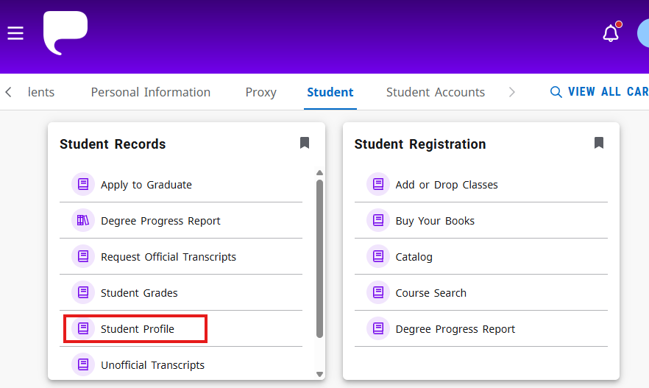
5. Click on Holds in the top right corner of your student profile. The number of holds on your account will be indicated here.
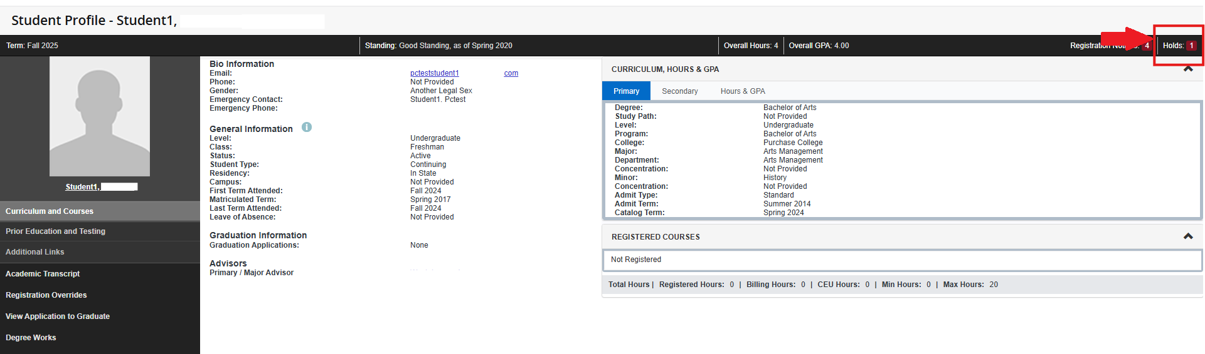
6. Click on the down arrow to view your hold details.
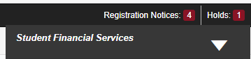
Originator: This refers to the office on campus that enforces the hold. This is the office you must contact to have the hold removed. The campus extension will be listed here.

From Date: This is the date the hold was posted to your account.

To Date: This is the date the hold will expire.

Reason: This describes why the hold was placed on your account.
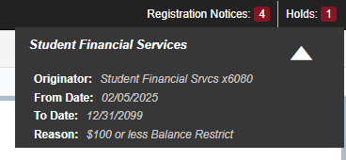

Clearing Holds
To clear a hold on your account, you must contact the office listed as the originator at the given campus extension. Dial (914)251- followed by the provided 4-digit campus extension.

