Introduction
Registration overrides allow students to register for a class past certain requirements or class capacity. Assigning a registration override to a student does not register them for the course. Faculty should be sure to notify the student after assigning a registration override. Registration overrides can only be assigned by the instructor of a course or the chair or director of the associated board of study.

Accessing Registration Overrides

Go to purchase.edu/faculty-and-staff/
- Go to Academics
- Go to MyHeliotrope and login with your Purchase College ID and password
- Go to Faculty Services
- Scroll down in the Faculty Services tile and click Registration Overrides

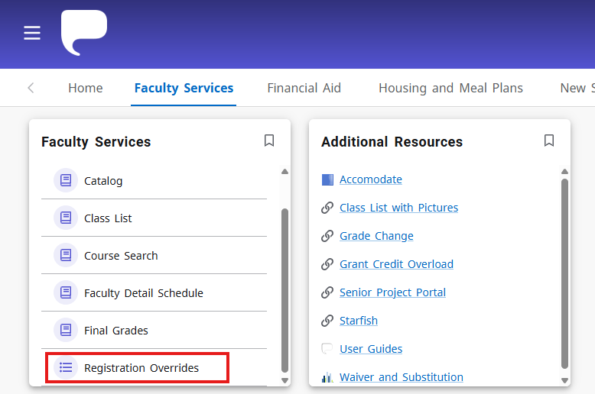

- Select the applicable term from the dropdown menu.

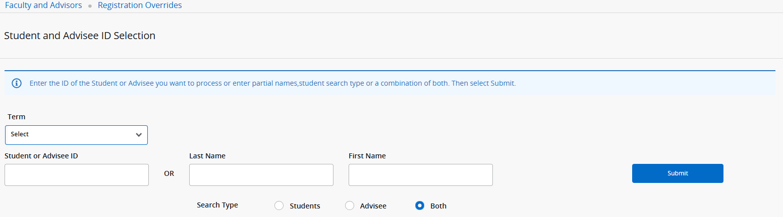

- If you have the student’s PID, enter it in the Student or Advisee ID field. Otherwise, you may search by name. Once you have entered your search parameters, click Submit.

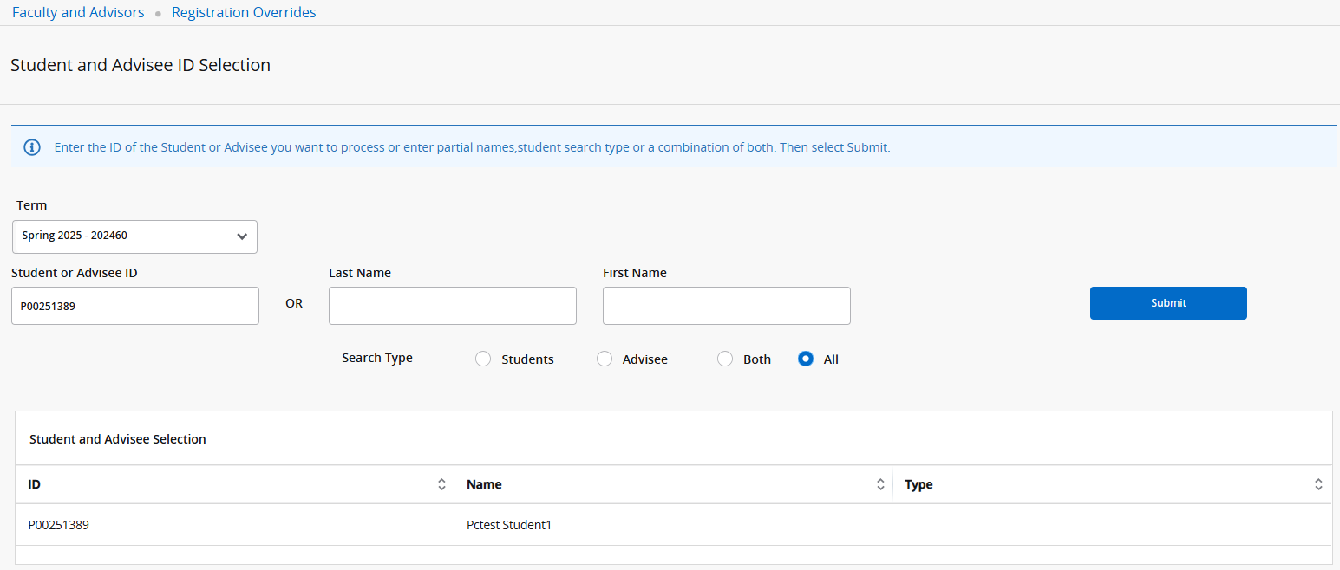

- Select the student from the search results appearing below the search parameters. If you searched by name and there are multiple students with the same and you are not sure which record is the one you are looking for, ask the student for their ID number to confirm.

Assigning Registration Overrides
Once you have found the right student, you will come to the page where you can process registration overrides.
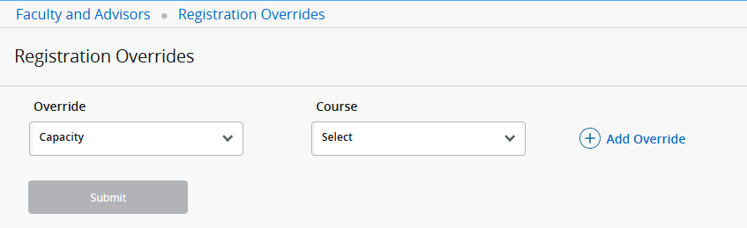

If the student has any existing registration overrides, they will appear under the Current Student Overrides section like this:

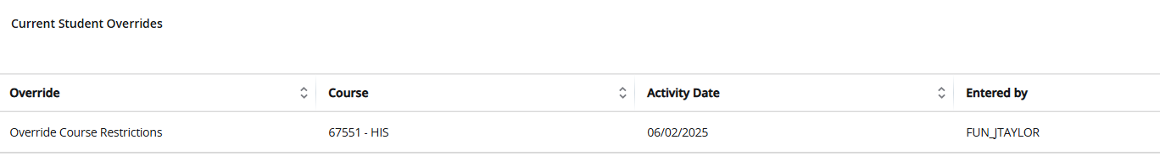

The student’s schedule will also appear at the bottom of this page, including courses they are on the Wait List for. Please note the student’s registration status for each course on their schedule.

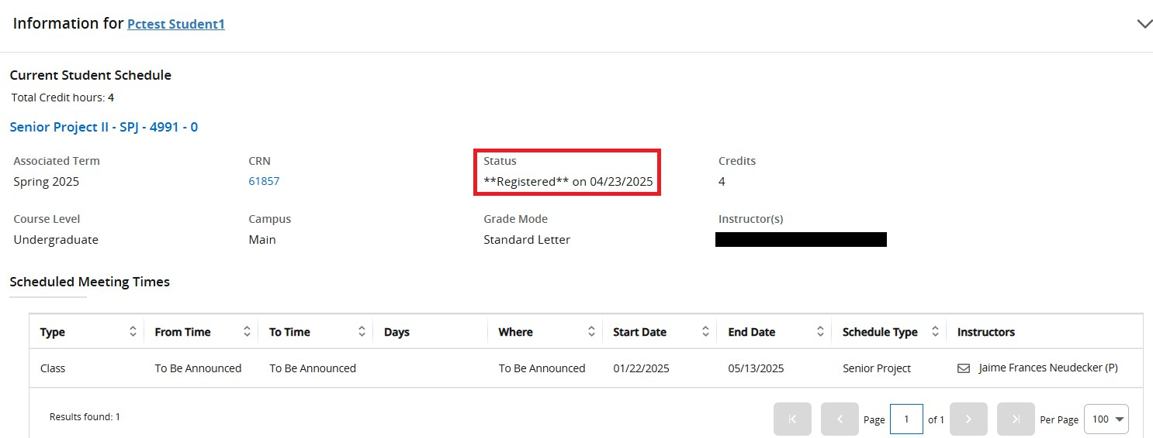
After checking the student’s schedule for conflicts and confirming that all information is correct, you can
process registration override(s) for this student.
There are three types of registration overrides that can be assigned: Capacity, Override Course Restrictions, and Director Override.

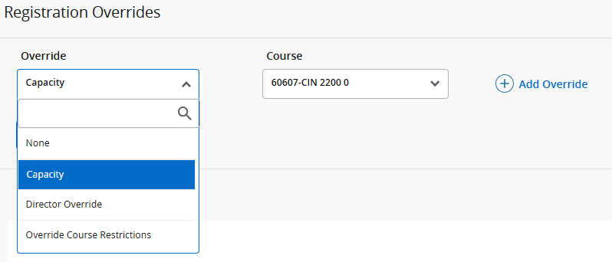

Capacity:
This type of registration override will allow the student to register for the selected course even if it at full capacity. This override will not allow students to register past other types of restrictions, such as pre-requisites or major restrictions.

Overenroll Course Restrictions:
This type of registration override will allow the student to register for the selected course past pre-requisites, co-requisites, major restrictions, and student class (sophomore, junior, etc.). This type of override also acts as Permission of Instructor. However, this override will not allow students to overenroll past capacity if the course is closed.

Director Override:
This type of registration override may be used only by chairs and directors of a board of study. It can override time conflicts, student attributes, and mutual exclusion.
At times, you may want to assign more than one type of override to the same student for the same course. For example, if I wanted to add this student to my course that was both closed and restricted to majors only, I would need to assign both the capacity override and the course restrictions override for

the same course so the student could register. You can add an additional override for the student by clicking the + Add Override.
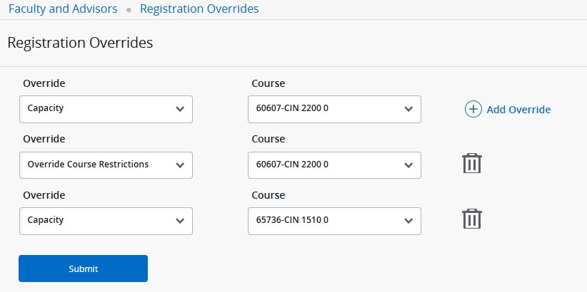

You may also assign registration overrides for more than one of your courses for the same student at one time. Please do not process more than three total overrides for a student in one submission.
After you select the types of overrides you want to process and the course(s) you want to process them for, click Submit.

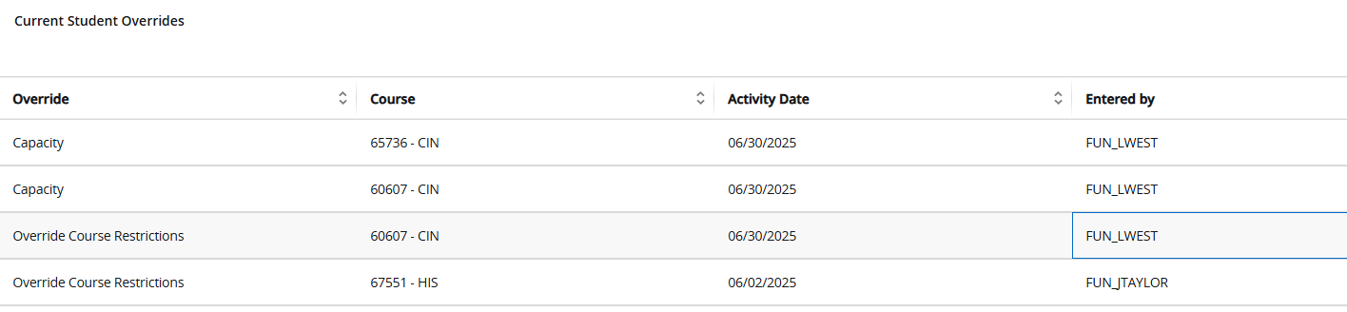

After submitting, you should see the overrides you just submitted listed among the student’s Current
Student Overrides.
If you have any questions about registration overrides that are not answered here, please contact the
Registrar’s Office.

