

Obtaining Student Alternate PINs

Viewing Your Advisees’ PINs
- Go to www.purchase.edu/faculty-and-staff/
- Go to Academics
- Go to MyHeliotrope and login with your Purchase College ID and password
- Go to Faculty Services
- Under Additional Resources, select Advisee PIN List
  - Please note this page may take a few moments to load.
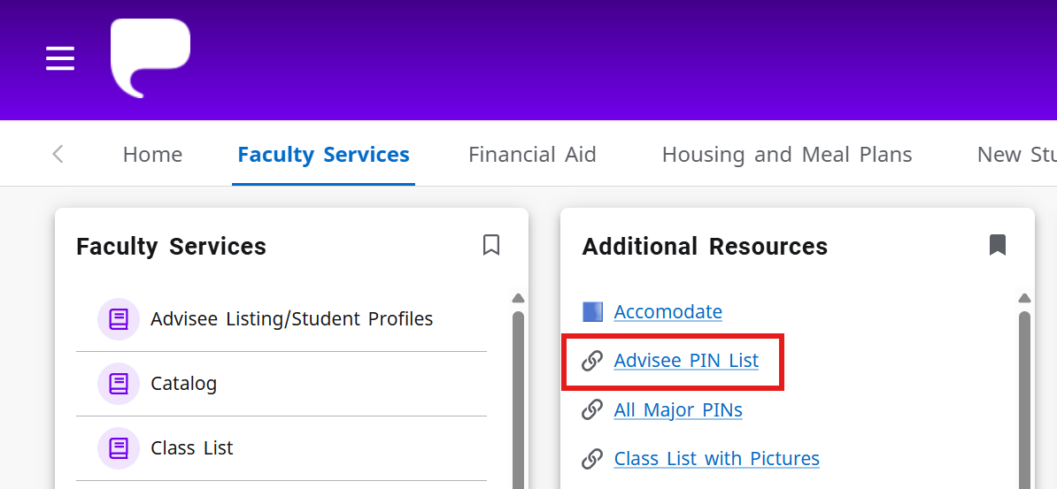

- Select the registration term and click Get Info
- All advisees assigned to you will appear with the PIN listed on the right.
  - The list is sortable by first and last names by clicking on the column header.
  - If the student does not have a PIN for the term, they no longer need one.
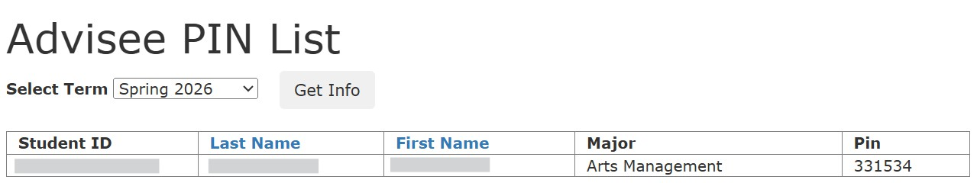



Obtaining Student Alternate PINs

Viewing All Major PINs
- Go to www.purchase.edu/faculty-and-staff/
- Go to Academics
- Go to MyHeliotrope and login with your Purchase College ID and password
- Go to Faculty Services
- Under Additional Resources, select All Major PINs
  - Please note this page may take a few moments to load.
- Select the registration term and click Get Info
- All declared students in your department will appear with the PIN listed on the right.
- The list is sortable by first and last names by clicking on the column header.
- If the student does not have a PIN for the term, they no longer need one.


