Go to www.purchase.edu/faculty-and-staff/
- Go to Academics
- Go to MyHeliotrope and login with your Purchase College ID and password
- Go to Faculty Services.
- Under Additional Resources, select Grade Change

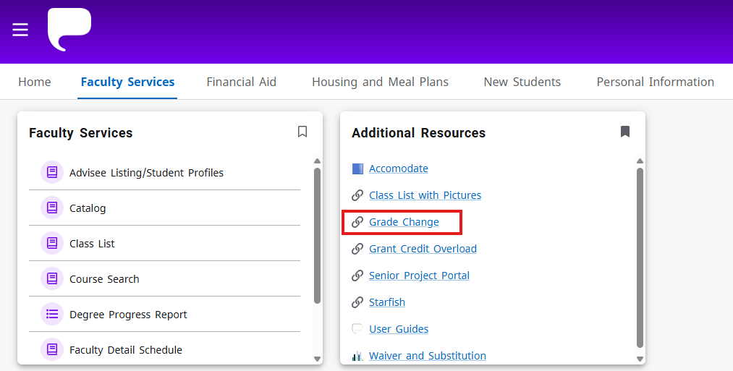
- Select the applicable term from the dropdown menu.
- Select the course by clicking the course title.
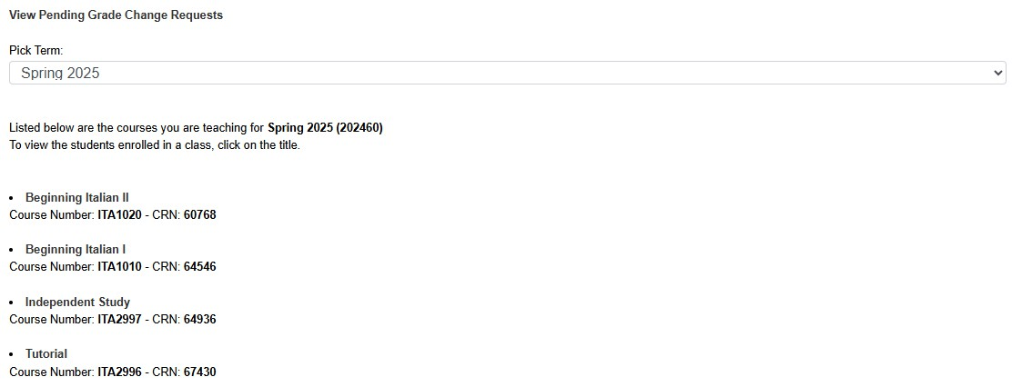
- Find the student whose grade is changing on the class roster. Click the Change button in the
Grade Change column for that student.

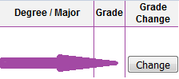

- Choose the student’s corrected grade using the (1) New Grade dropdown menu. Chose the (2) Reason for the change of grade from the dropdown menu below it. If the deadline for changes has passed*, you must include (3) an explanation for the lateness, or add any additional information. (4) Click Submit.
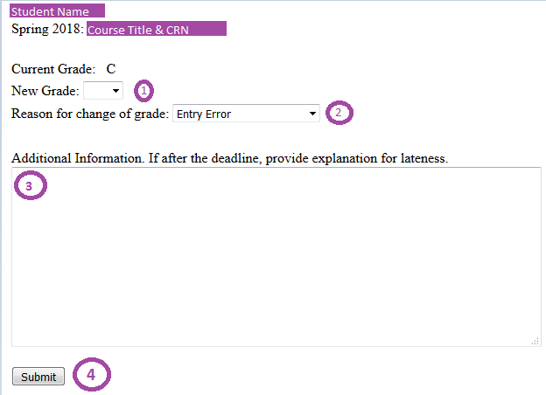
Only the original grade will appear on your Final Grades list, but the changed grade, if approved,
will show on the student’s Final Grades menu and appear in their DPR the next day.

* If the course ended six months ago or more, or if a grade of incomplete has passed the deadline and rolled to an ‘F’ additional information must be submitted for the change to be considered. Grade changes in both of these situations are against college policy, so any extenuating circumstances must be documented.

