Accessing Final Grades

Go to purchase.edu/faculty-and-staff/
- Click Academics
- Click MyHeliotrope and login with your Purchase College ID and password
- Click Faculty Services
- Click Final Grades

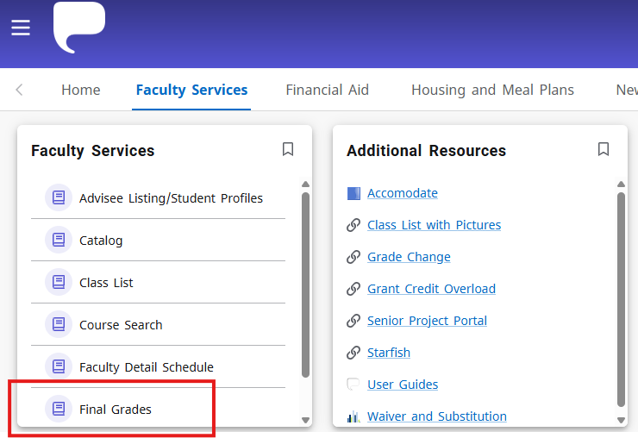

- Click on the Term column header to sort courses by term.
- Select the course you want to assign grades for from your list of courses.

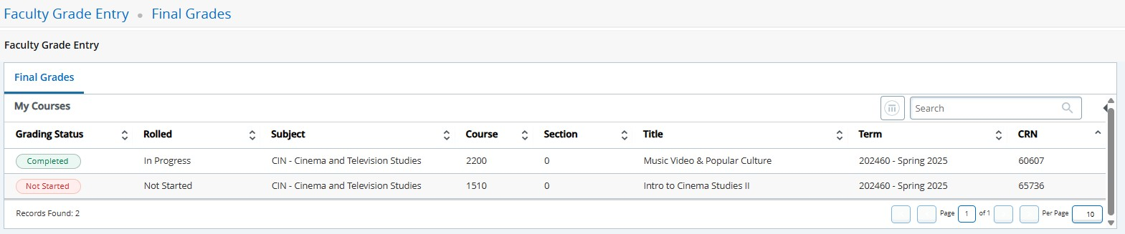

Entering Final Grades
Once you are on the grade submission screen, you may begin submitting final grades for enrolled students by selecting the grade for each student from the dropdown menu. You may enter grades for multiple or all students before clicking Save.
You do not need to enter anything in the fields for Last Attend Date unless assigning a grade of WF (student stopped attending but did not formally withdraw).

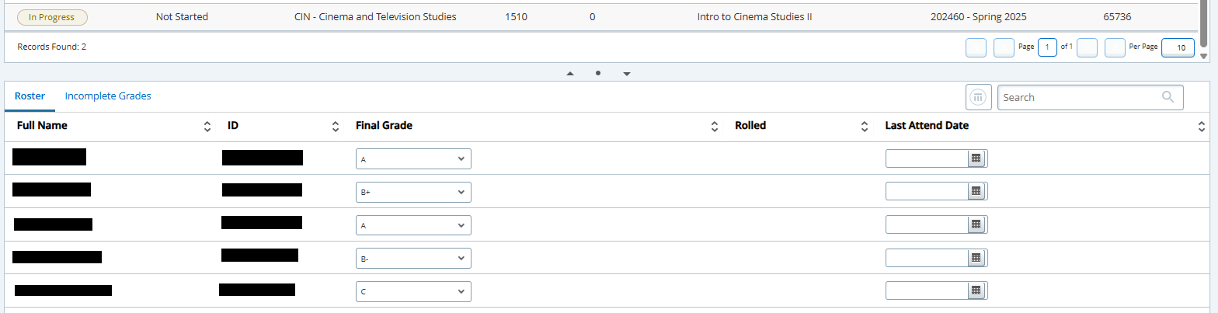

If assigning a grade of “I” for “Incomplete,” you will automatically be brought to the tab where you must enter the incomplete resolution date for this student. The date is set to the last day to resolve incomplete grades for the term by default. You may either change the date or enter one of your choosing prior to the incomplete resolution deadline. You can navigate back to the full list of enrolled students to continue assigning grades by clicking the Roster tab.

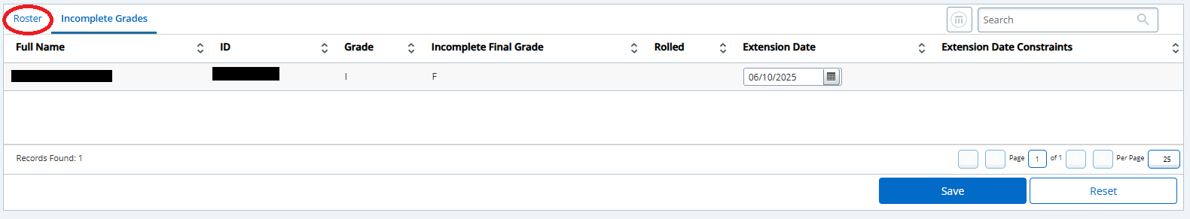

When all grades have been entered, click Save. You will receive the following confirmation pop-up in the top right corner of the window:
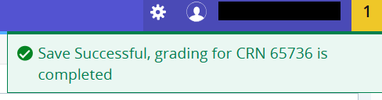
If you have any questions about submitting final grades that are not answered here, please contact the
Registrar’s Office at (914)251-6361 or Registrar@purchase.edu.

