Accessing Your Class List
- Go to www.purchase.edu/faculty-and-staff/
- Go to Academics
- Go to MyHeliotrope and login with your Purchase College ID and password
- Click Faculty Services
- Under Additional Resources, select Class List with Pictures

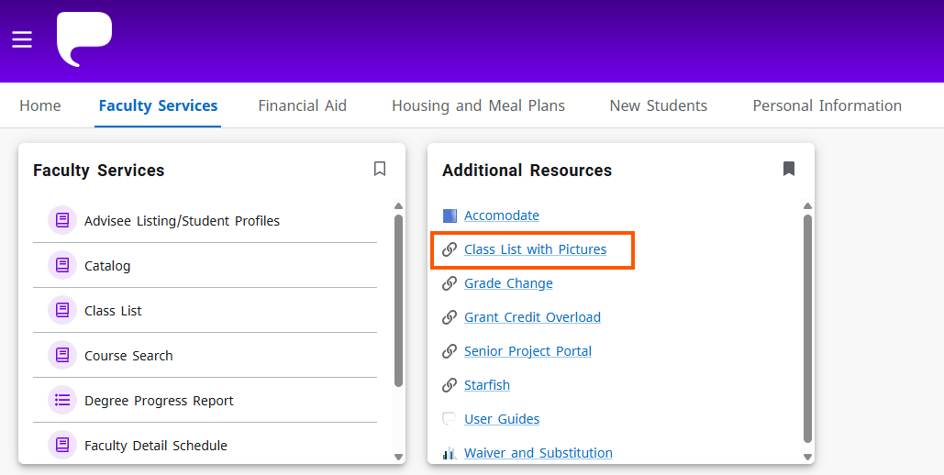
- Select the term of the class list you are looking for from the dropdown menu, then click on the course title of the course you want to see the class list for.
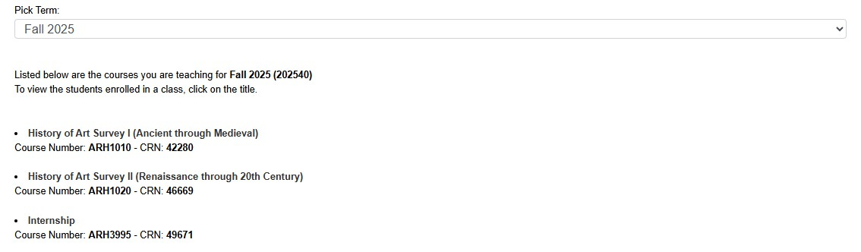

Using Your Class List
The Class List page shows course information, enrollment counts, and your class list.

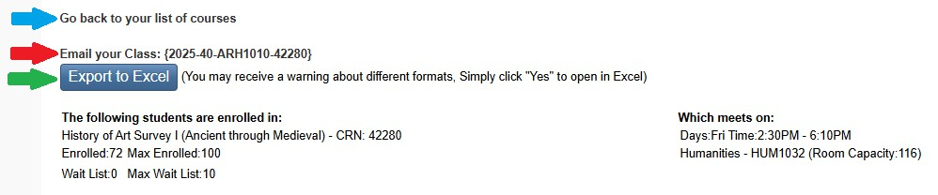

The Course Information section shows you the course title, course reference number (CRN), meeting days/time, and meeting location. A breakdown of the enrollment capacity (Max Enrolled) for the course, the number of students currently registered for the course (Enrolled), and how many students are on the wait list (Wait List) appears above your class list. This also shows the maximum number of students who can join the wait list (Max Wait List) and the number of students currently on the wait list (Wait List).
The class list will include the students’ photos, names, pronouns, phone numbers, and majors. If grades have been posted, they will appear in the column furthest to the right.

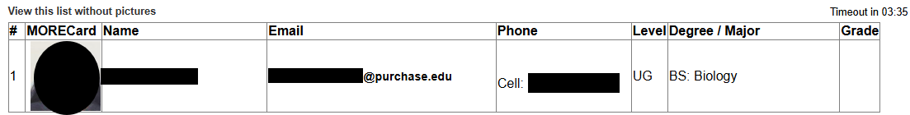

You can export the class roster to an Excel document by clicking the “Export to Excel” button (indicated above with the green arrow). The class pictures will not show on the exported Excel document.
You can also email your entire class through the “Email your Class” link (indicated above with the red arrow). To email an individual student, click their email address provided in the email column.
To return to your list of courses, use the “Go back to your list of courses” link (indicated above with the blue arrow).

