Accessing Your Class List

Go to purchase.edu/faculty-and-staff/
- Go to Academics
- Go to MyHeliotrope and login with your Purchase College ID and password
- Go to Faculty Services
- Go to Class List
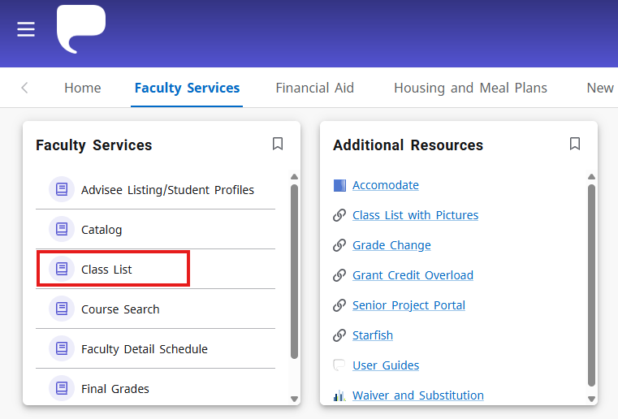

Select the term of the class list you are looking for from the dropdown menu.

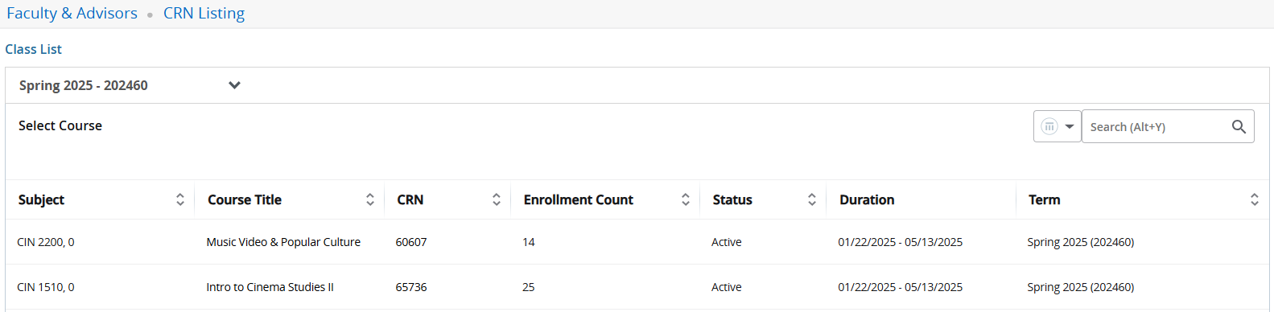

Mouse over the course number listed in the Subject column so that the entire row and click once the full row is highlighted. Do not click the course title or the CRN to navigate to the class list.

Using Your Class List
The Class List page has three sections: Course Information, Enrollment Counts, and Summary Class List (composed of the Class List and the Wait List).
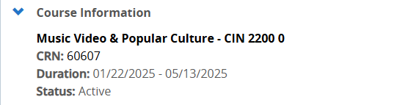

The Course Information section shows you the course title, Course Reference Number (CRN), and the duration and status of the course. Clicking on the course title will bring up expanded information about the course, such as course attributes, course description restrictions, prerequisites, and more. Clicking on the CRN will bring up section-specific information such as meeting times, cross listed courses, bookstore links, and more.
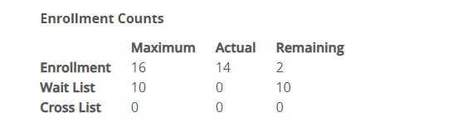

The Enrollment Counts section shows you the enrollment max (Maximum) for the course, the number of students currently registered for the course (Actual), and how many seats are remaining in the course (Remaining).
It also shows the maximum number of students who can be on the Wait List, the number of students currently on the wait list, and how many spots on the Wait List remain. You can view the students on the Wait List by clicking the Wait List tab. If the course is cross listed, this section will also show you the enrollment numbers for the cross-listed section of the course.

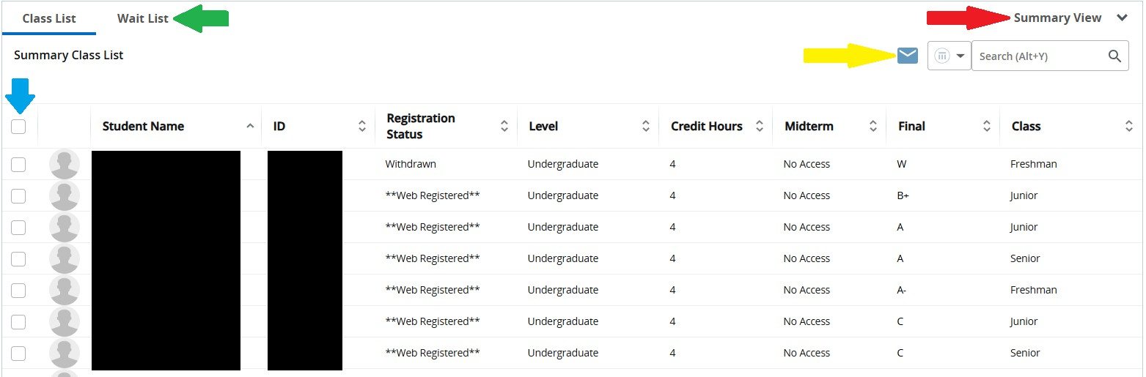Viewing Student Information
The Summary Class List section shows you the students who are registered for the course. You can switch between the Summary View and the Detail View of the class list, which will include more information about each student like their major and matriculation term, by selecting Detail View in the top right corner of the Class List Section (indicated above with the red arrow). You can also view this information one student at a time by clicking the student’s PID. Additionally, can click on a student’s name to view their student profile. The student’s profile will open in a new tab.

Emailing Students
To email students, use the checkbox next to their name or select the entire class list by checking the checkbox in the header row (indicated above with the blue arrow) and clicking the mail icon (indicated above with the yellow arrow). Emails will automatically open in your default mail client, and emails to the entire class will automatically blind copy students’ email addresses.

Wait List
To view students on the wait list, click Wait List (indicated above with the green arrow). When a spot opens in the course, the first student on the Wait List will receive an email stating that they have 24 hours to register for the course. After that 24-hour period, if the student has not registered, they will be removed from the Wait List and the next student in line will be offered the spot in the class. If a student misses their opportunity to register for an open spot and is taken off the Wait List, they will need to re-add themselves to the Wait List through online registration.
If you would like to give a student permission to register for your class from the Wait List, you may issue them a Registration Override. For further information about how to do this, please see the Registration Overrides user guide under Additional Resources.

