Accessing Your Advisee List
- Go to purchase.edu/faculty-and-staff/
- Go to Academics
- Go to MyHeliotrope and login with your Purchase College ID and password
- Go to Faculty Services
- Go to Advisee Listing/Student Profiles
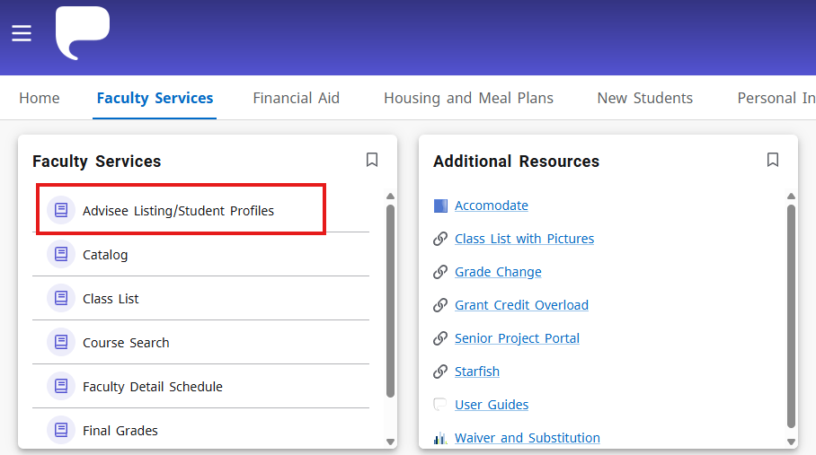
Searching for Advisees
Select the term you are advising for from the Term dropdown menu.
To view the full list of advisees assigned to you, click View My Advisee Listing at the bottom of the search box.
To search for a specific student, use the radio button to search via Student ID, Student Email, or Student Name, then enter your search parameters. If searching by ID or email, enter the full ID or email address, then click outside the field. If searching by name, begin typing the student’s name then select the correct student from the resulting dropdown menu. Then, click View Profile.

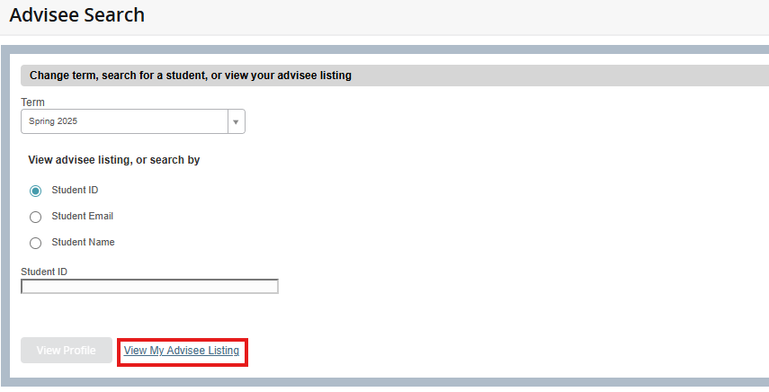

Using Your Advisee List
Your Advisee List will show all of your advisees for a particular term. You can click on the student to view their full student profile. You can also use the Email All link to send an email to your advising list.
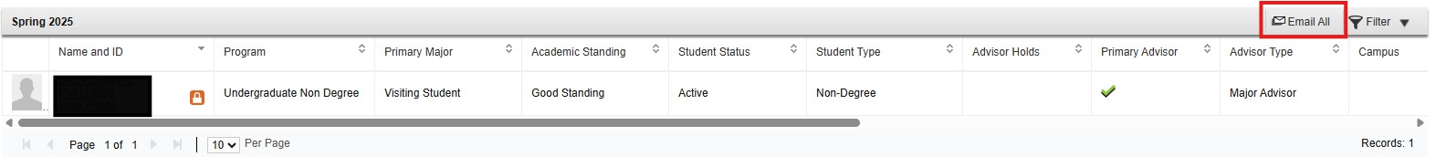
Alternate PINs
The Alternate PIN is a unique 6-digit number assigned to the student, needed to access registration for that term. You should provide your advisees with this number during your advising meeting with them. Students will need to enter this number to register for courses during the first day of their registration period. If there is no Alternate PIN provided in the Advisee List, the student will not need to enter a PIN to access registration.

Viewing Your Advisees’ Alternate PINs in MyHeliotrope
- Go to www.purchase.edu/faculty-and-staff/
- Go to Academics
- Go to MyHeliotrope and login with your Purchase College ID and password
- Go to Faculty Services
- Under Additional Resources, select Advisee PIN List
- Please note this page may take a few moments to load.
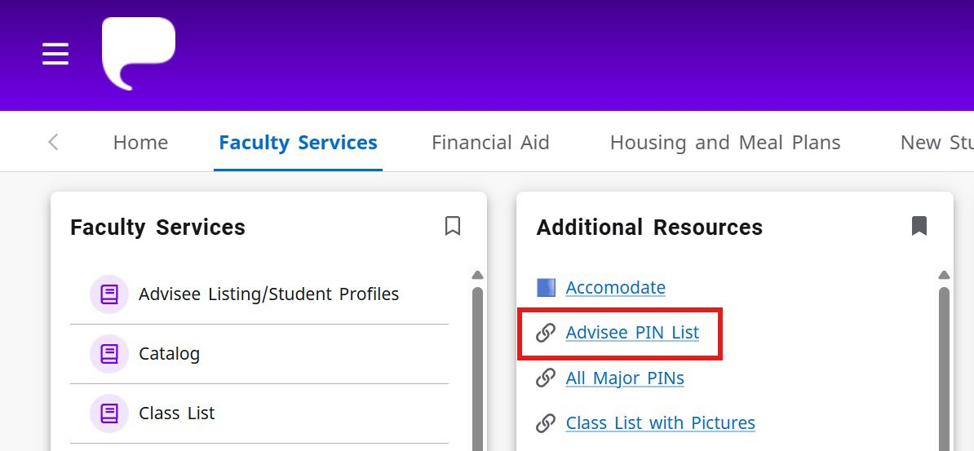
- Select the registration term and click Get Info
- All advisees assigned to you will appear with the PIN listed on the right.
  - The list is sortable by first and last names by clicking on the column header.
  - If the student does not have a PIN for the term, they no longer need one.
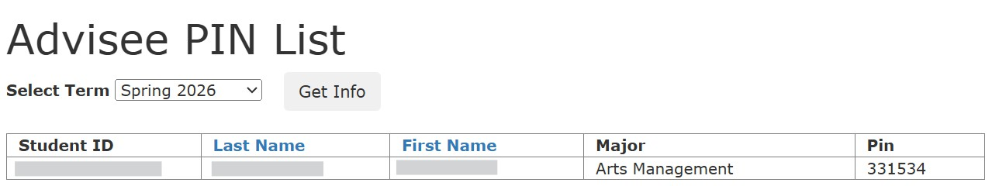
Viewing Your Advisees’ Alternate PINs in Starfish
- To access Starfish, go to https://www.purchase.edu/faculty-and-staff/, select Academics, then select Starfish.
- Log in to Starfish using your Purchase credentials
- Click on the three lines in upper left corner

- Click on “Students”

- You will see all students that you have a relationship with (students in classes or your advisees)
- To filter for your advisees, use the Search navigation bar in the middle of the screen and choose “connection” and “major advisor”
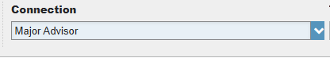
- Click on the student’s name
- The Alternate PIN will display in the Student Information listing under the Degree Progress Report link


