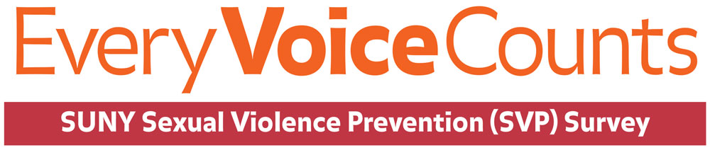
Administration period: February 15 – March 22, 2021.

Purchase College and SUNY are once again conducting the SUNY Sexual Violence Prevention (SVP) Survey. It is important to us that we create a living, learning and working environment that is safe for all community members. Please take 15 minutes to complete the survey when you receive the invitation from SUNY on Monday, February 15th.
This survey required by NYS law and is intended to gather information to ensure that we understand the full scope of sexual and interpersonal violence issues on campus as well as our effectiveness in communicating resources and services.
How do I take the survey?
An email invitation to participate in the survey will be sent from SUNY System Administration (survey@suny.edu) on Monday, February 15th.
If you have questions regarding the survey, please refer to the Frequently Asked Questions posted on the Collaboration Center. Or, please feel free to contact Barbara Moore, Director of Institutional Research at Barbara.moore@purchase.edu.

Why Should You Take the Time to Fill Out the Survey?
Your feedback is very important in helping us understand your Purchase experience.
- Ensures administration understands the full scope of sexual & interpersonal violence issues on campus as well as strengths and areas for improvement in communicating about resources and services.
- Provides an opportunity for collaborative work between students, faculty/staff and administration on this critical issue.
- Ensures administration understands your perspective (results will be viewed by senior administrators but only in aggregate).
- Helps campus community contribute to determining future steps and programming.

Links:
SUNY Campus Climate Assessment Policy webpage
Purchase College Title IX webpage
Purchase College Sexual Violence Prevention & Response webpage
Campus Climate Survey (Sexual Violence Prevention Report 2016)
SUNY Sexual Assault & Violence Response (SAVR) Resources

