EXPLORE REGIO NS 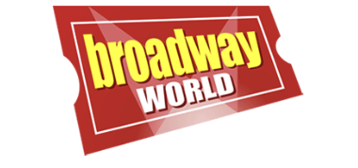

Awardees Revealed For the 2024 Kennedy Center American College Theater Festival Awards
These college students were honored for their outstanding work from the eight regional festivals that were held from January 9 through February 29, 2024.
By: Josh SharpeMay. 06, 2024
POPULAR

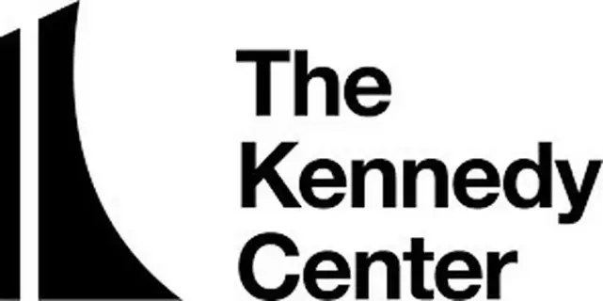
The John F. Kennedy Center for the Performing Arts hosted more than 125 outstanding theater students from colleges and universities across the nation as part of the Kennedy Center American College Theater Festival (KCACTF). These student artists from across the United States have been recognized for their outstanding work from the eight regional festivals that were held January 9 through February 29, 2024.
Individual awardees and representatives from productions honored in the eight regional festivals were celebrated by the Kennedy Center’s National Festival, April 21 and continuing until the National Awards Ceremony on April 26, 2024.
The productions and individual artists under consideration for these national awards have been recognized for special achievement. These awards, along with additional awards determined during the national festival process, were presented at the awards ceremony on April 26, 2024, on the Kennedy Center’s Millennium Stage South.

National KCACTF Awards
The National Committee of the Kennedy Center American College Theater Festival celebrates these institutions, productions, and individuals for their determination, adaptability, innovation and experimentation on home campuses nationwide.
THE Michael Kanin PLAYWRITING AWARDS for Festival Year 2024
The Milan Stitt Award for Outstanding Teacher of Playwriting
Kirsten Greenidge, Boston University
The National Student Playwriting Awards
In This Sepulcher, We Are Fed by Eli Campbell, University of Iowa
Second Place – Soul Magnet Beneath the Limestone by Dane Futrell, Arizona State University
The Inaugural Nathan Louis Jackson Playwriting Awards
The Oracle of Las Vegas - Halle Harper, University of Nevada Las Vegas
Second Place – To Cry into Sand - Kenndall Wallace, Central Michigan University
Distinguished Achievement
The Pleasure of Avarice by Wayne Sam, California State University, Dominguez Hills
The National Undergraduate Playwriting Award
salome. by Trevor Turnbow, Boston University
Second Place – Put the Fun in Funeral by Kathryn Cloonan, Williams College
Distinguished Achievement
Enid and the Near-Death Experience by Ella Bright, Alma College
The John Cauble Awards for Outstanding Short Play
Kimia Zaman and the Whispers of the Mountains
Isabelle Fereshteh Sanatdar Stevens, Boston University
Second Place
American Girl(s) by Abby Uphoff, University of Missouri
The Gary Garrison National Ten-Minute Play Award
Astroturf by Kolin Lawler, Hollins University
Second Place – No Me Sueltes by Diego Rodriguez, University of Michigan
The Jean Kennedy Smith Playwriting Award
Pierogi Play by Chris Lysik, Iowa Playwrights Workshop, University of Iowa
Second Place – Eat Your Young by J.C. Pankratz, Boston University
The Lorraine Hansberry Playwriting Awards
The Waterfall by Phanesia Pharel, University of California San Diego
Second Place, co-recipients
Fear the Crown by Sondai NaNaBuluku NaNa Buluku, Carnegie-Mellon University
and Thicker Than… by Agyeiwaa Asante, University of California San Diego
Distinguished Achievement
Tingum in Da Bush Ean Get No Name by Petron Brown, University of Southern Mississippi
The Kennedy Center Latinx Playwriting Awards
Untitled Dad Play by Jordan Ramirez Puckett, The Juilliard School
Second Place – With a Torch of Seven Virtues by Gretchen Suaréz-Peña, Carnegie-Mellon University
The Rosa Parks Playwriting Awards
The Kenosha Verbatim Project by Nora Carroll, Rayven Craft, Katherine Layendecker, Martin McClendon with the Citizens of Kenosha, Wisconsin Carthage College and
From the Ground Up by Elle Thoni, Carnegie-Mellon University
The Mark Twain Prizes for Comic Playwriting
SYLVIA SYLVIA SYLVIA by Beth Hyland, University of California San Diego
Second Place – From the Ground Up by Elle Thoni, Carnegie-Mellon University
The Paul Stephen Lim Playwriting Awards
Chinese Republicans by Alex Lin, The Juilliard School
Second Place – Tomorrow, by the Sea by Yunhye Park, Alexander Ronneburg, and Erika Ito, New York University
Say Gay Plays
The Greenhouse by James H. Stone, Hollins University And
Diet Pride by Derick Edgren, Iowa Playwrights Workshop at University of Iowa, will be appearing on a bill of plays including work by Fernanda Coppel, Mashuq Mushtaq Deen, Ty Defoe, Marquis D. Gibson, Nina Ki, Harrison David Rivers, Lucy Thurber, and Doug Wright.
Presented in association with Voyage Theater Company, Tectonic Theatre Project, Miami New Drama, Provincetown Theatre, PlayMakers Repertory Theatre, Silk Road Rising, and others, To be presented in New York on May 13 at NYU’s Skirball Center, as a fundraiser for New Alternatives NYC.
The Ken Ludwig Playwriting Scholarship
Sierra Blanco, SUNY Purchase
The National Partners of the American Theatre Julie Jensen Playwriting Awards
Glory to the Father by Pamela Morgan, Augsburg University
Second Place – American Dreaming, Joey Florez, Lesley University
The Planet Earth Arts Playwriting Award
From the Ground Up by Elle Thoni, Carnegie-Mellon University
The Hip Hop Theatre Creator Award
Into the Light of the Dark, Black Night by Donovan Rogers, University of Michigan
The Paula Vogel Playwriting Award
The Reservoir by Jake Brasch, The Juilliard School
Second Place Co-Recipients
Pretend It’s Pretend by Emma Watkins, University of Texas at Austin
and Snake by Davis Alianiello, Hunter College
The KCACTF Musical Theatre Award
Tomorrow, by the Sea by Yunhye Park, Alexander Ronneburg, and Erika Ito, New York University
The David Mark Cohen Playwriting Award
Eat Your Young by JC Pankratz, Boston University
The Darrell Ayers National Playwriting Award No Award this Year

ABOUT THE KENNEDY CENTER AMERICAN COLLEGE THEATER FESTIVAL
Developed in 1969 by Roger L. Stevens, the Kennedy Center’s founding Chairman, the KCACTF encourages and celebrates the finest and most diverse theatrical productions from colleges and universities nationwide. Through the regional and national festivals, the KCACTF celebrates the achievements of theater programs, individual students, and faculty of colleges and universities throughout the United States.

