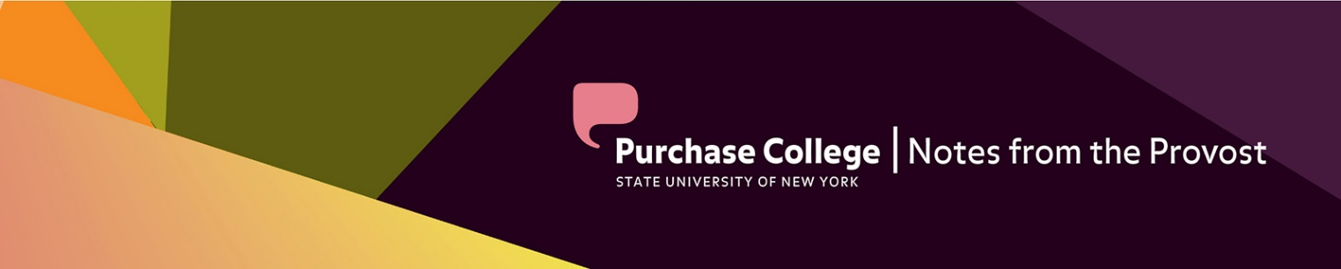

November 23, 2022

Since the roll out of Plan Wide Open I have had several opportunities to speak with individual faculty, departments, and staff members about their visions for increasing enrollment and attracting lifelong learners to Purchase. What has become abundantly clear is that great ideas can come from anywhere; and I encourage everyone to share their ideas with us by filling out the Plan Wide Open form and submitting it by December 2.

During my conversations, it also has become clear that other work needs to be done in addition to revising the curriculum. After all, curriculum and instruction do not exist in isolation. We also need to pay attention to creating and improving our organizational structures, policies/procedures, student services, and assessments that assures our institution’s effectiveness. To that end, I invite the campus community to participate in one of the following workgroups:

Enhancing of Writing Instruction:
- How can the institution help students to become better writers and critical thinkers, and researchers across the disciplines?
- What kind of curricular changes or support services do we need to provide?

Online infrastructure:
- Online education offers an opportunity to increase enrollment by attracting lifelong learners.
- What is the correct mix of online degree offerings for Purchase?
- What infrastructure and support will these programs need?
- What quality standards or user experience standards will we need to be necessary for us to be successful?

Hispanic Serving Institution/Global Education:
- What does it mean to be an HSI? and how are we meeting the needs of this important student group?
- How prepared are we to serve international students? and what opportunities are available for to grow international student enrollments at Purchase?
I hope these work groups will attract faculty and staff with expertise and interest in these areas. Stipends will be available for participants as the work may be significant. Faculty stipends are made possible from one-time funding from SUNY that will support the following activities on our campus:
- Faculty/staff stipends to do the necessary work to develop curricula, create operational standards, guidelines or procedures
- Support marketing and recruiting efforts to assist with enrollment recovery
- Strengthen and build capacity for data collection and assessment
- Support Services for underrepresented students and to improve campus climate
Please contact me at AAF.provost@purchase.edu, if you are interested in learning more about how you might participate in one of these workgroups.

Finally, during this season of gratitude, I would like to thank you for this opportunity to be your Provost during this important time at the institution. I am inspired every day by the faculty and staff’s dedication to our students and their future.

Art+Design:

Visiting Lecture Series
November 30 Kelli Anderson
December 7 Jessica Dickinson

Dance Conservatory

On December 9-11, 2022, the Purchase Dance Company Fall’22 Concert will return to the PepsiCo Theater (PAC). The program features an exciting and diverse range of world premieres and 20th century masterpieces which will showcase the dynamic range of the company’s professional caliber students, and reflect the Conservatory’s stature as a leading center for world-class dance training.
We are thrilled to present Bill T. Jones’s Ravel: Portrait or Landscape (2013), a contemporary masterpiece set to Ravel’s String Quartet in F Major. In addition, we will present Dance Magazine’s “25 To Watch” award winning choreographer Norbert De La Cruz III’s Reintegrate (2021).
Lastly, two exciting commissions will allow our students to be an integral part of the creative process as our guest choreographers bring their visions to the stage. Acclaimed artist Loni Landon, a Princess Grace Choreography Fellowship Winner, will create a cutting edge new contemporary work exploring current societal themes, and faculty member Michelle Thompson Ulerich, will offer a thrilling new contemporary ballet work.

Upcoming Performances:
Senior Project #1 The Dance Theatre Lab
Friday, 12/2 @ 7:30p
Saturday, 12/2 @ 7:30p

PDC Fall Dance Concert @ PepsiCo Theatre
Friday, 12/9 @ 8:00p Artist Talk @ 7:15p
Saturday, 12/10 @ 2:00p & 8:00p
Sunday, 12/11 @ 3:00p

Conservatory of Music

Upcoming Performances

