PURCHASE COLLEGE
JOURNAL OF ECOLOGY

Volume 5
Fall 2021

Editor: Dr. Allyson Jackson
allyson.jackson@purchase.edu

TABLE OF CONTENTS

Aquatic and Terrestrial Invertebrates Denser and More Diverse in a Suburban Location Along Blind Brook Stream
Anjelina King, Jasmine Pacheco, Alex Rubin………………………...……………….....3

WILDLIFE SPECIES ABUNDANCE IS AFFECTED DIFFERENTLY BY VARYING HUMAN DISTURBANCE
Kristen Pareti, Alyssa Rosenberger and Elsa Hata……………………......................….13

URBANIZED INVASIVE HOUSE SPARROWS BENEFIT BY HAVING FLEXIBLE DIETS
Skylar C. Cullen, Abdul A. Hassan, Robert Olsen, Gianna Papantoniou………..……...21

INVASIVE SPECIES POSSESS POTENTIAL BENEFITS BASED ON THEIR FALL PHENOLOGY
Jacob Lupie, Jillian O’Rourke and Sara Atlassi………………………………………....31

Aquatic and Terrestrial Invertebrates Denser and More Diverse in a Suburban Location Along Blind Brook Stream

Anjelina King, Jasmine Pacheco, Alex Rubin

ABSTRACT
How invertebrates relate to each other and their environment is an important aspect of understanding species distribution. Invertebrates are also more sensitive to changes in their environment than most other organisms. Things like climate change and land use can affect invertebrates in their habitat. Due to this, taking samples of invertebrates and recording their species richness and species diversity in both aquatic and terrestrial settings can help us understand the impact of our actions on the environment. Purchase College is unique in that it has both urban and suburban development on campus, which can lead to differences in invertebrate populations and densities. We set out to find the differences in density and diversity between invertebrates in both aquatic and terrestrial environments in two different locations on campus (alongside Lincoln Ave., which had a more suburban setting, and alongside the West 2 parking lot, which was more urban). We collected aquatic invertebrates using dip nets and terrestrial invertebrates using beat sheets. We found Lincoln Ave. stream was both more diverse and denser in both terrestrial and aquatic invertebrates than the West 2 stream was. These results could be used as a groundwork for examining how different aspects like land use affect invertebrates.
Keywords: Aquatic-terrestrial linkage; freshwater ecology; invertebrate density; species richness

INTRODUCTION
Species distribution is a major topic in conservation biology and ecology, especially how invertebrates interact with each other and the environment (Ptatscheck et al. 2019). Differences in density and diversity of invertebrates can vary based on rural vs. urban environments, marine vs. freshwater, and terrestrial vs. aquatic niches. Previous studies suggest that macroinvertebrate richness is strongly related to land use, where agricultural streams exhibit the highest macroinvertebrate diversity (Moore and Palmer 2005). Terrestrial and freshwater niches in particular have a symbiotic relationship. If the population of aquatic species decreases, there is a negative impact on the terrestrial invertebrates who use them as their primary source of food, which many terrestrial invertebrates (like arthropods and spiders) do (Krell et al. 2015). The populations of these invertebrates can also be affected by climate change (Hader and Barnes 2019).
There is also evidence to suggest that abiotic factors can affect diversity and richness. Urbanization can lead to shifts in species composition in spider and arthropod populations (Melligar et al. 2018). Abiotic stress, like environmental change, affects predator richness which in turn positively affects prey richness (Kulkani and Laender 2017). Freshwater niches are unique from other bodies of water and interact often with terrestrial environments. Less than three percent of the freshwater on Earth is an accessible body of water. This means that the ecosystems created around these bodies of water are unique. Temperature and dissolved oxygen (DO) play a role in these ecosystems by affecting species diversity. DO is essential for organisms to survive in aquatic environments. As water gets colder, it can hold more oxygen (Wateratlas.org). Along with that, litter breakdown aids in invertebrate diversity in freshwater (Nadaei- Monoury et al. 2014). These are factors that should be considered when doing research on ecosystems and invertebrates in and around these water systems.
Purchase College, State University of New York (SUNY) has a complex ecosystem on its grounds. There is a large amount of human presence, but also areas of seclusion located in the area. There is also a freshwater stream that runs through campus and interacts with the more heavily populated and more secluded areas of the campus. Invertebrates found in terrestrial- freshwater linkages, like the one found on campus, are affected by things like land use but the density and diversity of these invertebrates is not well known. We wanted to see if there is a difference in diversity and density of invertebrates in different parts of Purchase campus stream, Blind Brook. Throughout the month of October 2021, we collected data from two sections of the Blind Brook stream to answer the question of whether different areas of the stream have different species densities and distributions of invertebrates. We predicted that the terrestrial and aquatic invertebrates located in the Blind Brook on Purchase College campus will differ based on location.
METHODS
Field Sites. We collected data in two different locations in the Blind Brooke to perform sampling of density and diversity of invertebrates. The first site was labeled as ‘Lincoln Ave. Stream’, which was the suburb location, and the other site was labeled ‘West 2 Stream’ which was the urban location (Fig. 1). Data was collected between October 14th- October 29th.
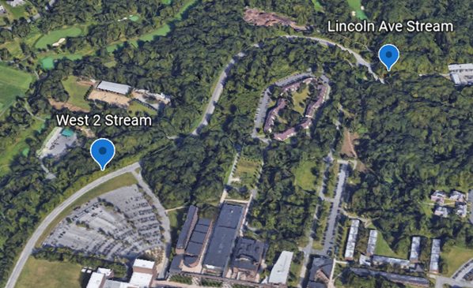
Figure 1. Google Map view of the sampling sites.
Experimental Design. We chose parts of the sampling sites with a decent amount of vegetation and water. First, we measured out 30m with a meter tape. We put marking flags every 10m, starting with 0m and ending with 30m, for collection. For terrestrial sampling, we used a beat sheet on every plant at each flag mark, extending 8m up from the mark. The bugs were collected using an aspirator and stored using jars with ethanol. These jars were labeled with the site name, the meter mark, the date, and where they were collected (on land). For aquatic sampling, we held a dip net in the stream water for 3-5 minutes and shifted rocks to stir any aquatic invertebrate activity. Any bugs caught were picked up out of the net and put into ethanol jars. The temperature and DO at each meter mark were also measured and recorded. These jars were labeled with the site name, the meter mark, the date, temperature, DO, and where they were collected (in the water).
Lab Work. The invertebrates we found in our sampling sites were collected in ethanol jars and brought back to the lab. The number of bugs at each meter mark at the sample sites, DO (and average for each sample site), temperature (and average for each sample site), and date were recorded. We examined each specimen under a dissecting microscope and determined the order if possible. Pictures were taken of all our samples.
Analysis. We analyzed our data using Microsoft Excel to generate tables and graphs. We calculated the averages of DO and temperature for each sample. We generated bar graphs to compare the differences in invertebrate density from the locations. We also calculated the correlation using Pearson’s r and generated correlation charts for our DO and temperature data. Species were identified and categorized based on order; number of invertebrates in each order as well as the location they were found (table 1).
RESULTS
The results of the data analysis suggest no correlation between temperature and number of invertebrates, as well as no correlation between DO and number of invertebrates in both sampling locations. The correlation graphs show no correlation between temperature and number of invertebrates (Fig. 2), and no correlation between DO and number of invertebrates (Fig. 3). Calculations of Pearson’s R state that correlation between temperature and number of invertebrates R = 0.15 and correlation between DO and number of invertebrates R = 0.17.
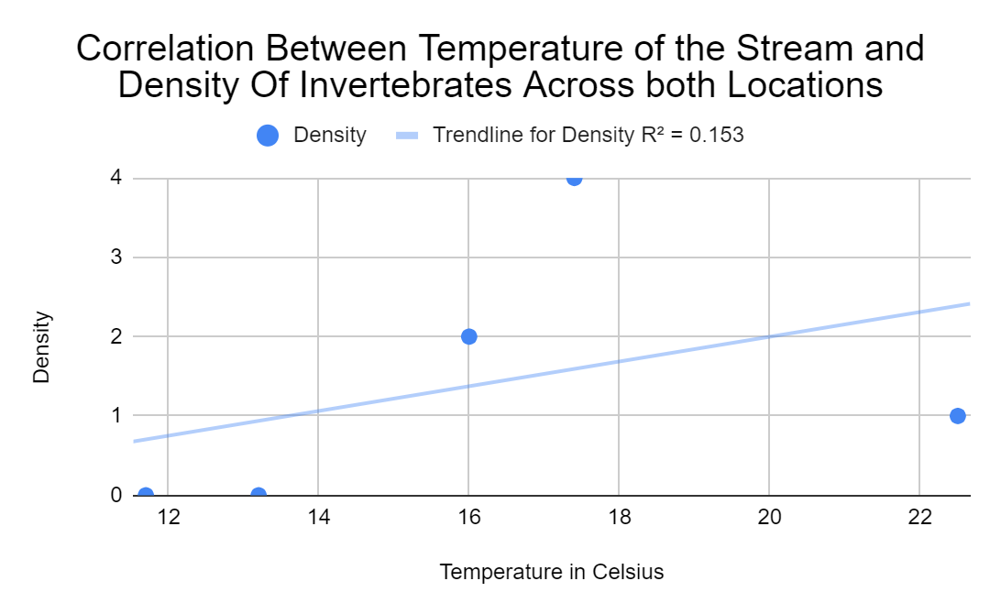
Figure 2. This figure displays the relationship between temperature of the stream and the density of invertebrates at each location.
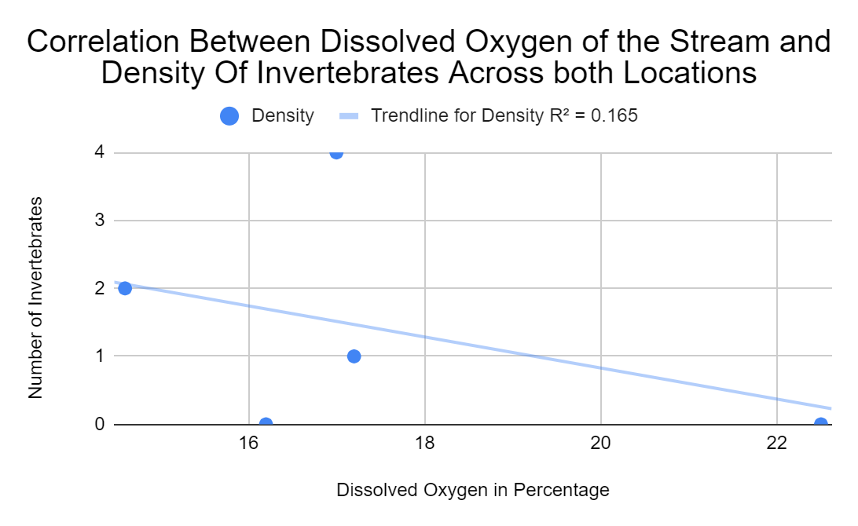
Figure 3. This figure displays the relationship between dissolved oxygen (DO), as a percent of air saturation of the stream and the density of invertebrates at each location.
The data also suggests a difference in density and diversity of invertebrates between the Lincoln Ave. location and the West 2 location. The total number of combined aquatic and terrestrial invertebrates collected was greater at the Lincoln Ave. location compared to the West 2 location. There was a total of 33 invertebrates collected at the Lincoln Ave. location compared to 16 total invertebrates collected at the West 2 location (Fig. 4). For aquatic invertebrates, there was a difference in the number of samples collected at each location. A total of seven invertebrates were collected at the Lincoln Ave. location and there were no aquatic invertebrates collected at the West 2 location (Fig. 5). There were more terrestrial samples collected at the Lincoln Ave. location compared to the West 2 location; a total of 26 terrestrial invertebrates collected at Lincoln Ave. and 16 invertebrates collected at the West 2 location (Fig. 5). Further analysis of this data shows that there is greater richness in invertebrates in the Lincoln Ave. location compared to the West 2 location (Fig. 6). Richness for the Lincoln Ave. location was 8 while the richness for the West 2 location was 5. The orders of the invertebrates collected are listed in Table 1.
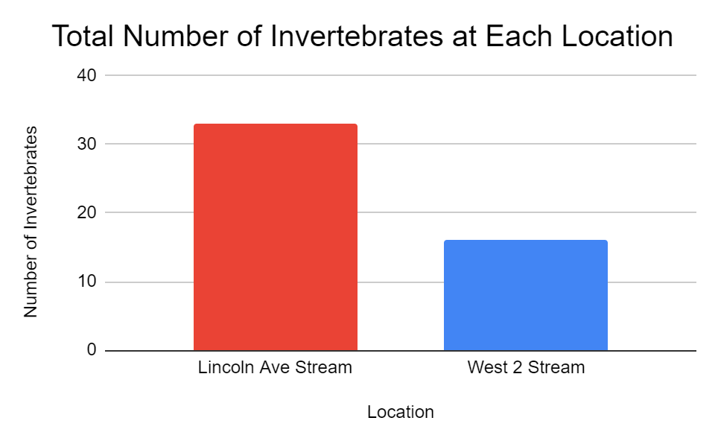
Figure 4. This graph shows the total number of invertebrates collected at each location, both aquatic and terrestrial. We collected more invertebrates at the Lincoln Ave. location than the West 2 Steam location.

Table 1. This table shows the order of invertebrates and their frequency in each location.
Location | Aquatic or Terrestrial | Order of Invertebrate | Number of Invertebrates
Lincoln Ave. | Aquatic | Hemiptera | 7
Lincoln Ave. | Terrestrial | Araneae | 9
Lincoln Ave. | Terrestrial | Coleoptera | 2
Lincoln Ave. | Terrestrial | Diptera | 2
Lincoln Ave. | Terrestrial | Hemiptera | 2
Lincoln Ave. | Terrestrial | Hymenoptera | 5
Lincoln Ave. | Terrestrial | Psocodea | 1
Lincoln Ave. | Terrestrial | Trichoptera | 3
Lincoln Ave. | Terrestrial | LOST | 2
West 2 stream | Terrestrial | Araneae | 9
West 2 stream | Terrestrial | Coleoptera | 1
West 2 stream | Terrestrial | Diptera | 1
West 2 stream | Terrestrial | Hymenoptera | 3
West 2 stream | Terrestrial | Trichoptera | 2
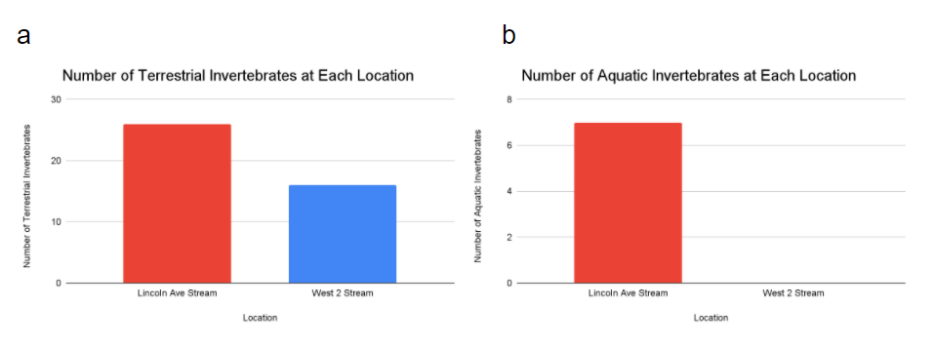
Figure 5. a This graph shows the total number of terrestrial invertebrates collected at each location. We collected more invertebrates at Lincoln Ave. location compared to the West 2 Stream location. b This graph shows the total number of aquatic invertebrates collected at each location. We collected more invertebrates at Lincoln Ave. location; we did not collect any aquatic invertebrates at the West 2 Stream location.
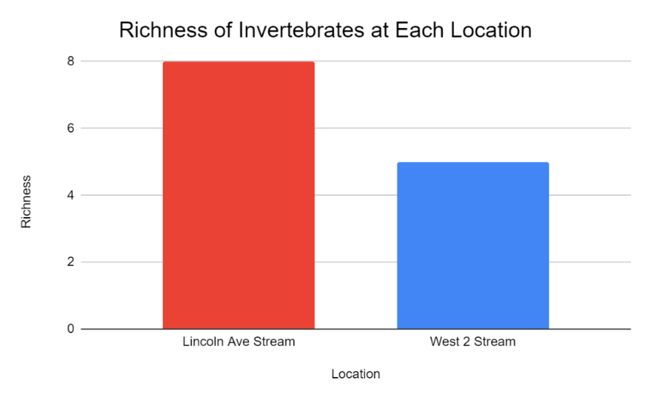
Figure 6. This figure shows the calculated richness of each location. The richness of each location was calculated using the order of the invertebrates which can be found in Table 1.

The data shows a difference in temperature and a small difference in DO when comparing the two sampling sites. The average temperature was higher at the Lincoln Ave. location compared to the West 2 location (Fig. 7). The Lincoln Ave. location had an overall temperature of 18.6 °C while the West 2 location had an overall temperature of 12.4 °C. There was a slight difference in DO in each location; the average DO at the Lincoln Ave. location was 17.5% while the average DO at the West 2 location was 15.9% (Fig.7).
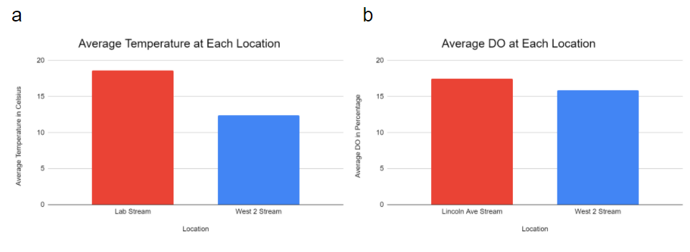
Figure 7. a This graph compares the average temperature, in Celsius, sampled at each location. b This graph compares the average dissolved oxygen (DO), as a percent of air saturation sampled at each location.

DISCUSSION
Purchase College has a diverse ecosystem and varying degrees of land use around campus. Previous research has suggested that there is a difference in invertebrate density and diversity based on their environment (terrestrial or aquatic). In this study we set out to examine the differences between terrestrial and aquatic invertebrate diversity and density. We examined these differences along two main facets: urban land use and suburban land use. The analysis of the data we collected suggests that there was a difference in invertebrate density and richness in both the Lincoln Ave. location compared to the West 2 location. The Lincoln Ave. location had higher invertebrate density as well as higher richness. The Lincoln Ave. location is in a suburban area of the Purchase college campus while the West 2 location is in an urban area of campus. Therefore, the data suggests that the urban area of Purchase college is less dense and less diverse compared to a suburban area.
Aquatic and terrestrial communities are considered to be separate by most ecologists, but they are both affected by wet and dry phases (Corti and Datry, 2015). From our research, we can conclude that there is a difference in diversity and density of invertebrates in different parts of the Blind Brook. There is also a noticeable difference in the density and diversity of aquatic vs. terrestrial invertebrates. In terms of species richness, Lincoln Ave. had eight different species that we found compared to the five in West 2. When we look specifically at the terrestrial and aquatic density of each location, there is also a stark contrast. The total number of invertebrates found at Lincoln Ave. was 33 and the amount found at West 2 was 16. All West 2 invertebrates were terrestrial finds; we did not collect any aquatic creatures. This could be due to the cold temperatures driving away the species that reside in that part of the stream. We also found a difference in temperature, and a slight difference in DO levels. There seems to be no correlation between temperature, DO, and number of invertebrates.
There were some limitations to our study. Because we only collected samples for a month, our sample size and density may not be accurate to the real diversity along the stream. This could be fixed by having a longer collection period and collecting along a larger area of the Blind Brook. Another issue is the time of collection. Habitat complexity has been shown to decrease in colder temperatures (Scrine et al. 2017). We collected our samples in October, while the weather was relatively chilly. This could have skewed our results because cold weather drives away invertebrates. This could be avoided by sampling in optimal weather and taking many samples to provide a more accurate depiction of the area. There was also an error introduced when two of the samples from the West 2 location were lost.
Another aspect of our study was determining if there was a correlation between temperature and the density of invertebrates across both locations. Although there were a variety of temperatures, there does not seem to be a correlation. The DO at each location was also similar between the areas, so the impact there would most likely be small at best. However, invertebrates are sensitive to temperature. The temperature of an environment affects an invertebrate’s growth rate and changes in temperature have a large effect on distribution (Butterfield and Coulson 1997). The reason our results show no correlation may be due to having a sample size that is too small. DO is also a good indicator of the health and biodiversity of an aquatic ecosystem (Kelley 2019).
Land use and human interaction are important to consider when looking at density and species in a given environment. These factors can impact species abundance and richness. Many human activities affect aquatic ecosystems, in particular the usage of hydropower is very damaging to freshwater systems (Borgwardt et al. 2019). Because aquatic and terrestrial invertebrate life is connected, a negative impact on one can also affect the other. Previous research suggests that land use can have an effect on the aquatic insects that inhabit a community and that can affect the amount of terrestrial predators present (Stenroth et al., 2014). When aquatic life decreases, the terrestrial predators in the area experience a nutrition deficit, which can lead to the dying out of those species as well. A paper by Didham et al. (2007) focuses on how to deal with interactive effects between specific global change and native species decline. This paper creates a framework that creates a better quantitative understanding of how land change affects biotic communities, which is an important part of preserving biotic communities against environmental change.
Climate change also has an impact on terrestrial and aquatic ecosystems. Climate change is a problem that has only increased in intensity as time goes on. Habitats and natural enemy exchange will be impacted by land-cover/use and climate change (Dreyer and Gratton 2014). These impacts can change the density of invertebrates that exist in aquatic and terrestrial areas because of the multifaceted nature of climate change. Overall, climate change affects ecosystem biodiversity, structure, function, and an ecosystems' ability to offer important services (Hader and Barnes 2019). Human induced climate change has put stress on aquatic ecosystems. Aquatic ecosystems have absorbed a majority of the surplus heat being generated by climate change. Future work should include looking at ways to preserve and enhance aquatic and terrestrial environments for the sake of preserving species diversity and combatting the effects of climate change.
CONCLUSION
This research is useful in the field of ecology in reference to human induced climate change and preserving species diversity. Land use and human interaction are factors that contribute to climate change. These factors have an impact on species density and richness. This research is important because many human activities and types affect aquatic and terrestrial ecosystems. This research looks at how exactly invertebrates are affected by land use and it allows us to look into further research regarding preservation. Understanding inverts can also help researchers understand the effect of climate change in semi-real time and help predict how diversity and density will be affected in the future. The suburban land on Purchase College was much more diverse in comparison to the urban land. This research could be used as the groundwork for future studies examining how land use impacts the organisms in that environment.

ACKNOWLEDGEMENTS
We would like to thank Dr. Jackson and Amanda Salmoiraghi for answering all our questions and editing our paper.

AUTHOR CONTRIBUTIONS
Conceptualization (all), Data collection (all), Data curation (all), Formal analysis (All), Methodology (all), Project Administration (AK), Visualization (JP), Writing- Abstract (AR), Writing- Introduction (AK), Writing- Methods (AK, AR), Writing- Results (JP), Writing- Discussion (AK, JP), Writing- Conclusion (AK), Writing- Review and Editing (AK, JP)

LITERATURE CITED
Borgwardt F., L. Robinson, D. Trauner, H. Teixeira, A. J. A Nogueira, A. I. Lillebo, G. Piet, M. Kuemmerlen, T O’Higgins, H. McDonald, J. A. Torres, A. L. Barbosa, A. I. Campos, T. Hein, and F. Culhane. 2019. Exploring variability in environmental impact risk from human activities across aquatic ecosystems. Science of The Total Environment. 652:1396-1408.
Butterfield J.E.L. and J.C. Coulson. Terrestrial invertebrates and climate change: Physiological and life-cycle adaptations. 1997. Past and Future Rapid Environmental Changes. 401-412.
Corti, R., and T. Datry. 2015. Terrestrial and Aquatic Invertebrates in the Riverbed of an Intermittent River: Parallels and Contrasts in Community Organisation. Freshwater Biology. 61:1308–1320.
Didham, R., J.M. Tylianakis, N.J Gemmell, T.A. Rand, and R.M. Ewers. 2007. Interactive Effects of Habitat Modification and Species Invasion on Native Species Decline. Trends in Ecology and Evolution. 22:489–496.
Dreyer J. and C. Gratton. 2014. Habitat linkages in conservation biological control: Lessons from the land–water interface. Biological Control. 75:68-76.
Florida UWI School of Geosciences, University of South. Learn more: DO - sarasota county water atlas - sarasota. Wateratlas.org.
Häder D.P. and P.W. Barnes. 2019. Comparing the impacts of climate change on the responses and linkages between terrestrial and aquatic ecosystems. Science of The Total Environment. 682:239-246.
Kelley, P. 2019. Relationship of DO Availability and Chloride Contribution to Freshwater Macroinvertebrate Diversity Found in Various Ponds in Northern Illinois. ESSAI. 17.
Krell B., N. Röder, M. Link, R. Gergs, M.H. Entling, and R.B. Schäfer. 2015. Aquatic prey subsidies to riparian spiders in a stream with different land use types. Limnologica. 51:1-7.
Kulkarni D. and F. De Laender. 2017. The combined effects of biotic and abiotic stress on species richness and connectance. PLOS ONE. 12(3).
Melliger R.L., B. Braschler, H.P. Rusterholz, and B. Baur. 2018. Diverse effects of degree of urbanisation and forest size on species richness and functional diversity of plants, and ground surface-active ants and spiders. PLOS ONE. 13(6).
Moore, A. A., and M.A. Palmer. 2005. Invertebrate Biodiversity in Agricultural and Urban Headwater Streams: Implications for Conservation and Management. Ecological Applications.15:1169–1177.
Nadai- Monoury, E. D., F. Gilbert, and A. Lecerf. 2014. Forest Canopy Cover Determines Invertebrate diversity and Ecosystem Process Rates In Depositional Zones of Headwater Streams. Freshwater Biology. 59: 1532-1545.
Ptatscheck, C., B. Gansfort, N. Majdi, and W. Traunspurger. 2020.The influence of environmental and spatial factors on benthic invertebrate metacommunities differing in size and dispersal mode. Aquatic Ecology. 54:447-461.
Scrine, J., M. Jochum, J. S. Olafsson, and E.J. O’Gorman. 2017. Interactive Effects of Temperature and Habitat Complexity on Freshwater Communities. Ecology Evolution. 9333-9346.
Stenroth, K., L.E. Polvi, E. Fältström, and M. Jonsson. 2014. Land-Use Effects on Terrestrial Consumers through Changed Size Structure of Aquatic Insects. Freshwater Biology. 60:1136–1149
WILDLIFE SPECIES ABUNDANCE IS AFFECTED DIFFERENTLY BY VARYING HUMAN DISTURBANCE

Kristen Pareti, Alyssa Rosenberger and Elsa Hata

ABSTRACT
Human disturbance is a primary cause of habitat and resource loss for wildlife species. Urbanization affects both species abundance and richness differently, with some species being less negatively impacted. To study which species are negatively impacted by human influence throughout the Purchase College State University of New York (SUNY) campus, trail cameras were set up in different locations along an urban-rural gradient of environments. Within these ecosystems, one camera was placed in a human-influenced area and another in a nearby remote section. We found higher species richness in the remote sections in all three sites, as well as a higher Shannon diversity index. The species with the highest occurrences overall were white-tailed deer, raccoon, and grey squirrels. The species with the lowest abundance were coyotes, bobcats, and striped skunks. Our findings conclude human disturbance due to urbanization results in a high or low abundance in the ecosystem depending on the species.

Key Words: Urbanization; Human disturbance; Species richness; Habitat fragmentation; Urban-rural gradient

INTRODUCTION
Human beings cause ecosystem degradation and biodiversity loss on a global scale (Cardinale et al. 2012). As human populations expand, we have subsequently spread out further into wild ecosystems and diminished them to drive urbanization. Ecosystems all around the planet are converted into viable land for us to develop commercially, residentially, and agriculturally for our population’s ever-growing needs. Human development gears towards the urbanized ecosystem made up of shopping malls, condensed residential areas, paved roads, and limited wild spaces. As society continues to advance in this direction, we have become further removed and disconnected from nature (Miller 2005). This has resulted in the general population finding it hard to fully grasp the extent of biodiversity in an ecosystem (Pett et al. 2016). This disconnect increases with growing distractions of cultural materialism and technological advancements. While demand for industrialization increases and development continues, untouched land and natural resources decrease at an alarming rate. Wildlife is forced to adapt to and coexist with the human-influenced spaces left behind or face possible extinction (Carter et al. 2012).
In addition to habitat loss, human influence on ecosystems results in other obstacles for wildlife. Urban sprawl has effectively redesigned many ecosystems surrounding cities (McKinney 2002). Commercial and residential buildings along with highways and other infrastructure shape the availability of untouched wild spaces. Habitats become fragmented, decreasing range availability for many species. This affects migrating species and wildlife that need a wider distribution range for territorial reasons, hunting, or looking for mates. A high frequency of roads leads to a greater chance of species falling prey to vehicle accidents (Prange et al. 2003). Additionally, an increase in development naturally results in an increase in pollution. This exhibits that human influence and urbanization can positively affect wildlife species in some ways. Garbage and waste provide supplemental food resources for the more opportunistic species, such as raccoons (Prange et al. 2003). Light and noise pollution from urbanization also have varying effects depending on the species (Newport et al. 2014). These factors all contribute to the abundance of wildlife species.
To get a better idea of which wildlife species are negatively affected by human-disturbed environments, we chose to use the Purchase College, State University of New York (SUNY) campus. There is a perfect blend of urbanized environments and wild ecosystems located throughout campus that are exposed to varying degrees of human influence. The wildlife on campus comes from a diverse ecosystem that has been altered over the years through the gain and loss of habitat due to development. It is crucial to acquire a better understanding of how these species are affected by our presence and by our actions, in addition to how certain species might suffer the consequences more than others (Suvajot et al. 1998). Human impact and disturbance are known to negatively affect the richness and abundance of various wildlife species, including birds and small mammals (Samia et al. 2015). Our main objective is to determine species richness and abundance throughout a gradient of human-influenced locations to see which species are most negatively affected by human presence.

METHODS
Study area. Purchase College, SUNY, and the surrounding area have been subjected to urbanization over the past century. Westchester County Airport was built in the 1940s for WWII (Zingesser 2015) which is still in operation today, now for commercial and public use. Purchase College, SUNY campus itself used to be Strathglass farm, a five hundred acre cattle farm. The farm was in use for fifty years before the land was sold in 1966, to become a SUNY school. The Purchase campus today consists of numerous dorm buildings, three sports fields, and many academic buildings while being nestled in-between patches of forest ecosystems of varying successional stages (Fig. 1). The Purchase College campus proves to be a mix of urbanized, suburban, and rural environments, therefore being an ideal setting for locations along a gradient of humanized influence to more wild ecosystems.
The three study sites chosen for our experiment were to represent a gradient of human exposure. This is similar to many studies done using urban-rural gradient effects on wildlife to determine exposure intensities effects (Prange et al. 2003; Randa and Yunger 2006; Blanchong et al. 2013). We determined our study sites based on the presence of human influence on an already existing wild ecosystem. The Sculpture Garden (SG) is located next to a popular academic building at the forest’s edge. Students use the SG as an ongoing art installation and frequent it often to express themselves creatively or as a place to socialize. SG is also located next to a parking lot, which warrants foot traffic from commuters, visitors, faculty, and staff. Therefore, the high human activity results in a comparable urban environment. The remote trail camera for this location was set up deeper into the woods. This location represented the most consistently frequented area by humans that is still part of a wild ecosystem.
The study area Alumni Woods (AW) was chosen next. This location has a slightly lower human presence and slightly more wildlife compared to SG. The entire forest is marked with trails for joggers, walkers, and students to peruse through the woods. It also connects to a nearby campus residence. This presence emulates an environment similar to suburban conditions. The trail camera was placed at a firepit location, not too far from a trail entrance. This location is popular on the weekends for students to gather for bonfires. The remote camera was placed deeper into the woods, further away from the main trail.
The last location chosen to represent rural conditions is the Athletic Fields (AF) study site. It is furthest from the main campus academic buildings and dorms. The AF cameras are located in a strip of woods between road, athletic sports fields, and a parking lot. The AF camera in the human-influenced location is on a walking path trail between the woods and the field. The remote camera is located inside a strip of forest. This area is frequented the least of the three sites by humans, who would only purposefully be there for sports games/practice or walking.

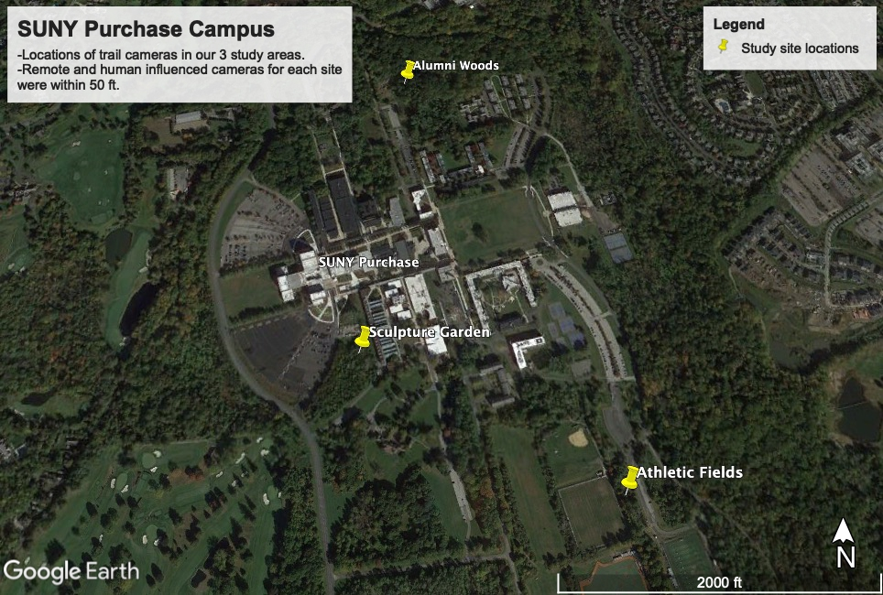
Figure 1. Map of SUNY Purchase College campus, in Purchase, NY. Our three study areas are Sculpture Garden (SG), Alumni Woods (AW), and Athletic Fields (AF).
Field Work. At each study site, we used two Browning trail cameras. In the human-disturbed locations, trail cameras were locked in safety cases. Every camera in our experiment had the same settings, with a 1s capture delay, low (4M) picture size, and had long-range night exposure. Each camera was set on trail mode and had multi-shoot capabilities off. The cameras were on and capturing photos continuously, from 10/14/2021 to 10/29/2021. Memory cards were collected once a week during this time period. This was to prevent filling up the memory card storage space and to more easily manage data analysis workflow.
Data Analysis. Once the memory cards were collected, the images were uploaded to a Google Drive folder to sort through and examine. Each wildlife and human occurrence were recorded in a Google spreadsheet. This data was organized per location. Occurrences within a similar time frame were deemed separate if there was at least a two-minute gap between appearances, in regards to the animal’s directionality. Humans were identified by their clothing when possible to prevent miscounting individuals. Large crowds were otherwise grouped together in estimates, particularly in AW. Cars and dogs accompanied by humans were observed by the trail cameras and counted as part of human disturbance to their respective locations. Due to the camera’s capture delay or slow shutter speed, especially in low light, some animals were unable to be identified. They were grouped together in an “unknown” category.
Species richness was determined by the number of different species observed at each location’s remote and human-influenced area. Shannon diversity was calculated using the equation H=∑- (P_{i}*ln P_{i}) for each site’s disturbed and remote locations. The Shannon diversity index formula is used to estimate species diversity, taking into account species richness and abundance. Unknown species counts were left out of species richness and Shannon diversity calculations to ensure an accurate representation of species. Our focus with this data was to assess species abundance and diversity at each site as well as to see how wildlife abundance was being affected by the human-influenced areas.

RESULTS
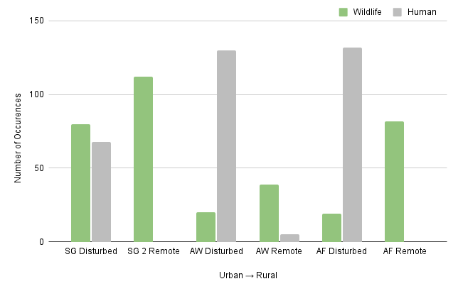
Throughout the campus study sites, we found varying results of wildlife and human occurrences (Fig. 2). At each site, the remote area had higher wildlife occurrences compared to its disturbed counterpart. Throughout the urban to rural gradient we see this trend persist. No human occurrences were recorded in the remote locations of the SG or AF. In the disturbed areas of the AW and AF locations, there were greater human occurrences and fewer wildlife occurrences. However, at the SG disturbed site, there were still more wildlife occurrences than humans (Fig. 2).
Figure 2. The total number of wildlife and human occurrences per study site across our gradient of human disturbance in urban to rural environments. Includes both disturbed and remote locations.
Species richness was higher in the remote sections of each study location (Fig. 3). Species richness in the disturbed sites decreases along the urban to rural gradient and follows no particular trend in the remote sections.
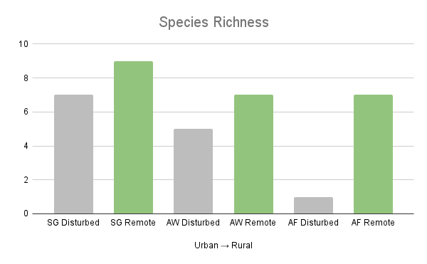
The SG had 9 different species observed in the remote section and 7 species in the disturbed area (Fig. 4a). The remote area had more occurrences overall, but certain species (such as the grey squirrel and raccoon) frequented the human-disturbed site more often. AW also had more species in the remote sections, totaling 7 species in remote and 5 in the human-influenced area (Fig. 4b). There was only one species recorded (the white-tailed deer) in the AF human-influenced site, and 7 species in the remote (Fig. 4c). Table 1 displays the total occurrences of each wildlife species recorded in the SG, AW and, AF. Thus deducing which species is absent or the extent of their presence throughout the six locations. Unknown or unidentifiable species were grouped together as “unknown”.
Figure 3. Wildlife species richness for each location.
The Shannon diversity index is a measure of the richness of a species in regard to abundance and evenness. In the remote locations for all three study sites, the Shannon diversity index was higher than in the disturbed locations (Table 2). The remote location at the SG had the highest Shannon diversity at 1.86, while the disturbed location at the AF had the lowest index at 0.26.
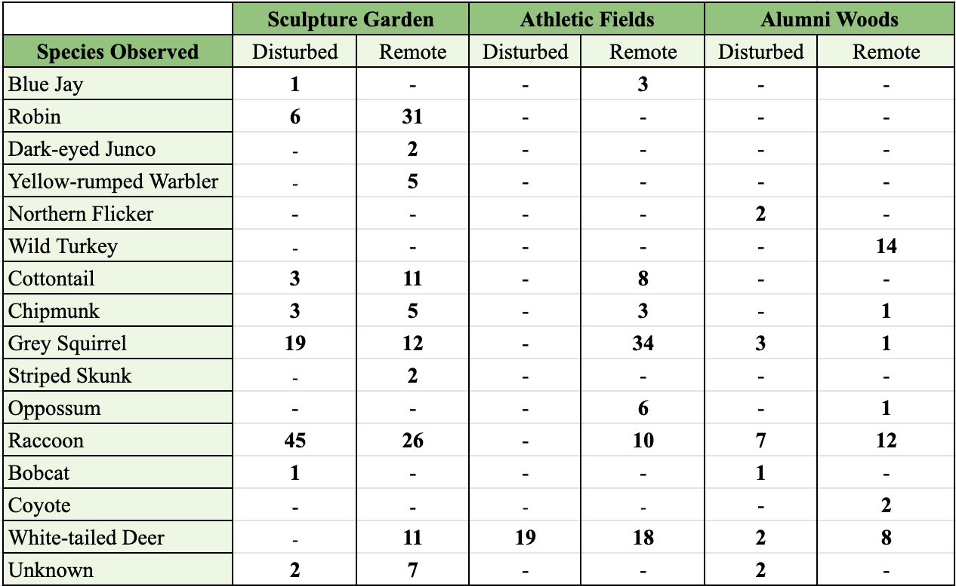
Table 1. The total number of occurrences of each species observed at each location. Dash marks indicate no recorded occurrences in that section.

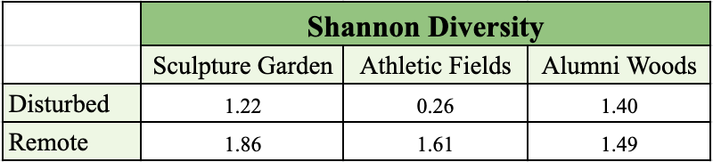
Table 2. Shannon Diversity of all three sites for remote and human-disturbed locations.
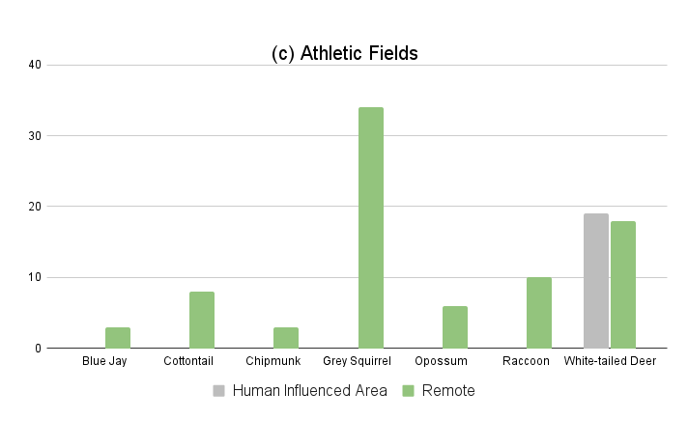
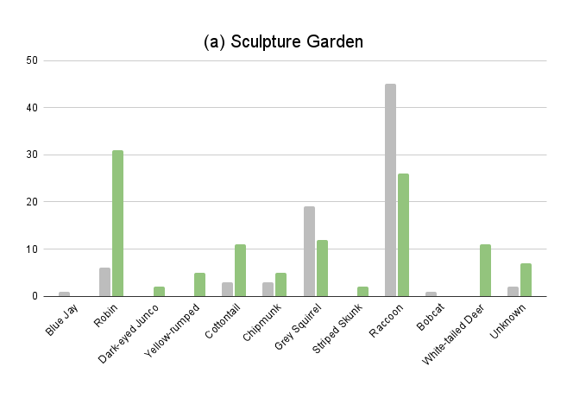
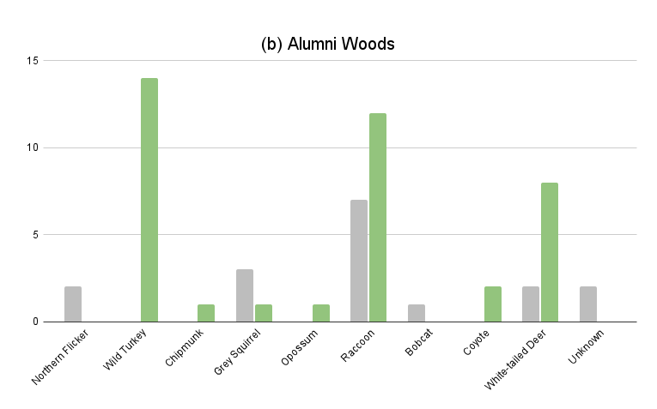
DISCUSSION
Figure 4. The total number of wildlife occurrences per species,
located in the (a) Sculpture Garden, (b) Alumni Woods and
(c) Athletic Fields

The species with the greatest abundance in the human-influenced area of the urban SG site were robins, squirrels, and raccoons. Raccoon populations thrive in urban/suburban environments due to supplemental resources (Prange et al. 2003). These three species are notably unaffected by the structures, debris, and man-made art pieces amongst the woods. Species found within the SG and not in the remote area include the blue jay and the bobcat. The bobcat’s presence in the human-influenced SG camera may be due to its ability to exist in areas with human activity (Tigas et al. 2002). The blue jay was present in the SG because they have adapted to environments with human disturbance (Kight and Swaddle 2007). However, recording bird species abundance with trail cameras is not the most effective method due to the inability to identify blurry photographs. It is important to assess each species abundance in regards to its own traits and characteristics rather than make generalizations (Brown and Graham 2015). In the remote location of the SG, we saw slightly more species moving through the area. Observed only in the remote area were white-tailed deer, striped skunk, and two bird species. Raccoon occurrences were roughly half of what they were in the human-disturbed area which supports the general decrease of raccoon density further from urban environments (Prange et al 2003).
The site we chose to represent a less urban environment and more suburban was the AW. The remote site of AW had four species that were not seen at the human-influenced location near the firepit.

Likewise, two species were observed at the firepit and not in the remote area. AW was the only location that had human occurrences at the remote location. There were almost twice as many raccoon occurrences in the remote location. However, the total number of occurrences was only a quarter of the occurrences in the SG. A possible explanation for this is that raccoons in urban environments generally have higher density populations (Prange et al. 2003). AW was the only location to have coyote occurrences. Their presence here in the forest environment supports coyote preference for less urbanized locations (Randa and Yunger 2006).
The rural AF site had the largest distinction of species abundance comparing human-disturbed and remote locations. This area is the most remote of all three locations. It is also greatly fragmented with roads, fields, and a walking path. Human occurrences were highest in AW and AF but respectively remained greater than their remote site counterparts for all three locations. This was different than we expected for AF since its location was the most remote but had quite high human occurrences. Only one species was found in the human-disturbed area, being the white-tailed deer. White-tailed deer have traits to combat the negative effects of human fragmented landscapes such as high reproductive outputs and large land dispersal (Blanchong et al. 2013). White-tailed deer are known to adapt to the disadvantages of fragmented land (Blanchong et al. 2013) which could explain their continued abundance. The absence of their natural predators (coyotes) could also explain a high abundance. The high frequency of occurrences of deer in certain areas more than others can be explained by the fact that a species ability to learn its surrounding environment plays a role in how they respond to and avoid threats (Laundre et al. 2010).
Interestingly enough, there were zero fox occurrences spotted on any of the trail cameras. Red foxes are native to these areas. It could be that the presence of coyotes and bobcats deter them. This competition is possibly enough to keep them away, as they otherwise could be violating the competitive exclusion principle. However, foxes are less adaptable to urbanized conditions and urban sprawl (Randa and Yunger 2006). Across the rural-urban gradient red foxes' abundance decreases, the coyote does fairly better, and the raccoon is ultimately the most successful. Raccoons and coyotes do better in more urban environments due to their ability to generally avoid humans by shifting their lifestyle from diurnal to nocturnal (Randa and Yunger 2006).
Potential scientific errors lie within the experiment itself as well as human error. On top of routine memory card collection, equipment settings malfunctioned a few times and therefore lead to excess handling of the cameras. This made it easier to mess up the exact angle captured per site. It was also difficult to identify some species because of blurred-out movement due to the automatic shutter speed and aperture settings of the camera. Trail camera studies, in general, cannot capture a full scope of what species are present, only what walks in front of the view and triggers the camera (Carter and Shrestha 1999). Some improvements for future studies could be using larger-sized memory cards to lessen the amount of handling needed to collect the data. Video footage could also be implemented to collect data on the behavior of the wildlife spotted and possibly aid in identifying otherwise unknown species. Studies involving trail cameras could also be improved by utilizing more cameras with multiple angles. This would increase the accuracy of the data collected in these studies and result in a better depiction of the area being recorded.
Possible future studies could focus on one specific carnivore on campus. It would be beneficial to implement bait boxes to see how the predator species in our area would react. This would provide a better idea of their preferred habitats and their abundance. It could also contribute further data to fox presence or absence. Despite our experiment’s urban-rural gradient, Purchase College is located in an overall urbanized area. To ensure that this isn’t skewing some of our results, we could compare our data to a strictly rural site, such as a national park, to expose possible discrepancies in data and overall trends.
Our experiment contributes to an important emerging field of the coexistence between wildlife and humans. As urban sprawl continues, it remains unclear exactly how our native wildlife species will fare. Several species such as white-tailed deer and raccoon are known to be highly successful in this gradient of urban-rural environments (Blanchong et al. 2013; Randa and Yunger 2006). However, it is important to see how other species are affected by human influence, especially apex predators higher on the food chain such as coyotes and bobcats. This data of species abundance is important to see the stability of the overall food chain, which is closely tied to the health of the entire ecosystem. Providing data to better understand wildlife species populations’ reactions to human disturbance can help sustain wildlife populations and conserve our wild ecosystems.

CONCLUSIONS
We observed a general trend of decreasing species richness from the urban (SG) to rural (AF) environments. This counters the idea that rural environments (AF) would have a greater species abundance. White-tailed deer, raccoons, and grey squirrels were the most abundant species respectively present at our study sites. Each species only being absent from one location (all of which were human-influenced locations). These species are the most adaptable and less afraid of humans. The least common species throughout campus locations include coyote, striped skunk, and the two bird species yellow-rumped warbler, and the dark-eyed junco. The high abundance of raccoon occurrences and lower abundance of coyote occurrences coincides with findings of carnivore occurrences across an urban-rural gradient (Randa and Yunger 2006).
Our findings conclude that the Shannon diversity index and species richness are greater in the remote sites for all three locations. Human occurrences were most frequent in AW and AF and were higher in the disturbed areas than in the remote locations. Knowing that animal richness and Shannon diversity are highest in areas less disturbed by humans can influence the inhibition of human encroachment on ecosystems. Our findings support that conservation efforts to control human disturbances can benefit wildlife habitats (Qiu et al. 2019).

ACKNOWLEDGEMENTS
We would like to thank Dr. Jackson, Amanda Salmoiraghi, and Nicole Helregel for their help and guidance through our first scientific paper. Kristen would like to thank all the people who crouched down, smiled, and waved at the cameras.

AUTHOR CONTRIBUTIONS
Conceptualization (all), data collection (all), data curation (all), formal analysis (all), methodology (all), project administration (all), resources (all), visualization (KP, AR), writing - Intro (KP), writing - methods (KP, EH), writing - abstract (KP), writing - results (KP, EH), writing - discussion (KP, AR), writing - conclusion (KP, AR), writing - review & editing (all).

LITERATURE CITED
Blanchong, J.A., A.B. Sorin, and K.T. Scribner. 2013. Genetic Diversity and Population Structure in Urban White-tailed Deer. The Journal of Wildlife Management 77 (4): 855-862
Brown. L.M., and C.H. Graham. 2015. Demography, traits, and vulnerability to urbanization: can we make generalizations? Journal of Applied Ecology 52: 1455-1464
Cardinale, B.J., J.E. Duffy, A. Gonzalez, D.U. Hooper, C. Perrings, P. Venail, A. Narwani, G.M. Mace, D. Tilman, D.A. Wardle, A.P. Kinzig, G.C. Daily, M. Loreau, J.B. Grace, A. Larigauderie, D.S. Srivastava, and S. Naeem. 2012. Biodiversity Loss and Its Impact on Humanity. Nature (London) 486: 59-67
Carter, N. H., B.K. Shrestha, J.B. Karki, N.M.B. Pradhan, and J. Liu. 2012. Coexistence between wildlife and humans at fine spatial scales. Proceedings of the National Academy of Sciences 109 (38): 15360–15365
Kight, C., and J. Swaddle. 2007. Associations of anthropogenic activity and disturbance with fitness metrics of Eastern Bluebirds (Sialia sialis). Biological Conservation 138: 189–197
Laundre, J.W., L. Hernandez, and W. Ripple. 2010. The Landscape of Fear: Ecological Implications of Being Afraid. The Open Ecology Journal 3: 1-7
McKinney, M.L. 2002. Urbanization, Biodiversity, and Conservation. Bioscience 52: 883–890
Miller, J.R. 2005. Biodiversity conservation and the extinction of experience. Trends in Ecology and Evolution 20 (8): 430-434
Newport, J., D.J. Shorthouse, and A.D. Manning. 2014. The effects of light and noise from urban development on biodiversity: Implications for protected areas in Australia. Ecological Management & Restoration 15 (3): 204–214
Pett, T.J., A. Shwartz, K.N. Irvine, M. Dallimer, and Z.G. Davies. 2016. Unpacking the People-Biodiversity Paradox: A Conceptual Framework. BioScience 66 (7): 576-583
Purchase College State University of New York. 20th Century History (1900-1964). https://www.purchase.edu/purchase-history/20th-century-history-1900-1964/
Prange, S., S.D. Gehrt, and E.P. Wiggers. 2003. Demographic Factors Contributing to High Raccoon Densities in Urban Landscapes. The Journal of Wildlife Management 67 (2): 324-333
Qiu, L., H. Han, H. Zhou, M. Hong, Z.J. Zhang, X. Yang, X. Gu, W. Zhang, W. Wei, and Q. Dai. 2019. Disturbance control can effectively restore the habitat of the giant panda (Ailuropoda melanoleuca). Biological Conservation 238: 108-233
​​Randa, L.A., and J.A. Yunger. 2006. Carnivore Occurrence along an Urban-Rural Gradient: A Landscape-level Analysis. Journal of Mammalogy 87 (6): 1154-1164
Samia, D.S.M., S. Nakagawa, F. Nomura, T. Rangel, and D. Blumstein. 2015. Increased tolerance to humans among disturbed wildlife. Nature Communications; London 6: 1-8
Suvajot, R.M., M. Buechner, D. Kamradt, and C. Schonewald. 1998. Patterns of human disturbance and response by small mammals and birds in chaparral near urban development. Urban Ecosystems; Salzburg 2 (4): 279-297
Tigas, L. A., D.H. Van Vuren, and R.M. Sauvajot. 2002. Behavioral responses of bobcats and
coyotes to habitat fragmentation and corridors in an urban environment. Biological
Conservation 108: 299–306
Zingesser, Lawrence. “HPN: A Bird's Eye View, Past and Present.” Air Facts Journal, Lawrence Zingesser Https://Airfactsjournal.com/Wp-Content/Uploads/2021/04/Air-Facts-Logo340.Png, 17 Sept. 2015, https://airfactsjournal.com/2015/09/hpn-birds-eye-view-past-present/.
URBANIZED INVASIVE HOUSE SPARROWS BENEFIT BY HAVING FLEXIBLE DIETS

Skylar C. Cullen, Abdul A. Hassan, Robert Olsen, Gianna Papantoniou

ABSTRACT
House Sparrows (Passer domesticus) are an invasive species that are commonly found across North America and many other continents. Originally, they were studied for their adaptations to biotic conditions, but over the years, House Sparrows have served as a focus for studies portraying their success as invasive species. Like many invasive species, their diets can consist of different types of feed depending on what’s available to them. In our experiment, a field study was conducted to determine their seed preference. We set out five different types of feed to observe what the House Sparrows would prefer. Our results showed that House Sparrows prefer corn over all other four feed types that were offered, including sunflower seeds with and without the husk, millet, and safflower. Being flexible in their diets allows invasive species like House Sparrows to thrive in novel environments. Our results provide experimental evidence for the importance of variable social connections when examining House Sparrows by using multiple food sources.

Keywords: Behavior; Diet; House Sparrows; Invasive species; Urbanization ______________________________________________________________________________

INTRODUCTION
Biological invasion is a major cause of biodiversity loss and environmental change. Invasive species threaten our native plants and animals by competing for food, water, and space damaging habitats (Martin et al. 2005). Damage and loss triggered by invasive species and the cost of control measures also result in a high and rising economic and environmental burden. (Hejda et al. 2009). Invasive species affect the economy by impacting fisheries, forest protection and reducing grazing land and crop yields. As humans evolve our exporting methods, foreign species have become more prevalent (Colleony et al. 2020). Multiple studies have shown that climate change can enhance plant invasion from regional to global scales (Ronald et al. 2005). However, ecologists and scientists have been working to prevent and control plant invasion issues. The majority of areas have received significant research attention over the past years based on habitat distribution of invasive plant species (Gallinat et al. 2020). Further studies have shown not all exotic species are considered harmful, non-native species can have neutral effects on other species (Demeter et al. 2021).
House Sparrows are absent from undisturbed forests, but they’re common in urban areas (Tuliozi et al. 2018). Invasive birds contribute to over $2.3 billion in damage to agriculture (Pimentel et al. 2001). Invasive birds include the Common Starling (Sturnus vulgaris), House Sparrow (Passer domesticus), Egyptian Goose (Alopochen aegyptiaca), and many more (Martin et al. 2005). Invasive birds are capable of adapting into any environment. Species hunt for food sources based on their environment conditions. These factors are based on physical limitations, predator abundance, and competitor abundance. Humans influence a variety of environmental factors when moving into cities and expanding their land (Wang and Liu, 2021). Urbanization leads to rapid and dramatic reductions in abundance and diversity of wildlife, because species are pushed out of their natural environments (Martin et al. 2005). Invasive birds have often acquired unique traits including fast growth, rapid reproduction and high dispersal ability that allows them to flourish and prosper in new lands. House Sparrows were introduced to the US back in the 1850s. They started in Brooklyn, NY, to control the caterpillar population, which would reduce the number of moths that were destroying the city's basswood trees (Lowe 2020). However, about half a century later, House Sparrows successfully invaded the rest of the country. In their peak back in 1940, 150 million House Sparrows were inhabiting America (Lowe 2020).
One factor determining invasive success within a non-native species is diet type. Animals with a broad diet are likely to be more successful in invading new areas (Shik and Dussutour 2020). House sparrows seem to fall into this category as they will eat almost anything which makes them notable invaders (Shik and Dussutour 2020). A species that requires a specific food type would be more restricted to certain habitats and would be less likely to survive as an invasive species because of dietary restrictions. The wide diet variety of the sparrows is a helpful trait that will increase their chances of survival in a new environment. When eating a wide range of seeds, they can adapt to almost any environment and effectively invade it which could harm the native species and could possibly force them to extinction (Chichorro et al. 2019). This shows that the sparrows will have food preferences when many selections are available, but they won't require a vast food selection to survive in a specific habitat or invade a new one.
Another factor is how much longer the native species has been in an area compared to the invasive species. If the House Sparrows are introduced long after the native species have already flourished, their invasive success may be reduced (Hess. et al. 2019). House Sparrows will eat a variety of organisms including insects, such as caterpillars, and different plants and berries that are found in their habitat. Although House Sparrows are known to eat a wide variety of foods found in nature, they do have a preference of choosing to eat from bird feeders. A study conducted on the Purchase College campus found that sparrows preferred to eat from bird feeders rather than nearby invasive or native plants. When bird feeders are set out, the House Sparrows tend to gravitate more to them since they are an easy to access food source (VanHouten and Yates 2018).
In our study, we tested five different types of birdseed to which ones were preferred by House Sparrows when they chose which one to eat. The choices were sunflower seeds with husks, bare sunflower seeds, millet, cracked corn and safflower seeds. We observed which seeds the sparrows preferred on five different days. All of these tests were conducted outside the humanities building which is where there is a high density of sparrows. We considered the variables such as weather, wind and protests that were taking place on campus and acknowledged that these factors could influence our results. It was predicted that the millet seed would be the most popular because it is not only the smallest seed but the most prevalent ingredient in the mixed seed.

METHODS
Experiment setup. Data was collected Oct. 18-29th, 2021. The data collection site was located on SUNY Purchase campus (Fig.1). We collected our data behind Purchase College library because of the large population of house sparrow (Passer Domesticus) birds found there. In total, we used five bird feeders to determine which food type House Sparrows prefer. The food options were Feathered Friend premium black oil sunflower seeds, Kaytee cracked corn, White Proso millet seeds, Lyric sunflower kernels, and Wagner’s safflower seeds (Fig. 2).
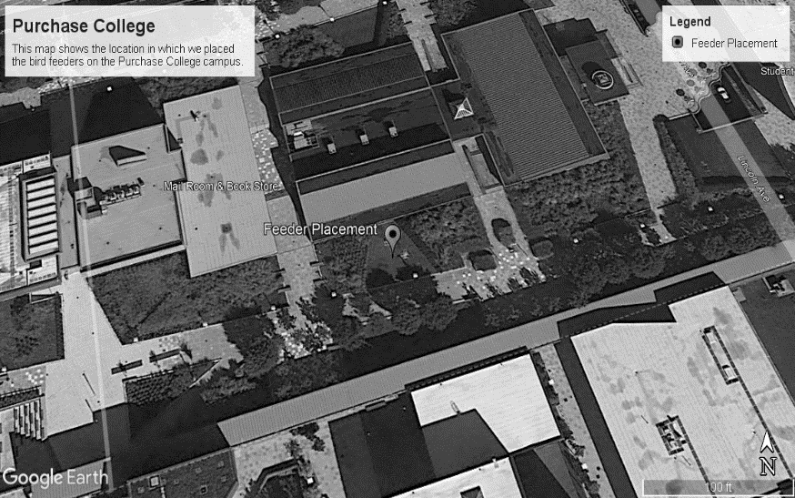
Field setup. We placed the feeders approximately one foot away from one another. Then, we stayed approximately twenty feet away to allow the birds to eat from the feeders. To collect the samples, we counted how many birds ate the seeds from each of the feeders. After completing the first sample, we changed the order of the feeders by shifting them to the left to see whether the order of the feeders affected what seed they prefer (Fig. 3).
Figure 1. A Map of Purchase College showing the location of the data collection site.
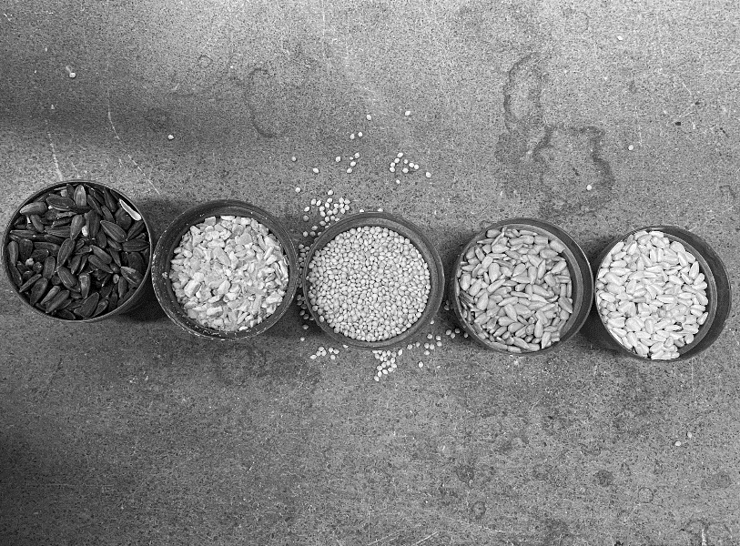
Figure 2. Types of seeds used for the feeders. Left to right: sunflower (with husk), cracked corn, millet, sunflower bare, and safflower
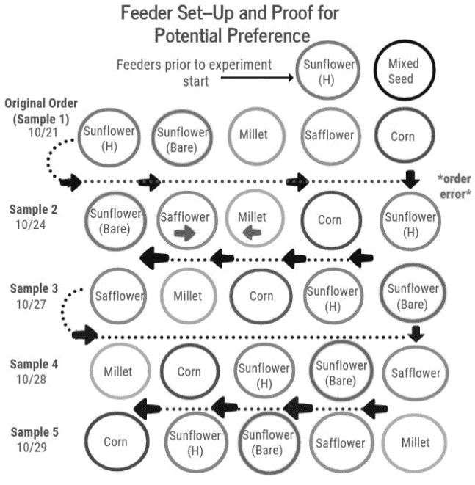
Figure 3. A display of our feeder set up per sample with location of original feeders for reference.

Data collection. Due to temperatures and external noise including construction and students, we collected samples for different amounts of time. On October 21st, we spent 2 hours collecting data. On the 24th and 27th, we were able to collect data for an hour each. On the 28th, we collected for an hour and twenty minutes, and on the 29th we observed for only 40 minutes due to bad weather and lack of sparrow presence. We removed the feeders after each sample we collected because the area was used by other students conducting different projects. Before conducting this experiment, a mixed seed feeder was placed on the collection site from another project. Throughout the sampling dates, temperature ranged from 55 to 68 degrees fahrenheit. The weather was mostly cloudy, windy, and foggy with occasional sunshine.
Statistical analysis. We used Microsoft Excel to create bar graphs to analyze our data. In total, two graphs were created for each of the samples. Also, we used google maps to indicate the region of the collection site. The results were calculated seeds/hour in order to compare inconsistent data collection times because some samples lasted more than one hour.

RESULTS
Over the course of our observations, we found that a total of 373 birds visited the cracked corn feeder. 279 birds went to the sunflower seeds with the husk and 138 went to the bare sunflower seeds. Next, 116 birds went to the millet feeder. Lastly, a total of only 58 birds went to the safflower feeder. This emphasizes the preferred choice in cracked corn and sunflower seeds with the husk over the rest of the food (Fig. 4).
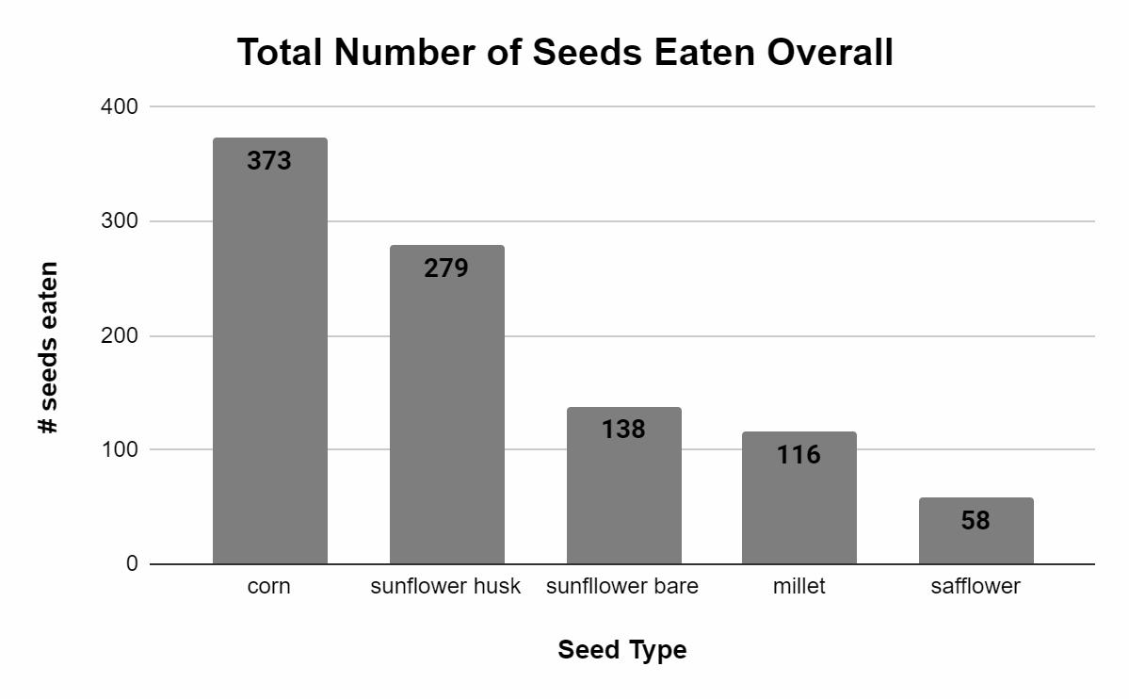
Figure 4. A table with the total number of seeds eaten in total throughout all five samples

In trial one, the weather was sunny and warm, and the House Sparrows preferred the cracked corn the most which had 70 birds visit per hour. The sunflower seeds with the husk were the second most preferred with an hourly average of 55 birds and after that was the bare sunflower seeds and the millet. The bare sunflower seeds had 7.5 visits per hour and the millet had 3.5 visits per hour. The House Sparrows did not prefer the safflower as much with only two birds gravitating towards it per hour (Fig. 5).
The second trial lasted for an hour and the weather was cloudy and gray. We found that during this trial the most preferred became the sunflower seeds with the husk. 70 birds flew to that feeder during the hour. Cracked corn became the second most preferred for the House Sparrows with 35 of them visiting the feeder. The third most preferred were the bare sunflower seeds which 23 birds visited. The last two types of feed that the birds preferred were the safflower and the millet. The safflower had 11 birds gravitating towards it and the millet only had 10 (Fig. 5).
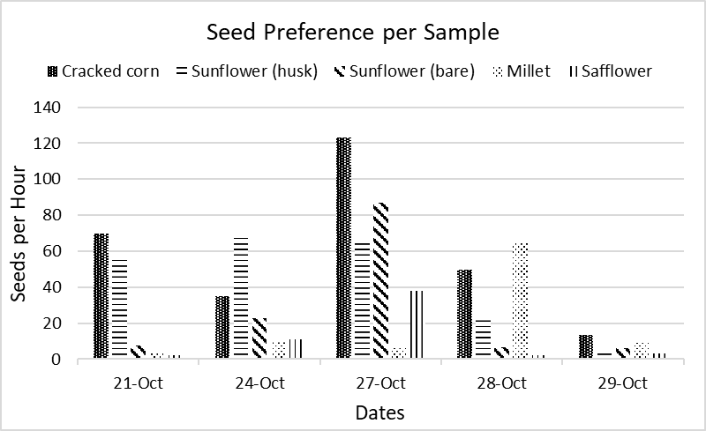
Our third trial was an hour long. On this day it was windy and there was construction occurring. Although it was across campus, the noises could still be heard from the feeding station. Within this trial, the cracked corn was the most eaten feed with 123 birds visiting the feeder over the hour. The second most eaten feed was the bare sunflower seeds. This feeder had 87 birds visit it. Third is the sunflower seed with the husks that had 66 birds visit it, and fourth is safflower with 38 birds. The birds did not prefer the millet as much with only seven birds visiting it (Fig. 5).
Figure 5. A chart comparing the number of seeds eaten per hour, per sample.
The fourth trial was an hour and twenty minutes long. On this day the weather was sunny and warm with a minimal amount of wind. During our trial, there was a protest going on across from the feeders. It took the birds a total of 35 minutes from when we started our observation to start coming to the feeders. Since this was different from our normal experiences, we have reason to assume it has something to do with the loud voices and heavier than usual foot traffic. The millet feeder had 64.5 birds visit it per hour, making it the most preferred feed of this trial. The second most preferred feed was the cracked corn that had an hourly average of 49.5 birds visit. Third was the sunflower seeds with the husks with 22.5 birds per hour, and fourth was the bare sunflower seeds that had 6.75 birds per hour. The least preferred was the safflower with only 2.25 birds per hour (Fig. 5).
Our fifth and final trial was 40 minutes long. This day was cloudy and windy with a chance of rain later in the day as well. Due to the excessive wind and gray weather, the birds were not as active as they normally were around the feeders resulting in a smaller number of birds in total. Throughout the 40-minute period, we had gaps of no birds going to the feeders and strong wind. We have reason to assume that the strong winds and poor weather conditions made the birds not visit the feeders as frequently. In this trial, the most preferred feed was the cracked corn with 13.5 visits per hour. Second preferred was the millet with nine visits per hour. The third most preferred feed was the bare sunflower seeds with an hourly average of six visits and the fourth most preferred feed was the sunflower with the husks that had 4.5 visits per hour. The least preferred feed was safflower with only three visits per hour (Fig. 5).

DISCUSSION
From our results, we learned that House Sparrows prefer cracked corn over all other five feed choices, seconded by sunflower seeds with the husk still on. Third best were sunflowers, then millet, and lastly safflower was the least preferred overall. We know that food with higher fat content offers more nutritional and energetic value for the birds, but it is not the only factor involved in their diet choices. Ideally, birds should select the food option that is easiest to eat while providing the most energetic benefit (Molokwu et al. 2011). For example, sunflower seeds tend to be high in fat while cracked corn helps to keep stable energy levels with simple carbohydrates like glucose. Birds also consider handling times (the level of effort it takes for them to eat and digest the food) when considering food options. Seed hardness normally determines how much time it would take for the birds to crack open the husk to get to the seed itself (Van Der Meij et al. 2004). We presumed the birds would prefer the bare sunflower seeds over the ones with the husk still on due to this factor, but further research would be required to see whether the bulk of the nutritional benefits of sunflowers is contained within the seed casing or the seed itself, or if they simply chose the husk seeds out of familiarity.
With every trial, we rotated the feeders to see if there would be any preference in the feeders towards the end of the line where the original two feeders were set up before our project began (Fig. 3). The feeder farthest to the left would be brought to the right end, and the adjacent feeders shifted left once. An error was made on the day of our second sample in which the millet and safflower seeds were misplaced. In some instances, this hypothesis seemed accurate and the feeders in the same location of the original two were preferred, as birds are known to be more likely to prefer guaranteed satisfaction over risk-for-benefit situations (Ilan et al. 2013). In other samples, one or more of the feeders in the middle had more activity than the feeders at the end, which brings us back to the idea that the House Sparrows choose their foods based on fat contents and how much energy it can provide, and less so their familiarity with its location. Overall our results were inconclusive in terms of original feeder location preference. As seen in Figure 4, there was almost always activity at the far right feeder (which is one of the usual 2 feeders’ spots), which may suggest familiarity, but; the safflower went near;y untouched the day it sat in that spot-making any assumptions difficult. This part of our study links to the birds’ comfort with novelty situations, as they tried each new feeder to determine what type of feed is where each time we sampled. Seed size and husk characteristics are important factors in determining whether the birds will prefer the feed being offered (Titulaer et al. 2018).
Along with rotating the feeders, there were also differences in weather and foot traffic in the area per sample time. Weather wise, some days were sunny and warm, while other days were cloudy and rainy with wind. Different weather patterns, like wind strength and rainfall, have effects on bird behavior overall (O’Connor and Hicks 2009). The wind and rain tended to affect the birds and their drive to get food, as high winds and rain hinder flying abilities for many flying organisms. On days such as those, we got less data than normal. When it came to foot traffic, there were many different sounds in the area during each trial. Loud, sudden noises and human proximity to the birds would affect their boldness in going to the feeders. For instance, during one of the trials there was a protest going on directly across from the feeders, the noise and density of people made the birds hesitate to return to the feeders as frequently as they usually did. On other days, the sounds of skateboards rolling by and people talking made the birds flee from the feeders while they were eating, but they returned with enough frequency to account for the numbers we saw in our results. We observed the sparrows’ behavior as well as their food choices, becoming increasingly comfortable in novelty surroundings such as a protest on campus. The birds could have been perceiving the louder noises as risks causing them to be as cautious as possible. Bird behavior can be impacted by predation risks and landscape connectivity which can, in turn, impact where they choose to live and get food (DeWitt et al. 2018). Once they noticed that there was no real risk, they went back to the feeders as they normally did.
The errors we encountered included the aforementioned accidental misordering of the safflower and millet seeds, as seen in figure three, as well as the weather and unforeseen campus activity going on during our intended observation times. It is important to clarify that although our results are accurate, as we counted the number of bird landings on each feeder, it does not reflect the true number of birds in the flock, nor does it prove how many individual birds may have landed there. The same bird(s) could have landed on a feeder multiple times, and would be accounted for as so, as we had no way to mark each bird to see if some were bolder than others in trying new foods.
There are many ways to replicate and improve this project, like studying different species of birds either simultaneously or individually, testing over a span of different seasons or locations. It is important to note that birds are also sensitive to and usually aware of the secondary compounds found in many of their feeds, especially those made in factories (Molokwu et al. 2011). Birds will make food choices that take chemicals like tannins and saponins into account, which raises questions about the quality and origin of the foods they eat. Another idea would be to offer the birds human foods, but, especially in America, foods are riddled with potentially toxic additives and preservatives that may harm the birds’ digestion systems. The seasons may influence the type of feed the birds choose to eat as well, depending on the activities they participate in throughout the year such as breeding and migration. It is important to test other species of birds and wildlife in general to get a sense of how we may be able to preserve their species, if necessary, as our world continues to explore the effects of anthropogenic climate change.
We know that many species are becoming more accustomed to urbanized spaces out of necessity for survival and observed the triggers that would scare the sparrows and those that didn’t. For example: one or two people walking by normally wouldn’t upset them, but a plane overhead, a skateboard, bike, or even a group of people passing by would send them into the trees or into the brush next to the feeders. There are many other places in which it would be useful to observe sparrows, like rural areas where adaptation to loud noise and commotion isn’t necessary. This was tested by Jarjour and her peers in 2020 where both urban and rural birds were tested for their willingness to accept novelty to feed. It was determined that even with many controls to prevent variability, urbanized birds are much more comfortable facing new experiences than those from rural or less populous areas (Jarjour et al. 2020).
Research like this is important because we can link how House Sparrows tend to be good at invading. Like many other species, House Sparrows are not native to the United States; they are mainly from Europe and parts of Asia and northern Africa. They can also be found in the United Kingdom, where their population seems to be decreasing (Summers-Smith 2003). Their level of boldness and adaptability to novel environments is what makes them such good invaders; seeing as they were able to feed from all five feeders regardless of preference shows their flexibility in diet, which also puts them at an advantage to many native species. This study can help to find ways to increase the house sparrow population there by using their food preferences, or even lure them away from a fragile environment if necessary. Research like this is important because as the world continues to be changed by humans we need to know how and if wildlife will be able to adapt, as well as their behaviors and preferences to ensure resource availability and pinpoint locations where these species may be able to thrive.

CONCLUSIONS
Our findings concluded feeder position had a minor impact on birds’ preference on the seeds. Overall, the cracked corn was most popular followed by sunflower seeds with husk and bare sunflower seeds. However, when each seed was positioned at each end, there was an increase of bird visits. Even though the millet and safflower portrayed an increase of bird visitors, they were not as popular compared to the other seeds. Like many other invasive species, House Sparrows have a flexible diet which makes them successful when introduced to new environments. Because of their flexible diets, House Sparrows settle mostly in urban areas. Their population continues to expand throughout many countries. This experiment is ideal because it demonstrates how House Sparrows affect other native plant species due to their diet. Species specific experiments allow us to obtain important data needed to preserve or restore different types of species if necessary, or even lure them away from environments they may be negatively impacting.

ACKNOWLEDGEMENTS
We are extremely grateful to Allyson Jackson, Ph.D., for her help and support during this research. Dr. Jackson provided us with materials for our experiment such as bird feeders and seeds. We would like to thank Amanda Salmoiraghi for her careful reading and comments on the outline and Nicole Helregel who provided us with useful research websites.

AUTHOR CONTRIBUTIONS
Data Collection (all), Formal Analysis (AH, SC, GP), Data Curation (AH, SC, GP), Methodology (AH, SC, GP), Resources (all), Visualization (AH, SC, GP), Writing - Intro (AH,RO), Writing - Methods (AH), Writing - Abstract (AH, SC, GP), Writing - Results (GP), Writing - Discussion (SC, GP), Writing - Conclusion (AH), Writing - Acknowledgements (all) , Writing - Charts and Tables (SC), Writing - review & editing (AH, SC, GP).

LITERATURE CITED

Chichorro, F., A. Juslen and P. Cardoso. 2019. A review of the relation between species traits and extinction risk. Biological conservation. 237: 220-229
Colleony, A. and A. Shwartz. 2020. When the winners are the losers: Invasive alien bird species outcompete the native winners in the biotic homogenization process. Biological Conservation. 127: 98-103
Demeter, L. M. ÁP, Bede-Fazekas. Á, Öllerer. K, Varga. A, Szabados. K, Tucakov. M, Kiš. A, Biró. M, Marinkov. J, Molnár Z. 2021. Controlling invasive alien shrub species, enhancing biodiversity and mitigating flood risk: A win-win-win situation in grazed floodplain plantations. Journal of Urban Ecology. 31 (1): 295
DeWitt, P.D., H. Grobbelaar, A. Unger, and D.R. Visscher. 2018. Bird foraging is influenced by both risk and connectivity in urban parks. Journal of Urban Ecology. 4(1): 1-6
Gallinat AS, R.B. Primack, and T.L. Lloyd-Evans. 2020. Can invasive species replace native species as a resource for birds under climate change? A case study on bird-fruit interactions. Biological Conservation, 19(1): 208-217
Hejda M, P. Pysek, V. Jarosik. Impact of Invasive Plants on the Species Richness, Diversity and Composition of Invaded Communities. 2009. Journal of Ecology, 97: 393–403.
Hess, Manon CM., F. Mesleard, and E. Buisson. 2019. Priority effects: Emerging principles for invasive plant species management. Ecological engineering. 127: 48-57
Ilan, T., E. Katsnelson, U. Motro, M.W. Feldman, and A. Lotem. 2013. The role of beginner’s luck in learning to prefer risky patches by socially foraging house sparrows. Behavioral Ecology. 24(6):1398-1406
Jarjour, C., J.C. Evans, M. Routh, and J. Morand-Ferron. 2020. Does city life reduce neophobia? A study on wild black-capped chickadees. Behavioral Ecology. 31 (1): 123-131
Lowe. J. Invasive Birds Of The U.S.: Seven Of The Most Common Species. February 24, 2020, https://abcbirds.org/blog20/invasive-birds/
Martin, T. G., B. A. Wintle, J. R. Rhodes, P. M. Kuhnert, S. A. Field, A. J. Tyre, and H. P. Possingham. 2005. Zero tolerance ecology. improving ecological inference by modelling the source of zero observations. Journal of Urban Ecology. 8(11): 1235–1246
Molokwu, M.N., J.A. Nilsson, and O. Olsson. 2011. Diet selection in birds: trade-off between energetic content and digestibility of seeds. Behavioral Ecology. 22(3): 639-647
O’Connor, R.J., and R.K. Hicks. 2009. The influence of weather conditions on the detection of birds during Common Bird Census fieldwork. Bird Study. 27(3): 137-151
Pimentel, D., S. McNair, J. Janecka, J. Wightman, C. Simmonds, C. O’Connell, E. Wong, L. Russel, J. Zern, T. Aquino, T. Tsomondo. 2001. Economic and environmental threats of alien plant, animal, and microbe invasions. Behavioral Ecology. 84: 1-20
Ronald, N.P, P. Louis, S. Allen M, N. Ran, M. Guy, F. Jóse, L. Heike, T. Ken. 2005. Forecasting Regional to Global Plant Migration in Response to Climate Change. Behavioral Ecology. 55: 749–759
Shik, J. and A. Dussutour. 2020. Nutritional Dimensions of Invasive Success. Trends in Ecology and Evolution. 35: 691-703
Summers-Smith, J.D. 2003. The Decline of the House Sparrow: a review. British Birds. 96(9): 439-446
Titulaer M, A.M. Castillo, F.A. Rodriguez Almeida, and J.A. Fernandez. 2018. Importance of seed characteristics in diet preferences of granivorous birds: A pilot study with house sparrows. Caracas. 43(7): 511-515
Tuliozi, B., Fracasso, G., Hoi, H. 2018. House sparrows’ (Passer domesticus) behaviour in a novel environment is modulated by social context and familiarity in a sex-specific manner. Animal Biology. 15: 39-46
Van Der Meij, M. A. A., M. Griekspoor, and R. G. Bout. 2004. The Effect of Seed Hardness on Husking Time in Finches. Animal Biology. 54(2): 195–205
VanHouten, H. and W. Yates. 2018. Bird Preference of Native vs Introduced Food Sources at Purchase College. Purchase College Journal of Ecology. 2: 10-16
Wang D, and X. Liu. 2021. Behavioral innovation promotes alien bird invasions. Innovation (NY). 2(4):100167

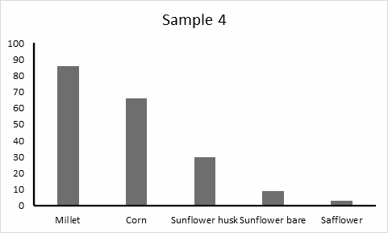
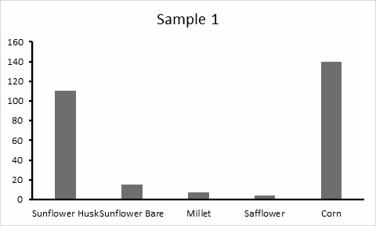
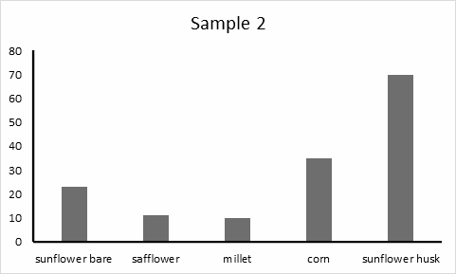
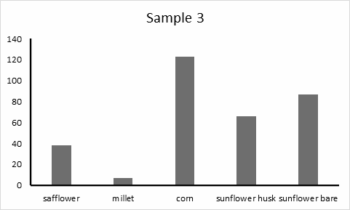
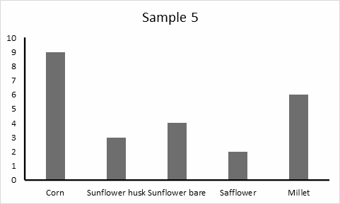

Appendix A. Graphs of all five sample results with respect to feeder location per sample.

INVASIVE SPECIES POSSESS POTENTIAL BENEFITS BASED ON THEIR FALL PHENOLOGY

Jacob Lupie, Jillian O’Rourke and Sara Atlassi

ABSTRACT
Phenology is the study of seasonal changes and their relationship to climate, plants, and animals. When looking at native species competing with non-native species, studying plant phenology can be helpful in understanding these plant species in their current environments. These non-native species outcompete native ones, thus changing the ecosystem. Invasive species typically outlive native species, which allows these invaders to continue to spread while the native ones become dormant. Our study was conducted on the Purchase College campus to determine if the phenology of non-native species will progress slower than that of native species on campus, and what species support invertebrates as phenology changes to late fall. Our results show that non-native species phenology changes slower than that of native species. By the end of our observation period, non-native species presented more leaves on branches, showed signs of being less withered, still provided food sources for animals, and the color of the leaves changed minimally compared to native species. Non-native species also provided habitat to about 50% more invertebrates than native species as the climate changed from early to late fall. Overall, the phenology of non-native species does change slower than that of the native species on campus. Additionally, they continue to provide habitat for invertebrates as the weather changes from early to late fall, leading to possible beneficial attributes of invasive species on campus.
Keywords. Guidelines; Phenology, Native Species, Non-native Species, Invertebrates
______________________________________________________________________________

INTRODUCTION
Invasive (non-native) species are those that have crossed environmental barriers to disperse in a non-native area and spread their population without any impacts to their survival (Brenton-Rule and Ormsby 2016). Invasive species thrive in non-native areas because they have no natural competition or predators preventing them from decimating the resources in a given area and altering the ecosystems. The biological invasion of these non-natives is an issue seen around the globe. Non-native Nile tilapia (Oreochromis niloticus) have invaded Lake Kutubu in Papua New Guinea. The Nile tilapia compete with native fish for food and breeding habitat as well as predation on native fry resulting in a severe population decline of the native fish species populations (Thresher et al. 2020). The non-native zebra mussel (Dreissena polymorpha) has widely expanded throughout northern North America, i.e. in The Great Lakes of the United States and Canada (Petsch et al. 2020). Again, the zebra mussel has no native predators in North America as they are from Asia which allows this mussel to thrive without any threat to their population (Petsch et al. 2020). In the meadows of France, invasive Himalayan balsam (Impatiens glandulifera) has invaded, altering the agricultural ecosystems, specifically in the Pyrenees (Guillerme et al. 2020).
In order for a species to become invasive, they disperse by crossing environmental barriers. Typically, invasive species are brought to non-native environments by anthropogenic means. The Nile Tilapia swam into Lake Kutubu from over-flooded aquaculture ponds (Thresher et al 2020). The Zebra Mussels in The Great Lakes of the United States, were carried from Asia to the US via the ballast water of ships (Petsch et al. 2020). In terms of invasive plants, the most notable way they cross barriers via anthropogenic means is by physically being brought from one place to another to be used as ornamental plants. The invasive porcelain berry vine (Ampelopsis glandulosa var. brevipedunculata) was brought to the United States from Asia because of the fruit it produces and its overall hardiness for survival (Huang and Sherald 2003). Norway maple trees (Acer Platanoides) were also brought to the US as ornamental trees. They were wanted for their early budding and late leaf off season making them a hardy and fast-growing tree for ornamental purposes (i.e. shade in parks) (Casey 2013). It was not until these plants were already established and thriving in their non-native environments did scientists see the negative effects they can have on the native ecosystems.
Invasive plants have deleterious effects on the non-native ecosystems for multiple reasons. Invasive plants have long been taking over the environment and research about the effects of them dates far back (the first introduction to the concept being born in 1958 through The Ecology of Invasion by Animals and Plants by Charles Elton). Some of the effects of invasive plants are the alteration of habitat and environmental composition (for example in soil), and the reduction and sometimes even extinction of native species, resulting in “richness reduction” (Powell et al. 2013). This can be a large issue due to their ability to modify soil microbial communities and influence ecosystem dynamics in the environments they invade (Wang 2021). This effect is dangerous as it creates a homogeneity in the environment which then transcends to less diverse habitats and food sources for other species, as well as a threat to the ecosystem. Some characteristics of invasive species include high dispersal, fast growth and reproduction, wider environmental tolerance, use of allelopathy, etc. concluding that invasive species can change ecosystems by altering the resources available (Gordon 1998). These events pressure native species into modifying their composition, possibly leading to the extinction of these species (Gordon 1998). These invasive species use multiple ways of altering environments in addition to their other competitive characteristics, and as a consequence they diminish the presence of native species thus decreasing the biodiversity of the spaces they invade (Gordon 1998; Powell et al. 2013; Hejda et al. 2009). A lack of native diversity is made possible through the various attributes that invasive species possess, which make them more successful in utilizing the primary resources native species need to survive (Gordon 1998).
Weather can play a large role in the adaptability of invasive species in non-native climates. Temperature is one of the abiotic factors that can control the success of an invasive species (Petsch et al. 2020). In the example of the zebra mussels, the cold temperature in the northern North America region allows for the invasive mussel to thrive. The general weather adaptation in combination with the lack of predators aids the mussels in their biological invasion (Petsch et al. 2020). This is also true for plants. We can observe this through the phenological changes in plants. For example, as the weather turns from fall to winter, the ability of a plant to acclimate to colder temperatures relies on its ability to maintain its leaves (Améglio and Charrier 2010). Also, the ability of most plants to flower and produce fruit typically occurs over the spring and summer seasons (Búrquez and Bustamante 2008). Temperature can also affect pollinator activity which could indirectly affect the population of a plant species. For example, if a plant is still producing flowers as the seasons change, that plant’s population will continue to grow versus a plant that cannot acclimate to colder weather and produce flowers (Búrquez and Bustamante 2008).
This sparks the question as to whether or not invasive species only provide negative attributes to the ecosystems they invade. One could speculate that if an invasive species is still flowering and providing food and habitat past the lifecycle of native plant species, maybe these non-native species can provide some benefits to their new environments. For example, the Pacific Oyster (Crassostrea Gigas) is a non-native bivalve mollusk to North America. Yet, the dense reefs they form provide habitat for bacteria, which provides food abundance for the bacteria eating invertebrates in these habitats (Chapman 2016). Another example could be the invasive apple snail (Pomacea Maculata) in Florida. Although the potential benefits of the non-native snail were not directly discussed in this study, the native Snail Kite (Rostrhamus Sociabilis Plumbeus) appeared to only be feasting on this one particular species of snail. These birds even nested in the areas where the invasive snail was most prominent (Cattau et al. 2017). One could argue that the Snail Kite’s ability to adapt to eating this new snail species eliminated most competition for food and allowed for food to be more abundant to this population. Of course, more studies need to be conducted on the benefits of invasive species but these few examples show that there is potential for benefits.
There have not been many studies conducted on the phenological differences between native and invasive species in a given area. Purchase College campus is overridden with invasive plant species. Some of the most prominent non-native species seen in these areas are Artemisia vulgaris (mugwort), Ampelopsis glandulosa var. brevipedunculata (Porcelain berry vine) and Polygonum Cuspidatum (japanese knotweed) to name a few. These non-native plants compete with natives for resources such as sunlight and soil (Westbrooks 1998). Because of that, we know that invasive plants are a threat to the environment and ecosystem diversity (Powell et al. 2013; Hejda et al. 2009). They hold various characteristics that make them more resistant to different non-native conditions and habitats (Gordon 1998). This is because invasive species tend to maintain their leaves through harsher conditions than native species. (O’Connell and Savage 2020; Maynard-Bean et al. 2020). However, if these non-native species continue to provide food and habitat longer than the native species we observed, they could possibly provide some benefits to the ecosystems on campus. The goal of our study was to observe phenological traits of non-native species on Purchase College, State University of New York (SUNY) campus to determine if the phenology of non-native species progressed faster or slower than native species on campus and if those species continued to provide habitat to invertebrates.

METHODS
Experiment setup. Our study was conducted at various sites on Purchase College campus (Fig. 1) between October 18th and October 29th. In total we collected data from 11 different species, 5 invasive and 6 native, with 2 replicates of data for each species. We made sure to collect a variety of species in order to diversify our data and make for a sturdier analysis and conclusion. We researched native and invasive species that had similar attributes to have a more coherent data set to compare. The non-native species we chose to study were mugwort (Artemisia vulgaris ), porcelain berry (Ampelopsis glandulosa var. brevipedunculata), japanese knotweed (Polygonum cuspidatum), norway maple (Acer platanoides) and callery pear (Pyrus calleryana). The native species we chose to study were common goldenrod (Solidago rugosa), white wood aster (Eurybia divaricata), american pokeweed (Phytolacca decandra), northern spicebush (Lindera benzoin), sugar maple (Acer saccharum) and american beech (Fagus grandifolia). We used iNaturalist to help confirm the identification of plant species. In addition to collecting qualitative data from the plant species, we also collected invertebrates from each species.
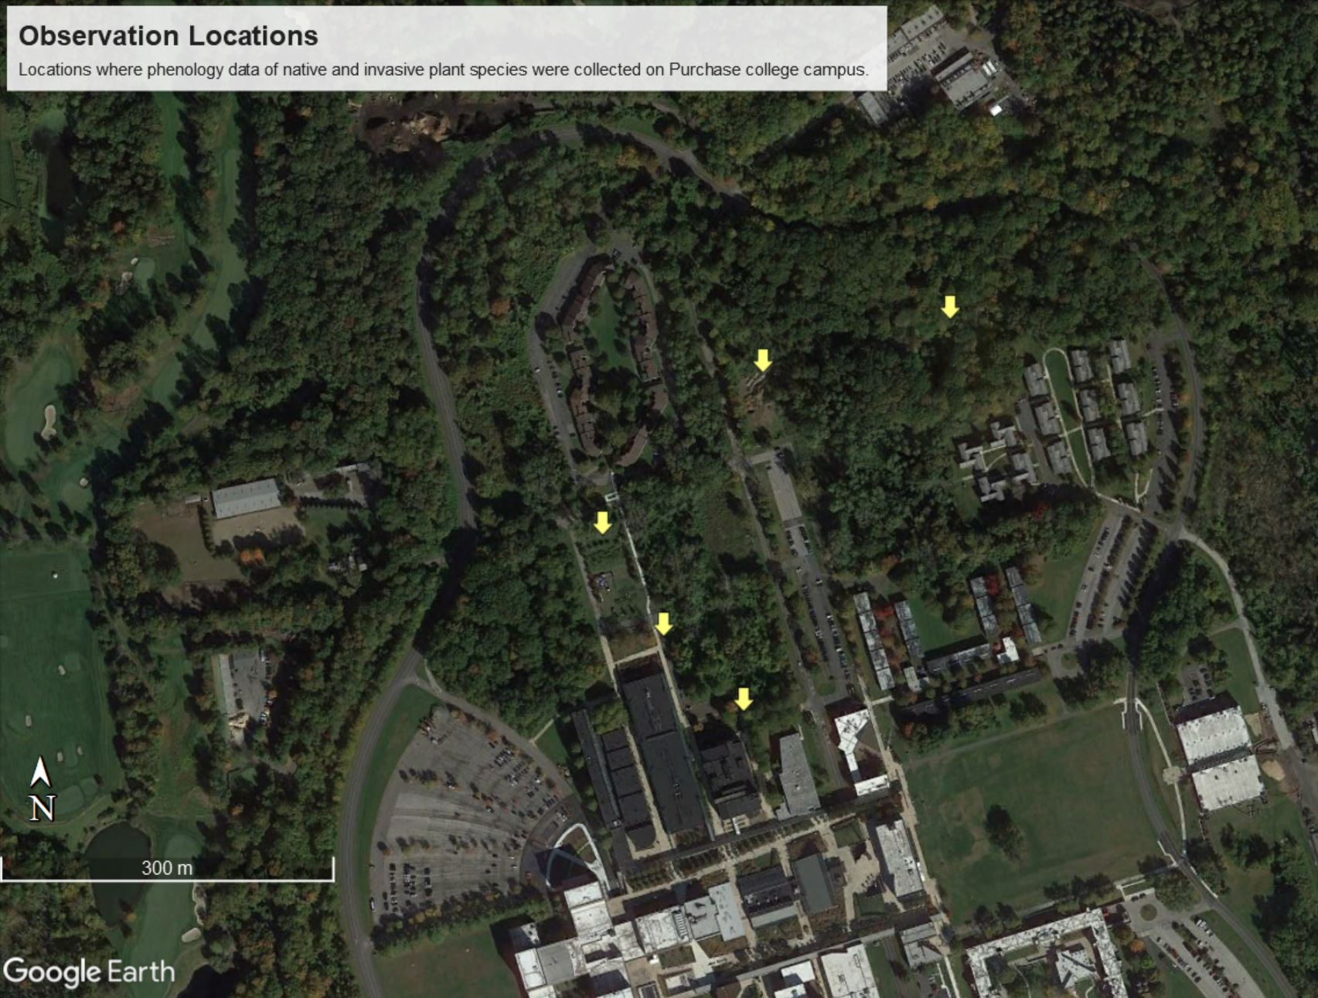
Field collection. To collect our data in the field, we used the phone application Budburst to guide us in visually collecting data. With that knowledge we observed the presence of flowers, food sources (fruit or seed), leaves, and invertebrates. We also observed the extent to which the plant or tree was withered on a scale of 1 – None (or no withering) to 5 – All (being fully withered). Furthemore, we observed the color of the leaves as they progressed from green to brown. Green being most alive, yellow being started to wither/die, and brown being all withered/dead. To get these observations for tall trees we used binoculars to analyze these attributes. Our observations were made visually rather than having specific measurements for each category. All of these attributes were then written down in a notebook. We used the camera/phone as a way to take pictures of the plants we were observing and compare the pictures through time. To collect invertebrates, we used a beat sheet and an aspirator for collection. We placed those invertebrates in labeled empty vials and then in a cooler to count the quantity later in the lab.
Figure 1. Map of the locations where data was collected on Purchase College campus

Data analysis and lab work. When in the lab we input the data and observations noted in the field collection into an excel sheet. The categories on excel were the same as the ones previously mentioned (species, invasive or native, presence of flower, presence of food source, presence of leaves, leaf color, the amount the species withered if at all, and quantity of invertebrates found). We put the current collection of invertebrates in the freezer, and took out the previous collection to count the quantity for our Excel sheet. We continued this process for the rest of our observation period.

RESULTS
Out of the 4 days of observations and data collection, we observed a general phenological trend of invasive species surviving longer through the changing of the seasons than the native species. Overall, there was not too much variation on the availability for food sources. The plants that produced flowers contained a food source up to the point of the flower being fully withered. This appeared to be relatively consistent between both native and invasive species throughout our weeks of observation. The only plants containing a food source by our last day of observation were the invasive Mugwort, Japanese Knotweed, and Callery Pear tree (Table 1). The only native plant to still contain a food source was the Northern Spicebush. This supports our hypothesis that the invasive species would continue to thrive in late fall/early winter (Table 2).
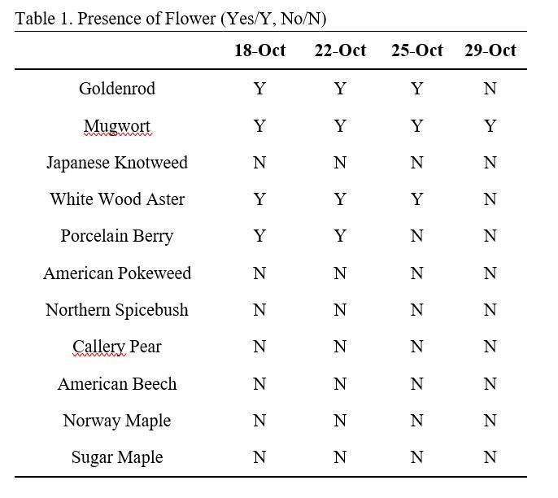
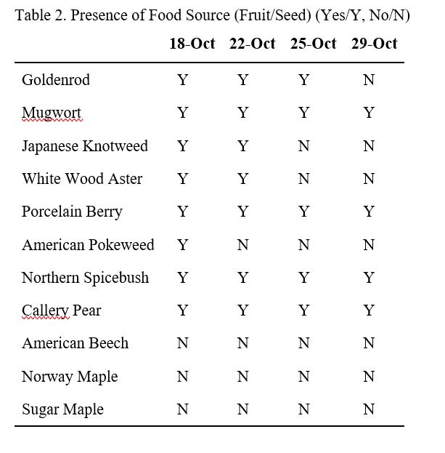Tables 1-2: These tables show if the plant species did or did not have the presence of flower or food source.
As we monitored the progression of leaf off in each species, we observed that the native species of both plants and trees started with fewer leaves overall from day 1 of our observations (Fig. 2.) Invasive species started with most or all of their leaves from day 1 of our observations. Northern Spicebush was the only native plant on day one to contain most of its leaves and ended with most of its leaves on day 4. As you can see, all of the invasive plant species ended with the same level of leaf presence that the native species started with on day 1. By day 4, there was a drastic drop in leaf presence in native plant species as compared to the invasives. We observed the same trend in native and invasive tree species. By day 4 of observations, native trees only had some to few leaves remaining whereas invasive trees had most to some of their leaves remaining.

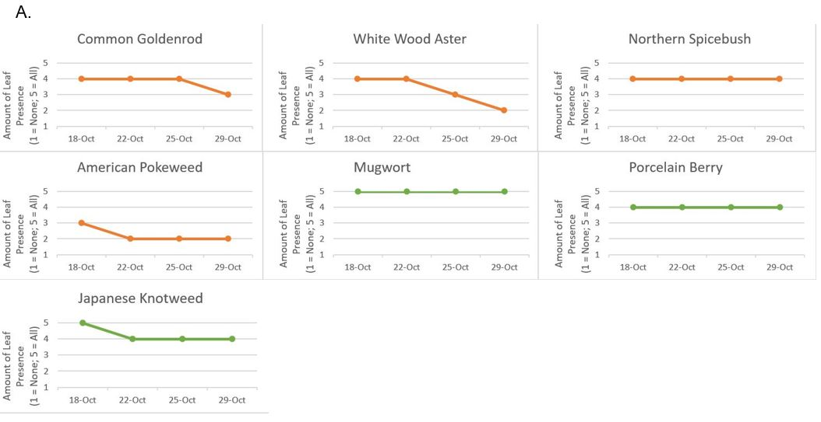
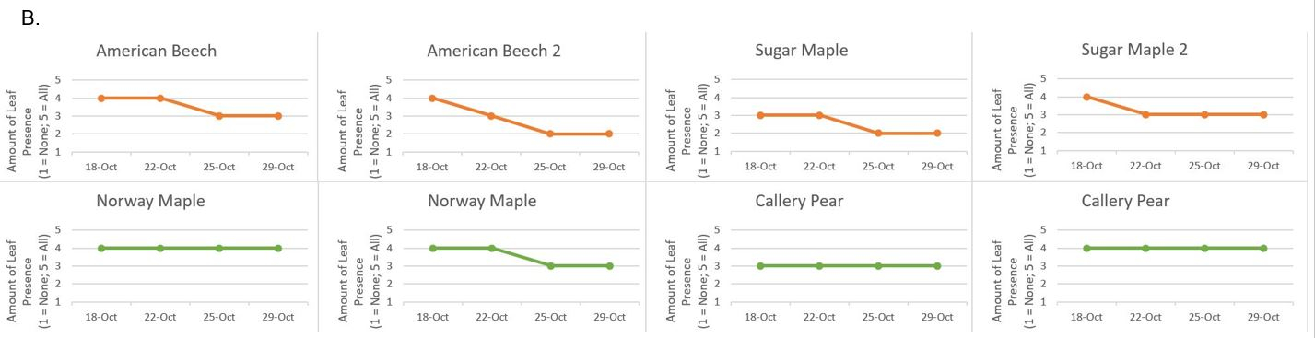
Figure 2 A-B: These graphs show the presence of leaves throughout the observation period in native species as compared to invasive species. Fig 2A. represents shrubs, Native Fig 2B. represents trees. Species. Native species ended the observation with more leaf off than invasive species.

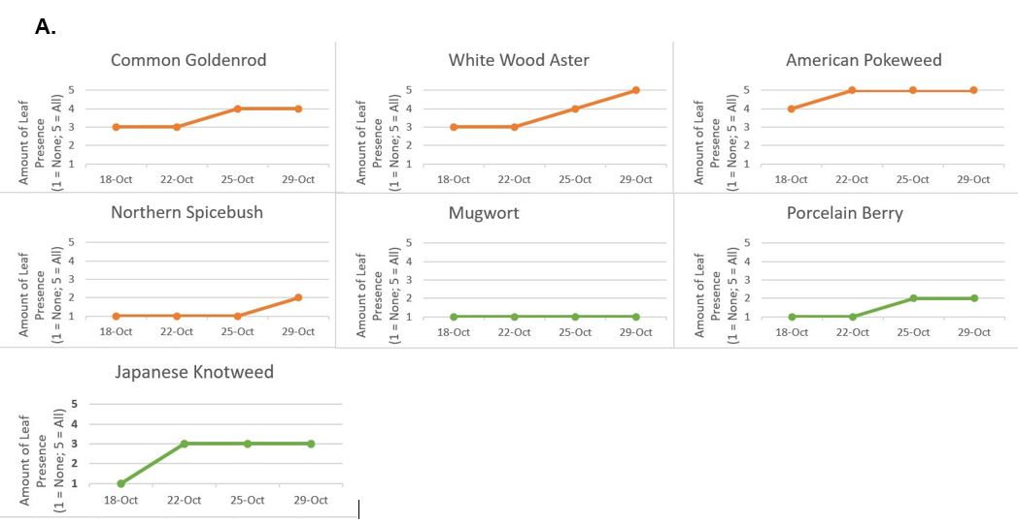
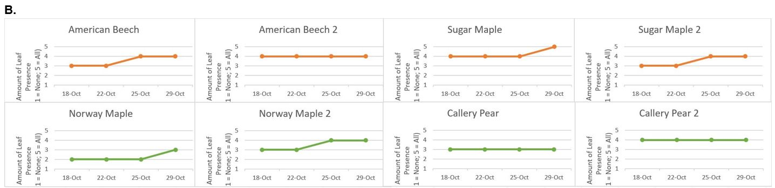Figure 3: Graphs represent the progression a species had withered while being monitored from Oct 18 through Oct 29. Fig 2A. represents shrubs, Native Fig 2B. represents trees. Species. Invasive species ended the observation period being much less withered than the native species.

The amount a plant or tree was withered did not always correlate to the number of leaves present. For example, American Pokeweed still had leaves remaining even though all of the leaves were completely withered. Overall, as the weeks progressed, the American Beech trees and the Sugar Maple tree leaves were much more withered than the Norway Maple trees & the Callery Pear trees by day 4 (Fig. 3.). The most noticeable difference in the amount of withered-ness between native and invasive species was in the plants. Invasive Japanese Knotweed and Porcelain Berry had very little withering by day 4. Invasive Mugwort was not withered at all. All of the invasive species’ leaves remained mostly green throughout the weeks of monitoring. As for the native plants, by day 4 they were mostly or all withered. Except the Native Spicebush just started to experience withering by day 4. The other days of observation Native Spicebush remained completely green and un-withered. Native Goldenrod and Aster slowly started to wither as the weeks progressed. Their leaves also changed from green to green and yellow to yellow the more they withered. American Pokeweed was completely withered and brown from the very start of our observations (Fig. 4.).
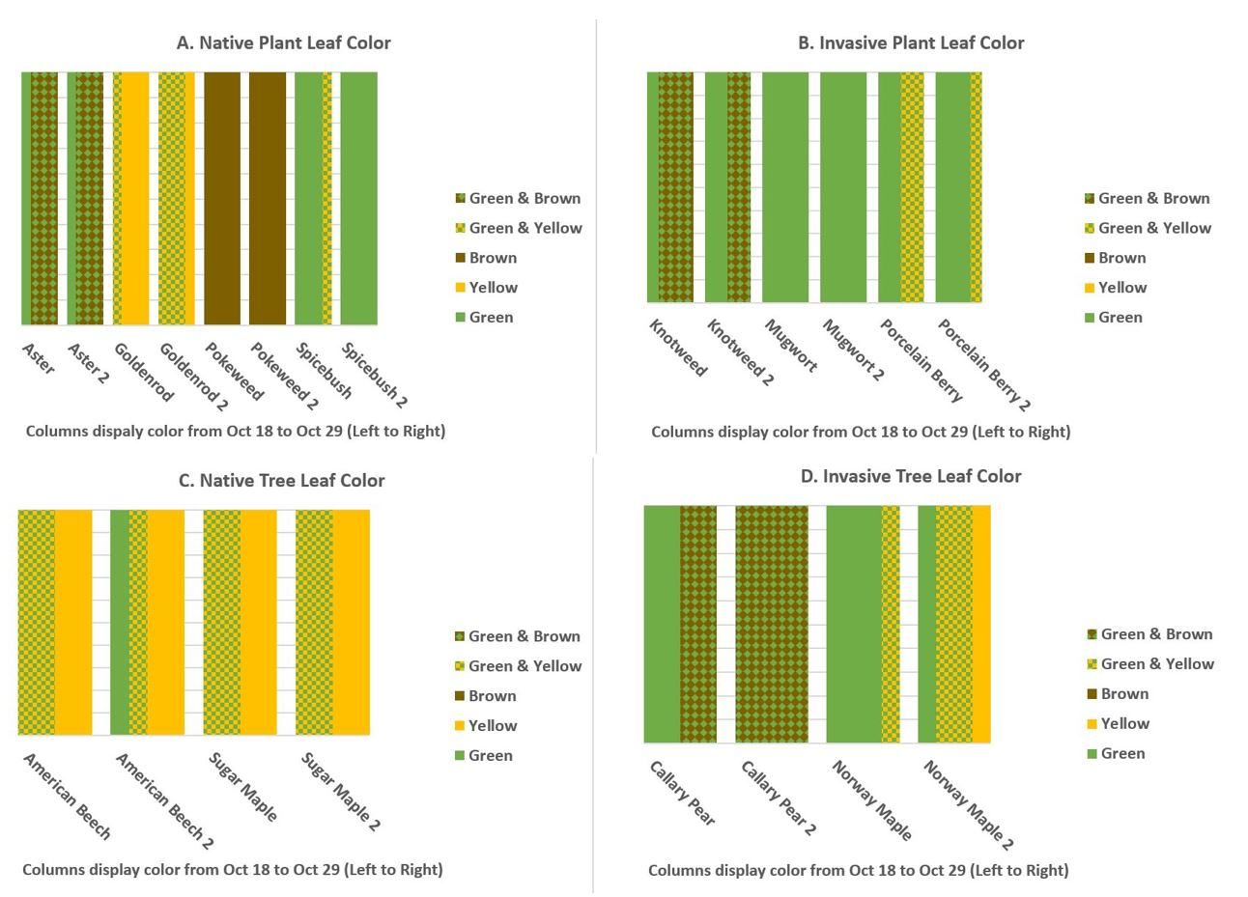
Figure 4: Graphs A-D illustrate the gradual change in leaf color in the native and invasive species observed. All green showing no change in the leaves at all. Green & brown or green & yellow showing some change. All yellow and all brown showing complete change in the color of the leaves.
Throughout our weeks of observing the phenology of native and invasive species, we also monitored the number of insects to determine which type of species was still being utilized by invertebrates as the weeks got colder. The total number of invertebrates found on all native species we observed was 64. The total number of invertebrates found on all invasive species we observed was 120. Overall, the hearty invasive species seemed to be the most utilized (Fig. 5.). Invasive Mugwort was the most favorable plant with a total number of 44. However, Northern Spicebush was the most favorable native plant with a total number of 34, almost equivalent to the second favorite invasive Japanese Knotweed, which has a total number of 35. However, the tree species we observed did not show much variation in invertebrates as it was difficult to find many insects solely on the bark.
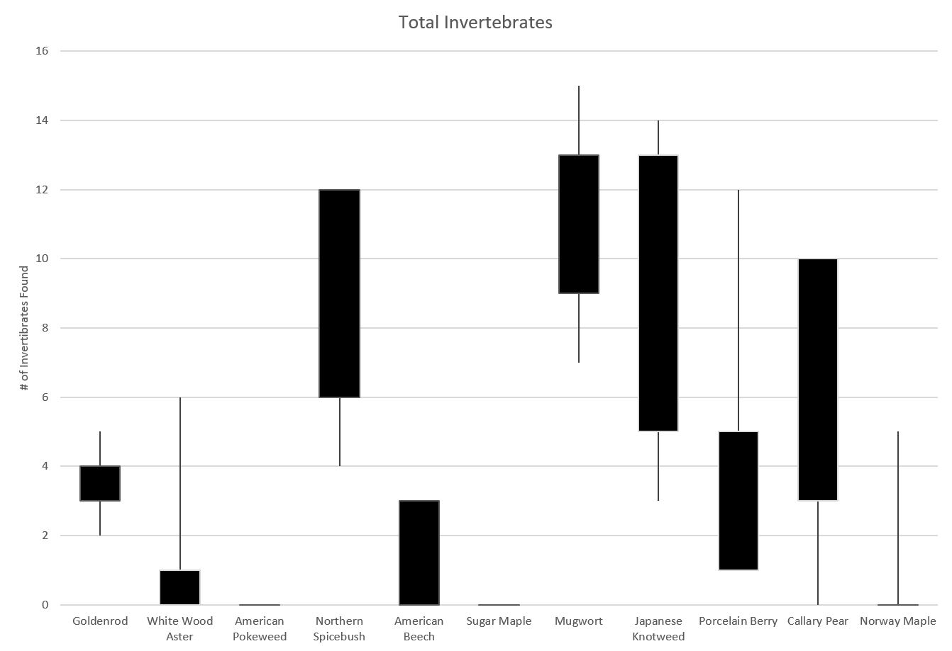
Figure 6: The comparison of the total number of invertebrates found on both native and invasive species. There were many more invertebrates found on invasive species than native species over the course of our observations.

DISCUSSION
Throughout our data collection, we extracted data that seemed to correspond with our hypothesis. It was successful and suggested that invasive plants do out compete in many situations. Although our study would yield greater results with more replicates of data over a longer period of time, our results have supported our hypothesis that the phenology of invasive species progresses slower for early to late fall than native species. The invasive species contained food sources and other resources such as shelter for many invertebrates later in the season. We saw a significantly larger quantity of invertebrates on our invasive plants than our native plants (Fig. 5.). Our research showed that invertebrates are more likely to make habitat selection on non-native plants than native plants, creating large populations in the area. Studies such as this have shown that an abundance of non-native grass can greatly improve insect diversity in a given community (Metcalf 2015).
Unfortunately, our research contained a fair share of inconsistencies. The weather was a factor that affected our data collection. Throughout our observation period, there were weather events such as rain, humidity, and wind. Populations of invertebrates that select habitat in forested areas heavily rely on their host plants for survival and will decline when disturbed by weather related events (i.e rain) (K.J. Gandhi et al 2007). We also hypothesize that weather we experienced affected the quantity of our invertebrate collection among other things. Other things that were not consistent throughout data collection was we did not establish a standard timeframe in which data was required to be collected. Some days we collected data in the afternoon, and other days collected in the early morning. Although the time of day was not consistent every day of collection, there was an even split between afternoons and mornings. There were 2 days we collected data in the afternoon at about 12:30 PM and 2 days we collected data early in the morning at about 9 AM.
Our largest inconsistency was the time we took to collect invertebrates from each species. We did not set a standard amount of time for which we would use our beat sheet at each species. For example, Goldenrod 1 might have had beat sheet collection for 1 minute where Goldenrod 2 might have gotten beat sheet for 2-3 minutes. This affects how much time we allow for invertebrates to fall onto the beat sheet, thus causing a large variation in the number of invertebrates that could have been collected and providing inconsistent data. If we were to recreate this study, there would need to be standards set on data collection days, times, length of times etc. in order to get better samples to best represent the non-native and native species we selected.
When doing a study on the phenology of plants we must consider how climate change may impact those phenological changes. Climate change can affect native species phenology differently from non-natives, potentially causing cascade effects on native populations (Raymundo 2021). This is important because it directly affects how the plants and invertebrates will behave. From early to late fall, we found that the phenological traits of native plant species wither sooner than invasive plants. This suggests that the invasive species we observed have a higher longevity in this non-native environment. Climate change is affecting when seasons change, the average temperature during a given season and the phenological shifts of plants are driven predominantly by climate variability and change (Fitchett et al 2015). One could hypothesize that this gives the advantage to the invasive species as they are more tolerant of these non-native conditions, allowing them to continue growth while native plant populations could decline. For example, some invasive species can be affected by rainfall which can change according to climate changes. Average rainfall conditions will greatly impact the spreading of invasive and native plant species (Raymundo 2021). This could benefit invasive species as it causes more spreading of their species. Furthermore, climate change is affecting the dispersal of invasive and native species. Invasive species, though durable, cannot always withstand the intense effects of climate either. Because of this, it will force native and non-native species to relocate to potentially the same area, forcing competition. Therefore, these invasive species will continue to invade other parts of the non-native ecosystems they have biologically invaded (Wang 2021). This invasion will likely end with invasive species winning the battle against native species.
Initially this study was inspired to observe how climate change affects the phenology on native and non-native plant species. However, because climate change is a very long and ongoing process, a phenology study on climate change needs to be observed over years, with much more data to be collected. The reason for recording data for several years would be to better understand the timeline of climate change. It would also be interesting to perform the same experiments from winter to spring, to observe if bud burst occurs earlier in native or non-native plant species.

CONCLUSIONS
Biological invasions of invasive species to non-native environments have been and will continue to be a growing threat to global ecosystems. However, these species can provide potential benefits to their new environments. Therefore it is important to conduct studies such as phenological trait studies, to further understand if a non-native species is beneficial or harmful to the ecosystem. Especially to protect native plant species as they are pivotal to our native ecosystems. As seasons change from summer to winter, the phenology of plants changes to wither until the next bud burst season. Observing these changes is an important point in the year for native and invasive species, as some will thrive longer than others giving them an advantage to continue to thrive and expand their populations later in the fall season. Our research concluded that the invasive plant species we observed will change phenologically at a slower rate than natives thus providing benefits, such as invertebrate habitat. The reasoning for this is because native plants have changed earlier in the fall. In conclusion, because of their fall phenological traits invasive species may greatly improve insect biomass and biodiversity, even though they pose threats to native plant ecosystems.

ACKNOWLEDGEMENTS
To coffee: for fueling our souls through late night revision sessions. We would also like to acknowledge Oliver Gunderson: a budding entomologist who assisted in invertebrate collection. And of course, thank you to Dr. Jackson for all of your guidance.

AUTHOR CONTRIBUTIONS
Conceptualization (all), Data collecting (all), Data input (all), Data analyzation and organization (JO), Abstract (all), Introduction (JO, SA), Methods (SA), Results (JO), Figures and Tables (JO), Discussion (JL), Conclusion (JL), Editing (all)

LITERATURE CITED
Bustamante, E., and A. Búrquez. 2008. Effects of plant size and weather on the flowering phenology of the organ pipe cactus (Stenocereus thurberi). Annals of Botany 102(6): 1019–1030.
Casey, C. 2013. The Norse Invader. Landscape Architecture Magazine 36–38.
Cattau, Christopher E., Fletcher, Robert J. Jr., Kimball, Rebecca T., Miller, Christine W., Kitchens, Wiley M. 2017. Rapid morphological change of a top predator with the invasion of a novel prey. Nature of Ecology & Evolution. Vol. 2, pages108–115
Chapman, Peter M. 2016. Benefits of Invasive Species. Marine Pollution Bulletin Vol. 107 Issue 1, p1-2. 2p. DOI: 10.1016/j.marpolbul.2016.04.067
Charrier, G., and T. Améglio. 2011. The timing of leaf fall affects cold acclimation by interactions with air temperature through water and carbohydrate contents. Environmental and Experimental Botany 72(3): 351–357.
Chicago Botanic Garden. 2021. (Version 1.0.49) [Mobile app]. App Store. Google Play https://budburst.org/the-app
Fitchett, J. M., S. W. Grab, and D. I. Thompson. 2015. Plant Phenology and climate change. Progress in Physical Geography: Earth and Environment 39(4): 460–482.
Gandhi, K. J. K., D. W. Gilmore, S. A. Katovich, W. J. Mattson, J. R. Spence, and S. J. Seybold. 2007. Physical effects of weather events on the abundance and diversity of insects in North American forests. Environmental Reviews 15(NA): 113–152.
Gordon, D. 1998. Effects of Invasive, Non-Indigenous Plant Species on Ecosystem Processes: Lessons from Florida. Ecological Applications. 8. 975-989. 10.2307/2640955.
Guillerme, S., H. Barcet, N. de Munnik, E. Maire, and C. Marais-Sicre. 2020. Evolution of traditional agroforestry landscapes and development of invasive species: Lessons from the pyrenees (France). Sustainability Science 15(5): 1285–1299.
Huang, Q., and J. L. Sherald. 2004. Isolation and phylogenetic analysis of xylella fastidiosa from its invasive alternative host, Porcelain Berry. Current Microbiology 48(1): 73–76.
Martin Hejda, Petr Pyšek, and Vojtěch Jarošík “Impact of Invasive Plants on the Species Richness, Diversity and Composition of Invaded Communities.” Journal of Ecology, vol. 97, no. 3, 2009, pp. 393–403. Crossref, doi:10.1111/j.1365-2745.2009.01480.x.
Maynard-Bean, E., M. Kaye, T. Wagner., and E. P. Burkhart. 2020. Citizen scientists record novel leaf phenology of invasive shrubs in eastern U.S. forests. Biological Invasions 22(11): 3325–3337.
Metcalf, J.L . 2015. Non-native grass invasion associated with increases in insect diversity in temperate forest understory, Elsevier 69: 105-112
O’Connell, E., and J. Savage. 2020. Extended Leaf Phenology has limited benefits for invasive species growing at northern latitudes. Biological Invasions 22(10): 2957–2974.
Ormsby, M., and E. Brenton-Rule. 2017. Forest Invasions: A review of global instruments to combat invasive alien species in forestry. Springer International, 3355–3364.
Powell, K., J. Chase, and T. Knight. 2013. Invasive Plants Have Scale-Dependent Effects on Diversity by Altering Species-Area Relationships. Science (New York, N.Y.). 339. 316-318. 10.1126/science.1226817.
Raymundo, M. 2021. Annual rainfall variation and dispersal limitation combine to alter invaded plant community diversity, dominance hierarchies and seeding phenology, Climate Change Ecology 2: 1 - 11.
Thresher, R. E., R. Smith, and J. Cutajar. 2020. Optimizing the impacts of an invasive species on the threatened endemic biota of a remote ramsar site: Tilapia (Oreochromis niloticus) in Lake Kutubu, Papua New Guinea. Biological Invasions 22(9): 2661–2670.
Wang, A. 2021. Potential distributional shifts in North America of allelopathic invasive plant species under climate change models, Plant Diversity, ScienceDirect 1: 1-9.
Westbrooks, R. G. 1998. Invasive Plants: Changing the Landscape of America. Federal Interagency Committee for the Management of Noxious and Exotic Weeds.

