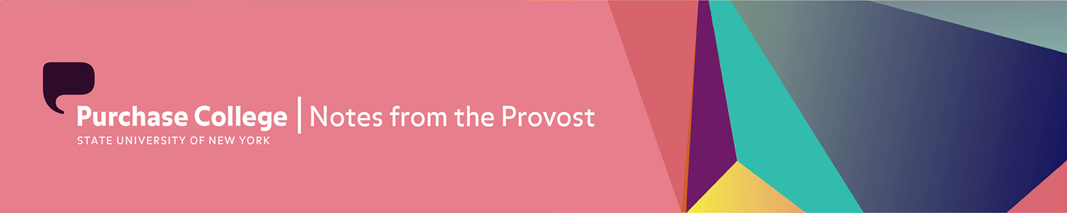

May 14, 2021

Dear Colleagues:

A student once said to me, when I asked where she was from, “I’m from just outside of Normal.” I’ve laughed a lot about this moment because this year has certainly felt just outside of normal. (By the way, the student, Linda, went on to say she was from just outside of Normal, Illinois—which is in fact a real place.)

The discovery that I’ve rediscovered, time and again this past year, is that we know our lives by their routines. Each regimen has its purpose. Each one fulfills a practical and/or spiritual need. Communally, we all feel extraordinarily lost without the daily, weekly, and monthly routines that mark time and play out the progression and sequence of events that make our purpose visible. Most halted in this stall are our students. Resembling the void emanating from their shut off video feeds, many must feel suspended and adrift.

With this in mind, our urgency must reverse its course. What once drove us into remote must be refocused on urgently meeting the in-person needs of our students and community as we come out of COVID. And the needed response is to be back on the campus, engaged in the physical tasks of making education. There is an urgency at work. Foremost, it’s been a very long pandemic. In the lives of our students, the toll is unmistakable.

I would be remiss, however, if I didn’t acknowledge the generosity of everyone at Purchase and thank those who were instrumental in helping the campus remain safe. Thank you to everyone for all the acts of kindness you’ve bestowed on our students to help them during this difficult year. It is especially important to thank all the staff, many of whom turned up almost every work day of the pandemic to serve students and the campus community in a variety of efforts, including surveillance testing, support of students in quarantine, health and wellness work, staffing the library, and instructional support in art and design, dance, music, theatre, natural/social sciences, and film and media studies. Thank you to the OCE staff. Thank you to the building managers who worked overtime, the stagehands who disinfected, and the assistants and PAC staff that doubled up in responsibilities. Thank you to everyone on the Continuity of Programs and Services Task Force. And a big debt of gratitude to everyone in HR and operations who ran the testing program, while also assuring employees’ needs were met, and made every effort to pump clean air into buildings, track down safety information, and keep things running. Your undertakings were immense.

NEUBERGER MUSEUM
We would like to remind everyone that the Museum is now open to the campus community on Wednesdays, Thursdays & Fridays from 12pm - 5pm. You will need your MORE card and a daily COVID screening submission to enter. If you’d like to a setup a class visit, please email nma.education@purchase.edu.

Also, checkout our recent NEU Student Voices blog that takes you through the newly reopened Museum from the perspective of a Purchase College Student.

First Through the Doors
Last week I had the opportunity to be one of the first students to walk back through the Museum’s doors after over a year of the building being closed to the public. As a remote student, being back on campus felt surreal, but as soon as I walked back through the exhibits at the Neuberger I felt like I was back home as a campus resident once again.

PERFORMING ARTS CENTER
Staying Connected: Spring 2021 Programs for K-12

Programming for K-12 audiences has always been a big part of the work being done at The PAC. Their efforts to deliver arts experiences to young people via school time performances and in-class learning have continued this spring, but in a whole new way.

Ian Driver, Manager of Education and Engagement, has put great care into curating a season of engaging and inspiring performances. As always, The PAC’s school time performances include easy-to-use tools for exploring curriculum, supporting social-emotional learning, and activating creativity. But this season, they are all available entirely online. And, as a gesture of support to teachers, parents, and children in recognition of their dedication and hard work throughout the pandemic, the whole K-12 virtual field trip season can be experienced by students throughout the region free of cost.

The PAC's work in the classroom also continues with StorySeekers, a program partnership with the AIE Practicum course taught by Janis Astor Del Valle, Assistant Professor of Practice in Arts Management. Students enrolled in the course have been working (virtually) with the 5th grade community in Peekskill's Hillcrest Elementary School, implementing arts-based lesson plans that they have created. Building on the academic focus of The PAC’s previous work - critical literacy, storytelling, theater, and creative writing - the program has provided opportunities for mentorship and college awareness conversations alongside the arts and academic engagement for both sets of students.

To date, over 9,500 students representing 500 classrooms from 27 schools have participated in The PAC's virtual K-12 programming. While we miss seeing the kids here on campus, it is so gratifying to know that the arts are still thriving in our local schools, thanks in no small part to the dedicated team at The PAC.

