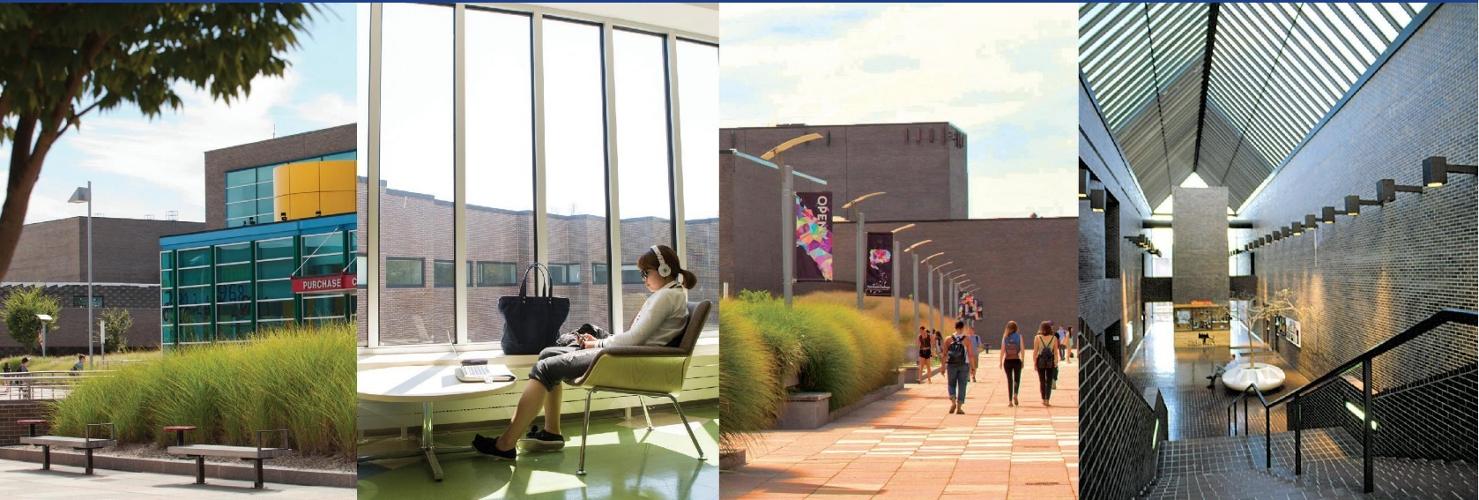

Tools for Success:
Self-Marketing and Résumés
Job & Internship Seekers Guide

Career Development Center
career.development@purchase.edu
Instagram: @purchasecdc

A well-planned and executed job search campaign takes time.

In fact, even in the best of job markets, most people need about 3-6 months to actually locate their first full-time position after graduation. It makes good career sense to “be ready” should a great opportunity come your way, even when you are not actively seeking jobs. When it comes to speeding up one’s job search, those with a strong “personal brand” and networking skills are more likely to get a “foot in the door” of the organization. A primary goal for your job search campaign is to create awareness and to help build relationships. The Purchase College Career Development Center helps students build their personal job search campaign with connections to networks, tools, resources, and valuable career services.

One of the first steps to launching an effective job or internship search is to ask yourself the following questions:

- What am I searching for? (job, internship)
- In what field do I want to find work?
- What skills do I have to offer?
- What kind of organization am I interested in?
- Where can I find the employer contacts and resources?
- Have I met with a career counselor/coach yet who can help me?

Whether you are seeking full-time work, part-time or summer jobs, internship opportunities or other career-related experiences, the Career Development Center is here to help you, each step of the way.

When you need assistance with writing your résumé, tailoring your cover letters, sharpening your interviewing skills and networking techniques, or organizing and developing your job search strategy, you’ll find the search tools necessary in this guide and through our services.

Remember, the dedicated career counselors at the Career Development Center are here to assist you as you begin your job or internship search.

Résumé Guidelines & Samples

The main purpose of a résumé is to persuade a potential employer to interview you. It is a summary of your abilities, accomplishments, and experiences. This is an introduction to writing your basic job/internship search résumé:
- One-page résumés are preferred for most fields. (Two-page résumés are appropriate if you have a great deal of relevant experience)
- Keep your formatting clear and consistent.
- Have others proofread for clarity, grammar, and spelling (make an appointment with a Career Counselor).
- Customize your résumé based on each job you are applying for using keywords from the job description.
The following categories are typically included in a résumé however, your particular situation will dictate those that are most appropriate for you. See also basic information to include for each category and additional tips.
Name/Contact Information | - Full name and/or preferred name  - Address (can be just town/state)  - Phone number and email address | - URL to your website, portfolio, blog, professional social media  - Use appropriate email (name, initials)
Qualifications Summary  (optional) | - Highlight key skills and expertise  - Snapshot focused on the position | - Can be bullets, a brief paragraph, or  both
Education | - Institution, school/conservatory, location, degree, (expected) grad date  - All majors/minors; GPA if above a 3.0  - All relevant institutions; study abroad | - Specialized training/ workshops/ instruction in your field  - Senior Project/ Thesis (if it doesn’t fit into another category)
Related Coursework  (optional) | - Coursework- even if outside your major - that is relevant to the position | - Be sure to focus this section on what you are applying for
Experience | - Paid employment, internships, and more  - Organization name, location (city/state), job title, dates of employment (month/year – month/year), and a brief description  - Use concise and concrete descriptions; Action verbs to describe  - Specific relevant details of the experience | - Emphasize results/accomplishments  - Don’t lead with “Duties” or “Responsibilities”; avoid “I” statements  - Demonstrate what you accomplished  - Include transferrable and career  specific skills/experiences  - Quantify when you can - show results
Related Experience/  Professional Experience | - Can be a separate section that focuses on relevant experience | - Can separate into individual sections (see below)
Additional Experience Sections (optional) | - Freelance | Gigs | Projects  - Exhibits | Performances  - Teaching | Fellowships | Residencies | - See the résumé examples in our Artist’s Guide for additional résumé categories for artists
Skills | - Computer, language, and related skills  - Characterize ability level: “basic/ conversational/ fluent,” “familiar with,” “knowledge of,” or “proficient in” | - Skills specific to your field  - Skills may be broken down into  separate categories or sub categories
Honors and Awards  (optional) | - Honors, scholarships, or awards you have received | - Educational, community and outside organization honors
Activities/Leadership/  Athletics (optional) | - Student organizations, student government, athletic teams, and other involvement | - Emphasize leadership roles, if any  - Can be listed under Experience instead  if related
Volunteer/Community Service (optional) | - Steady or sporadic volunteer experience/service learning | - If steady (ex: once a wk. for 6 m) can  be included in Experience instead
Interests/Hobbies  (optional) | - Adds a personal dimension to the résumé that can’t be expressed in another section | - Travel experience may be included  - Show career focus in other areas

Amy Williams
Middletown, NY ∙ (555) 555-5555 ∙ amy.williams@email.com

EDUCATION
Purchase College, SUNY - Purchase, NY
Bachelor of Arts, Expected Month Year
Majors: Mathematics/Computer Science and Economics, G.P.A. 3.7
Honors: Merit Scholarship, Dean’s List All Semesters
Senior Thesis: Include Title. Can include an experience section instead if relevant

RESEARCH (or PROJECTS)

Title (Senior Project, Other Research, Class or Other Project) Mo/Year-Mo/Year
Describe the research/hypothesis, your role, how you collected and analyzed data and the outcome
Describe the project, including skills used/developed

EXPERIENCE

JP Morgan Chase-New York, NY Commercial Banking Analyst Intern Mo/Year - present
- Support bankers and provide support for commercial clients
- Research prospective clients and assist manager with building and fostering client relationships
- Conduct and analyze market research and recommend strategies to team

Math Enrichment Program-Middletown, NY Teacher’s Assistant Summer Year
- Prepared for and co-taught mathematics lesson twice a week
- Facilitated student learning through individual and group activities

Cypress Services-White Plains, NY Business Analyst Intern Mo/Year - Mo/Year
- Assisted with data analysis activities including data structuring and data collection
- Worked with project managers to identify, analyze and resolve project related issues
- Prepared and maintained project reports, goals, and provided ongoing status reporting

LEADERSHIP

Purchase College, Latinos Unidos President Year - present
- Facilitate weekly meetings and plan social and educational events with the executive board
- Collaborate with off-campus organizations to increase involvement with the local community
Purchase College, Economics Club Treasurer Year - present
- Manage club finances and allocate funds for events and programming
Residential and Student Life Orientation Leader Summer Year
- Engaged and acclimated new students and their families to Purchase College

SKILLS

Java, C++, PHP, MySQL, HTML, CSS; Microsoft, PowerPoint, Excel, Familiarity with Bloomberg
Fluent in Italian, Working knowledge of Spanish

ADDITIONAL EXPERIENCE

Purchase College Library-Purchase, NY Student Assistant Mo/Year - present
Applebee’s-Goshen, NY Host Summers Year - Year

VOLUNTEER EXPERIENCE
Big Brothers Big Sisters Mo/Year – present
Salvation Army Summers Year – Year

Résumé Sample Peter Parker - Journalism

Canva Public View Link for Peter Parker

Résumé Sample Clark Westfield: Sociology, Film/Video Production
Canva Public View Link for Clark Westfield

Career Changer

Review past experience, education, and transferable skills to evaluate how to re-position and re-brand your background. It’s important to understand what is considered most important in a new career field.

K. Berger
Queens Village, New York 11427 | (914) 555-0000 | KBerger@mail.com

Educator / Trainer

Over 10 years of experience in providing therapeutic counseling and educational wellness training.
Foster an environment where clients/students can participate in the process of learning and growing.
Awarded “Top Achiever in Wellness Training” for three consecutive years.

PROFESSIONAL CERTIFICATION
New York State Teaching Initial Certification, Biology 7-12 Expected Month, Year

SUMMARY OF QUALIFICATIONS & SKILLS
- Established highly effective communications with students and parents
- CPR Certified, EMT Certified, Recreation Therapy Trained
- Conversational Spanish
- Proficient User of Microsoft Word, Excel, Outlook, JASP, SPSS
EDUCATION
Queens College, CUNY, Queens, NY M.S. Ed General Science Expected Month, Year

Purchase College, SUNY, Purchase, NY Bachelor of Arts Month, Year
Major: Psychology Minor: Biology
PROFESSIONAL EXPERIENCE
Queens Children’s Psychiatric Center Queens Village, NY
Caseworker- Intake Department Month, Year- Present
- Conduct intake interviews with psychiatric social worker
- Facilitate wellness training and nutritional counseling for clients
- Assist psychiatrist with psycho-social research analysis
- Provide counseling assistance as needed

Whispering Pines Nursing Home Bayside, NY
Recreation Therapist/Wellness Trainer Month, Year- Month, Year
- Effectively engaged, planned and developed recreational activities for residents
- Trained new therapists in therapeutic interventions used to enhance psychomotor skills
- Instructed residents in wellness strategies including daily exercises
Yonkers High School Yonkers, NY
Teaching Assistant Month, Year- Month, Year
- Tutored high school juniors in biology lab assignments
- Graded and edited term papers and exams
- Proctored Biology Regents exams with teachers as assigned
ADDITIONAL EXPERIENCE
Baltimore Aquarium, Marine Life Exhibits Baltimore, MD
Biology Research Intern/ Tour Guide Month, Year- Month, Year
- Conducted tours for visitors, including Middle and High Schools
- Assisted in research of endangered marine life
- Identified species, collected data
- Reported analysis of local environmental impact

American Museum of Natural History Museum Store New York, NY
Customer Service Representative Month, Year- Month, Year
- Provided information to museum visitors and assisted the with their purchases

PROFESSIONAL AFFILIATIONS
The New York Academy of Sciences, Member Month/Year - Present
National Academy of Sciences, Member Month/Year - Present
National Science Foundation, Committee Chair Month/Year - Present
National Science Foundation, Member Month/Year - Month/Year

Summary of Qualifications

When highlighting a job seeker’s key skills and expertise in a chosen career field, a “Summary of Qualifications” section can be an effective alternative to an “Objective” or “Goal Statement.” It can be formatted as a brief paragraph or 3-5 bulleted statements. This section allows employers to immediately see a snapshot of the candidate’s key qualifications for the position to which they are applying, and can be a strategic and powerful marketing tool.

Below are examples of Summary of Qualifications’ sections on a résumé, also labeled as “Profile,” “Professional Profile,” or “Professional Summary.”

SAMPLE 1:
Social Media Marketing Professional

- Dedicated and creative marketing professional with exceptional skill in strategic outreach and connection with client-base.
- Recognized for exemplary interaction and record number of followers.
- Increased profitability by 57% within two-year period, through extensive social media outreach.
- Awarded “Outstanding Social Media Strategist” title for 3 consecutive quarters.

SAMPLE 2:
Professional Summary

Over 6 years of experience in the film industry as editor, production coordinator, production assistant, and director. Proven ability to thrive in a fast-paced environment that requires flexibility, adaptability, and a sense of humor. Notable experience with top networks such as NBC, Comedy Central, and Disney Channel. Winner of “Honorary Short Film Award” in the 2024 Greenwich Film Festival.
Core Competencies:
- Film and Video Shooting
- WavePad, Audacity, Adobe Audition
- Avid Media Composer, Adobe Premiere Pro, Adobe After Effects
- Directing and Producing Short Films
- Proficient in Microsoft Excel, Word, Outlook; Windows and MAC OS

Action Verb Suggestions for Preparing Your Résumé
Use present tense verbs for current positions/activities and past tense verbs for those which have ended

Management/ Leadership Skills

Administered
Analyzed
Appointed
Approved
Assigned
Attained
Authorized
Chaired
Considered
Consolidated
Contracted
Controlled
Converted
Coordinated
Decided
Delegated
Developed
Directed
Eliminated
Emphasized
Enforced
Enhanced
Established
Executed
Generated
Handled
Headed
Hired
Hosted
Improved
Incorporated
Increased
Initiated
Inspected
Instituted
Led
Managed
Merged
Motivated
Organized
Originated
Overhauled
Oversaw
Planned
Presided
Prioritized
Produced
Recommended
Reorganized
Replaced
Restored
Reviewed
Scheduled
Secured
Selected
Streamlined
Strengthened
Supervised
Terminated

Communication & People Skills

Addressed
Advertised
Arbitrated
Arranged
Articulated
Authored
Clarified
Collaborated
Communicated
Composed
Condensed
Conferred
Consulted
Contacted
Conveyed
Convinced
Corresponded
Debated
Defined
Described
Developed
Directed
Discussed
Drafted
Edited
Elicited
Enlisted
Explained
Expressed
Formulated
Furnished
Incorporated
Influenced
Interacted
Interpreted
Interviewed
Involved
Joined
Judged
Lectured
Listened
Marketed
Mediated
Moderated
Negotiated
Observed
Outlined
Participated
Persuaded
Presented
Promoted
Proposed
Publicized
Reconciled
Recruited
Referred
Reinforced
Reported
Resolved
Responded
Solicited
Specified
Spoke
Suggested
Summarized
Synthesized
Translated
Wrote

Research
Skills

Analyzed
Clarified
Collected
Compared
Conducted
Critiqued
Detected
Determined
Diagnosed
Evaluated
Examined
Experimented
Explored
Extracted
Formulated
Gathered
Identified
Inspected
Interpreted
Interviewed
Invented
Investigated
Located
Measured
Organized
Researched
Reviewed
Search
Solved
Summarized
Surveyed
Systemized
Tested

Technical Skills

Adapted
Applied
Assembled
Built
Calculated
Computed
Conserved
Constructed
Converted
Debugged
Designed
Determined
Developed
Engineered
Fabricated
Fortified
Installed
Maintained
Operated
Overhauled
Printed
Programmed
Rectified
Regulated
Remodeled
Repaired
Replaced
Restored
Solved
Specialized
Standardized
Studied
Upgraded

Teaching Skills

Adapted
Advised
Clarified
Coached
Communicated
Conducted
Coordinated
Critiqued
Developed
Enabled
Encouraged
Evaluated
Explained
Facilitated
Focused
Guided
Individualized
Informed
Instilled
Instructed
Motivated
Persuaded
Set goals
Stimulated
Taught
Tested
Trained
Transmitted
Tutored

Financial/
Data Skills

Administered
Adjusted
Allocated
Analyzed
Appraised
Assessed
Audited
Balanced
Budgeted
Calculated
Computed
Conserved
Corrected
Determined
Developed
Estimated
Forecasted
Managed
Marketed
Measured
Planned
Prepared
Programmed
Projected
Reconciled
Reduced
Researched
Retrieved

Creative Skills

Acted
Adapted
Began
Combined
Composed
Conceptualized
Condensed
Created
Customized
Designed
Developed
Directed
Displayed
Drew
Entertained
Established
Fashioned
Formulated
Founded
Illustrated
Initiated
Instituted
Integrated
Introduced
Invented
Modeled
Modified
Originated
Performed
Photographed
Planned
Revised
Revitalized
Shaped
Solved

Helping Skills

Adapted
Advocated
Aided
Answered
Arranged
Assessed
Assisted
Cared for
Clarified
Coached
Collaborated
Contributed
Cooperated
Counseled
Demonstrated
Diagnosed
Educated
Encouraged
Ensured
Expedited
Facilitated
Familiarized
Furthered
Guided
Helped
Insured
Interviewed
Motivated
Prevented
Provided
Referred
Rehabilitated
Represented
Resolved
Simplified
Supplied
Supported
Volunteered

Organizational
Detail Skills

Approved
Arranged
Catalogued
Categorized
Charted
Classified
Coded
Collected
Compiled
Corrected
Corresponded
Distributed
Executed
Filed
Generated
Implemented
Incorporated
Inspected
Logged
Maintained
Monitored
Obtained
Operated
Ordered
Organized
Prepared
Processed
Provided
Purchased
Recorded
Registered
Reserved
Responded
Reviewed
Routed
Scheduled
Screened
Set up
Submitted
Supplied
Standardized
Systemized
Updated
Validated
Verified

Other Accomplishment
Verbs

Achieved
Awarded
Completed
Expanded
Exceeded
Improved
Pioneered
Reduced
Resolved
Restored
Spearheaded
Succeeded
Surpassed
Transformed

Cover Letters

A cover letter should accompany each résumé that is sent out. Cover letters can personalize your application, sometimes making the difference between getting an interview or not. Although cover letters are customized to each employer/job, it is common to share the same ideas you wish to convey in all your letters. Be sure to address each letter to the hiring manager in the department you wish to work. If you cannot locate their name, use “Dear Art Director” or “Human Resource Manager,” but only as a last resort.

First Paragraph:
Why you are writing?

In your initial paragraph, state why you are writing the letter, name the specific position or type of work for which you are applying, and indicate from which you learned of the opening. Highlight your basic skills or experience that relates to the job/internship described.

Second Paragraph:
Why you? -- how are you qualified?

Indicate why you are interested in the position, the organization, its products or services- and above all what you can do for the employer. If you are a recent graduate, explain how your academic background makes you a qualified candidate for the position. If you have some practical work experience, point out your specific achievements or unique accomplishments. Try not to repeat the same information found on your résumé. Attempt to identify what the potential employer is looking for and describe your abilities, skills and accomplishments as they relate to the job.

Third Paragraph:
Why them?

The cover letter should also reflect your knowledge and understanding of the organization. Know who they are and what they do. Add a few lines to demonstrate that you’ve done your homework and connect how you would be a good fit for their organization.

Fourth Paragraph:
Closing

In the closing paragraph, indicate your desire for a personal interview and close your letter with a statement or question, which will encourage a response. Thank them for their time and consideration.

Sample Cover Letter

JQ College
Purchase, NY | (914) 251- 1000 | jcollege@gmail.com

Ms. Maggie Zine
WESTY Magazine
500 Broadway
White Plains, NY 10605 Today’s Date

Dear Ms. Maggie Zine:

I am applying for the position of Retail Relations Coordinator with WESTY Magazine that was posted on Purchase JobScore, Month/ Year. As a student graduating from Purchase College in mid-May, I am very interested in pursuing a career in the promotions and marketing industry.

While taking classes in Journalism and interning at The Journal News, I saw the importance of a well-run promotions department. As the Assistant to the Marketing Director, I assisted in compiling the “Know Westchester” special addition where I contacted potential advertisers and helped them decide what size advertisements to place. At my previous position, I served as Editor of my college publication “The Beat”. My activities within this position included selecting which stories to cover, writing and assisting with news coverage and overseeing the advertising and printing staff. I believe my skills and experience could easily be applied to your publication.

I have been an avid reader of Westy Magazine and I have been continually impressed by the way the magazine has evolved to remain on the cutting edge of the industry. I am aware that you recently expanded internationally; my coursework in Language and Culture has provided me with cultural insight and understanding to contribute to your global efforts.

Attached is my résumé for your review. I look forward to hearing from you and learning more about the team at WESTY. Thank you for your consideration.

Sincerely,
Your Name

Do Not Copy – Be Original
Interviewing Tips

An interview is really a conversation; a mutual exchange of information. Your role during the interview is to promote yourself, market, and sell your skills and qualifications to the employer for a specific position. The interviewer will be trying to learn more about you and determine if you will be a good fit for the job and for the organization. Whenever possible, illustrate your qualities with concrete examples that support them. For example, how have you demonstrated problem solving, team playing, or flexibility? While these are desirable qualities, the candidate who tells a story or gives examples is more likely to be remembered.

Employers want to know:

Can you do the job? Will you do the job? Do you want the job? Will you fit in?

Remember you want to use the interview to:
- Discover information you may not have found during your research
- Provide information that will highlight your accomplishments, and expand upon your résumé/cover letter
- Learn more about the job, position, and company
- Make the interviewer see you as an asset to the organization, and reaffirm the decision to meet you
- Get a second interview

Self-Assessment
This is the most important kind of research. You must know yourself: your strengths, weaknesses, and career goals. Be able to explain your skills as they apply to the position. What contributions can you make to the organization? Be able to give descriptions of how you have and would handle difficult situations professionally.

Research
It is imperative that you go into the interview having researched the organization and the position. Go right to their website to start learning about the organization. Check helpful sites such as LinkedIn and Glassdoor and search for articles and feedback. Check out industry and professional association websites to gather more specific information on salary ranges, and job descriptions. In addition, follow the social media pages of the organization

Dress for Success
When conducting your research, find out about the usual attire in this work environment. Even a photography studio may prefer employee candidates to dress in appropriate interview attire, than what is common for their typical work day. For many industries, a suit or professional attire is the expected apparel for an interview. It is best not to wear cologne or perfume during an interview (some people are allergic) and to keep make-up and jewelry to a minimum. Remember, you want the employer to focus on what you are saying not what you are wearing. Bring a portfolio or professional bag, not a backpack. Flip-flops, sneakers, Crocs, and hiking boots are not appropriate for an interview. Some organizations have a “business casual look” every day and may suggest that dress for the interview. The “casual” look can consist of pants, khakis or dark jeans that fit well; skirts/dresses (at an appropriate length); button down shirts, sweaters, blouses, and blazers. You may be the “boss” someday, so show the employer that you are an excellent fit. Be professional!

Types & Styles of Interviews/Questions

Individual: You are the only one being interviewed. You will be interviewed by one interviewer, a few, or by a panel/committee.
Group: Here you will be interviewing with other candidates to see how you perform in a group setting and it may include a group activity.
Video/Phone: This may be your 1st round interview – it is important. Inflection and talking speed are even more important. Be sure you are in a quiet environment and if on a video call, be aware of what is in the background.

Interviewing questioning styles can also vary- depending on the industry for which you are interviewing. Prepare for each kind and you will better understand the interviewer approach.
Behavioral: Here the focus is on your past in an effort to predict future behavior on the job.
- “Describe a time where you didn’t get along with a colleague”. Briefly talk about a situation and how you successfully overcame the conflict, if there indeed was any.
Situational: This questioning approach is about your future performance. You may be asked here how you would solve a particular problem that might come up.
- Questions might begin with “How might you handle...”
Presentation: You may be asked in a second or subsequent interview to conduct a brief presentation on a topic relevant to the organization. The interviewer may learn how you plan and carry out a task and your ability to communicate effectively.

Interview Day

Before the Interview
Know where you are going. Have your directions printed out, as well as using a directions app. Write down the name, address, and phone number of the person with whom you have the interview, and bring it with you. Have extra copies of your résumé and references.

Face to Face
When you are brought into the interview make eye contact, smile, give your interviewer a handshake and introduce yourself (they will appreciate the correct pronunciation of your name). Be enthusiastic and show your self-confidence. Sit after being asked; maintain your posture with feet on the floor, and smile, as it will hide any nervousness. Don’t play with your hair or bite your nails. Keep your eyes on the interviewer. Be yourself and remember there are no right answers, just good responses.

Closing the Interview
Ask the interviewer if there is anything else they would like to know about your skills or experience. Make sure you let them know how interested you are in the position. Be sure you get a business card from all the people you meet, and ask what the next step in the hiring process is. Find out what the time frame is for making the decision. Shake hands, say “thank you” and smile as you say good-bye.

Follow-up
You should follow-up twice after the interview. The first should be a thank you email within 48 hours. The second should be a call or email two weeks later, depending on the decision-making timeline they provided, (if you have not heard from them) to inquire about the progress of the current search. Remain professional at all times.

Illegal Interview Questions

There are federal, state, and local laws that regulate questions you can or cannot be asked in an interview situation. Any question you are asked should be related to the job you are seeking. Personal questions with a basis on sex, age, race, national origin, disabilities or religion are illegal.

If asked a question that you feel is illegal and you don’t want to answer it you can ask, “Could you explain the relevance of that question to the position?” You can also address what you feel the question is asking. For example, if you are asked if you a US Citizen you can answer by saying “I am authorized to work in the United States”.

Resources: NACE: An Employer’s Guide to Navigating the Hiring Process, 2024 ; USEEOC: Prohibited Employment Policies/Practices

Interviewing Resources

You can practice your interview skills on Purchase JobScore. Go to resources on the top menu to access the Mock Interview tool. Practice answering interview questions with 40 recommended interviews or create a new mock interview on your own from over 1,000 interview questions. You can request feedback of your recorded video answers from a Career Center staff member or you can share a link to your interview with anyone you would like feedback from.

You can also gain interview tips on our CandidCareer Interview Channel.

Typical Interview Questions

When answering questions, keep in mind interviewers ask “open ended” questions and do not want a “yes” or “no” answer. Tell your story through highlights of your accomplishments in previous experiences. Try to tie in these accomplishments and personal qualities to the job for which you are interviewing. Remember to respond to questions with examples that illustrate your point for each question asked.

For Behavioral Questions use the STAR approach and focus on:
Situation: Set the scene and present the situation/challenge
Task: Describe the task you needed to accomplish
Action: What did YOU Do? Describe the action you took and be sure to keep the focus on YOU.
Results: How did your actions affect the outcome? What did you accomplish and learn?

Below is a sampling of questions that you may be asked:

What can you tell us about yourself? Think about why you chose to apply to this position. Focus on experience and education that led you to apply to the opportunity.

Why are you interested in working for us? This question can be easily answered if you have done your research and know who they are. Understand why you want to work for the organization and in that particular position. You can discuss how your skills, interests and experiences are ideal for the position and the organization. Show you are genuinely interested!

What do you think are your greatest strengths? Weakness? Go into the interview knowing some strengths you want to highlight. Be sure you demonstrate to the interviewer(s) how you have used that strength in a way that is relevant to the position. Always give examples! When discussing a weakness, stick to just one! (don’t say “one of my weaknesses is”.) Use conditional and non-absolute words (I “seem” to; it “might” be). Always end on a positive note and how you are working on the weakness. Remember you are human – we all have weaknesses. Just be sure the weakness you discuss isn’t something that may impact on your work performance.

Describe a challenging situation you have faced in your work or school experience. Use STAR! The interviewer wants to know how you problem solve and overcome obstacles. We have all faced a challenge, so be sure to have examples ready before the interview. Pick a situation that was truly a challenge, and where you were a key part of solving the problem and producing a successful outcome.

Tell me about a time you demonstrated leadership skills? Use STAR! Think of an appropriate situation or task. Remember leadership skills can be demonstrated even if you are not the official leader. Focus on the actions and initiatives you took and the outcome that resulted from your leadership.

Why should we hire you? Let them know why they need you. Recap your skills, experience, accomplishments and motivation. Show your confidence and enthusiasm.

Questions You May Ask the Interviewer

An interview is generally a mutual exchange of information. You should have questions prepared to ask an interviewer that demonstrate you have taken an active role in preparing for your interview. Ask questions that focus on the job, the responsibilities and opportunities. Questions about salary, fringe benefits, vacation days, and health insurance should not be asked until you receive the job offer.

Below is a sampling of questions that you may want to ask:

What are the day-to-day responsibilities of this position?
Do you have a formal training program? If yes, could you describe it?
What is a typical career path for an employee entering your organization?
What have you enjoyed most about working here?
What are the challenges your office faces?
How has this position evolved since it was created?
What qualities does a person need to do well in this position?
How do you see this industry developing in the future?

Writing Thank You Letters

The “thank you” letter is written after you have interviewed with an organization. It should be sent to every person who has interviewed you (i.e. you met with three individuals, then send three individual thank you notes) and do not send the same exact letter to each person.

A thank you letter reminds the hiring manager that you exist and offers the following vital opportunities:
- It politely reconfirms your interest in the position and in the organization.
- It gives you a chance to share additional information that was not covered during the interview.
- It further demonstrates your excellent communications skills.

Use a formal greeting, i.e. Ms., Dr., Mr., Mrs. – unless you have already been on a first name basis in your communication.

Use the word “meeting” instead of “interview”. It has a more professional overtone, (i.e. Thank you for meeting with me).

As you prepare to write the letter, make an outline of the key points covered during the interview. Try to remember what seemed important to the interviewer. If your letter covers the following five points, you probably will increase your chances of getting the job.
- Remind the interviewer of the position for which you were interviewed for and the date of the interview.
- Stress your interest in the position and in the organization.
- Emphasize one or two of your strongest talents and slant them towards the interviewer’s concerns.
- Include your telephone number and the best times you can be reached.
- If possible, close the letter with the suggestion for further action, such as a second meeting.

If your main communication with the interview has been via email, you can email the thank you letter. Just be sure to remain professional in your language. Check that your spelling is accurate. Another option is sending a handwritten note card, which may help you to stand out from others. If you choose this option, be sure to write neatly and legibly.

Always keep in mind that a thank you letter may give you a second chance to strengthen your first impression!

Sample Thank You

(Your Address, including City, State & Zip Code)
Today’s Date

Mr. Brian Brown
Director of Marketing
PepsiCo
700 Anderson Hill Road
Purchase, NY 10577

Dear Mr. Brown,

Thank you for meeting me yesterday to discuss the Associate Marketing Assistant position. I enjoyed speaking with you and learning more about your department and the PepsiCo experience.

My excitement for the opportunity to work at PepsiCo has been strengthened as a result of our conversation. I am confident that my employment and internship experiences as well as my academic background will prove to be a good fit with the requirements of the position. I am sure that if given the chance, I can make a significant contribution to PepsiCo.

Please feel free to contact me at janesmith@purchase.edu or 555-555-5555, if you require additional information. Thank you again for your time and consideration.

Sincerely,
Your Signature
Jane Smith

Planning Your Search

Looking for a job is a job in itself. There are things you can do to make the process easier and more productive. Your time should be split between networking and engaging potential contacts, researching, sending out résumés and cover letters, and following up on leads. Effective self-marketing can tell the person who has the hiring power, who you are and what you can do. You will then be able to better position yourself and be ready to respond and apply promptly; demonstrating your enthusiasm for those emerging job and internship opportunities.

Evaluate & Define - What Are Looking For: Self-assessment is the process of exploring and identifying your career direction. Career counselors can help you determine the career fields and positions that interest you. Through a discussion of your relevant skills, goals, and work values, you will be better equipped to develop a targeted search strategy. Once you have a clearer picture of the types of opportunities you seek, you will find it easier to target and respond to specific jobs.

Get Organized: Find a way to track and record your progress (ex. record using a spreadsheet to list the employer name, titles, contact info, website, and application deadline.). Indicate the position you applied for, the exact job title, and location and date of the posting, with whom you spoke, department, and contact info.

Research Organizations: Learn more about the industry you are targeting. Find the job titles, descriptions and videos for the interesting positions on websites such as O’Net, OOH, Candid Career, Firsthand/Vault, Focus and other career research sites. Check out online resources in your field of interest for information and updates. Look at employer websites, social media, and other resources. Use BuzzFile to view organizations and the majors of the employees they hired. Do “informational interviews” by speaking with professors and professionals to get field specific information. Use the Purchase Alumni Mentor Network to help connect to professionals.

Search: Make sure you are using Purchase JobScore to search for jobs, internships and more. All students have an account. Learn more about this system for students and alumni here. You can also access CareerShift, an additional search site, through Purchase JobScore. Get to know LinkedIn as your site for building network connections, researching industries, and searching for jobs. Visit Glassdoor, Indeed, Handshake, and other job search resources. Social media can be a tool in the job search as well. Visit the Center’s website for job search sites and resources.

Create a Personal Website or Online Portfolio: Most job seekers can benefit from creating a website or online portfolio. There are a variety of platforms you can use to create a website for free or for a fee for more advanced features. Whether you choose to have a website or not, be sure to regularly update your current information about your skills, knowledge, and accomplishments on LinkedIn and other professional social media. Employers are mining even passive job seekers more than ever.

Network, Network, Network: The process of developing and maintaining contacts can connect you to the vast majority of job opportunities not advertised on websites or publicly announced. Many job seekers locate jobs through their network of contacts whether on-line through social media sites, professional associations or through other venues. Family, friends, professors, and other personal connections are the lead source in any job search. As you meet and connect with professionals, they should become part of the network you create, and continue to build.

Job Fairs: Meet with representatives from organizations looking to hire. Before you go, you should:
- Research who is coming - Be sure to bring enough résumés for those you want to visit and more.
- Dress professionally - Wear appropriate professional attire for the type of fair and comfortable shoes.
- Prepare your “elevator pitch” - Focus on your strengths, goals and your interest in the organization.
- Prepare to discuss what you like doing, what you are looking for, and your most relevant skills.
- Network with attendees, learn about other opportunities, and get business cards/contact info from everyone.

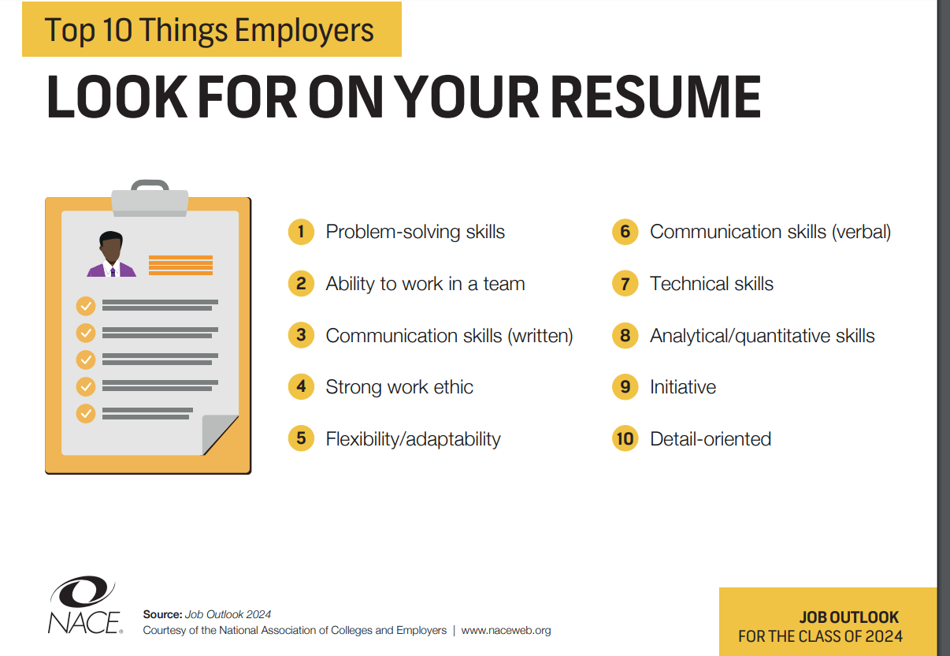

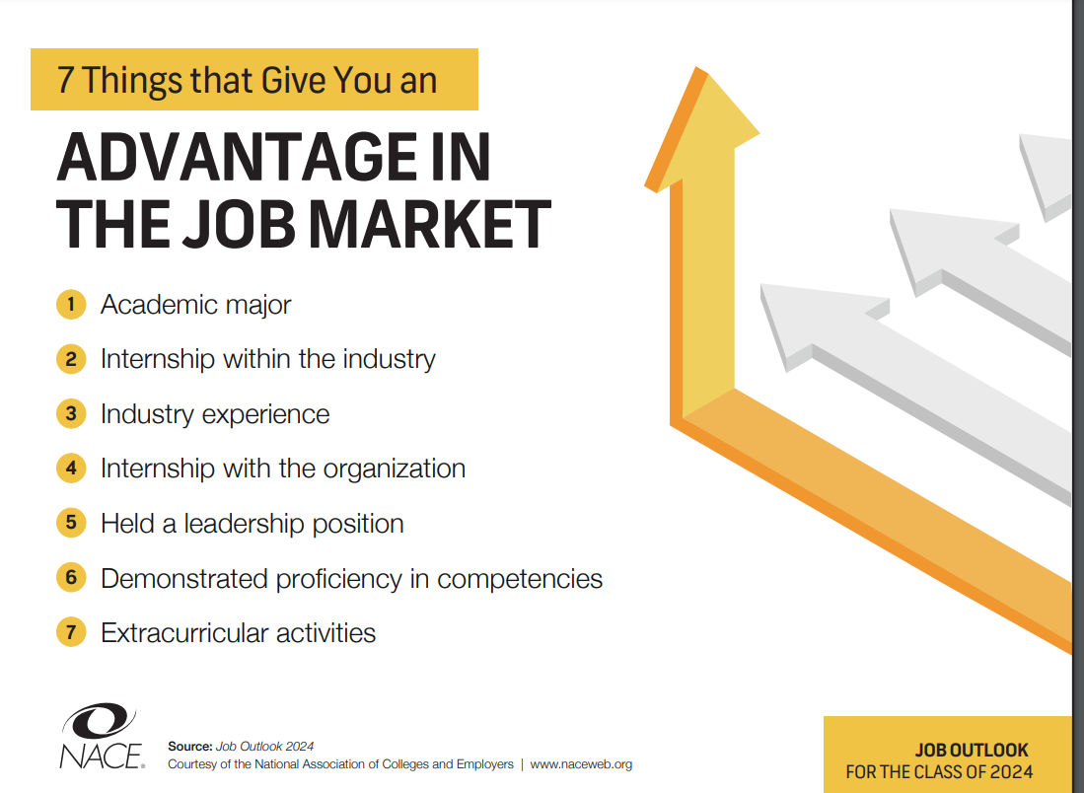
Creating A Strong Follow-Up Email

When connecting with professionals, it is essential that an effective networker follow up with an engaging, friendly but professional follow-up note or email. Email is still one of the most effective ways to connect with professionals- who, studies show, will still check their email every day. If you are hoping to grow your network, try these tips for composing effective networking emails that can result in responses.

- Be personally engaging. Never start a networking email with “To Whom It May Concern.” Networking emails are designed to help build a new relationship so approach the contact in a friendly manner. If you can’t find a name to email, search LinkedIn, their employer’s website, and social media. Use the “About Us” page of a company website where you can often locate a name.

Your introduction might start with:

Hi Chris,

Thank you for connecting with me on LinkedIn last week. It was a pleasure to meet you!

- Be appreciative. Mention one of their impressive accomplishments or a quality you admire about them. This shows them you have done some research and that you are genuinely interested in building a relationship with the person. For example:

Hi Chris,

Thank you for connecting with me on LinkedIn last week. It was a pleasure to meet you!

I saw your article on writersforum.com group and thought it offered some great advice for aspiring writers seeking to publish their work and the job market. I was wondering if we could speak further about your thoughts and advice for writers…

- Be concise. It is important you keep a networking email note short and sweet. Once the contact opens your email, they should be able to view it quickly to respond within a few minutes, if they choose to.
Key points for your networking email:
- Introduce yourself and explain your purpose for reaching out.
- The recipient’s interests and why you would like to know them.
- Some call to action. Perhaps you might meet for tea/coffee or to set up a phone interview?
- Finally, close the email politely and professionally.

- Grab their attention with your subject line. The subject line gives you an opportunity to make a positive first impression, Engage the prospective contact with a person touch when possible.
Here are some examples of effective networking email subject lines:
- Purchase Grad Seeking Job Shadow Opportunity
- Following Up from Sunday’s Networking Event
- Request for Informational Interview – Brian Glass
- Public Service Professional Seeking Career Advice

- Don’t grab attention with mistakes.
- Use a professional email address (Purchase address, name@). Avoid address with nicknames, birthdate, and slang.
- Watch your grammar, spelling and style. Avoid falling into text abbreviations.

6. Be persistent, yet patient. Following your networking email, give the contact a week or 2 to get back to
you. Remember it is easy for emails to get lost in inboxes, so do not get discouraged if you do not hear back
right away. If they do not get back to you, then it is appropriate to send a follow-up email.

Your Professional Social Media Presence

Search for Yourself

Google yourself and see what comes up. It is important to know what others see when they search for you. Is it positive or negative?

What Your On-line Presence Should Show
You want to show your skills, passions, talents, and interests. It is a tool to promote what you have to offer.

Stay Up-to-Date
If you have a professional website, on-line portfolio, or social media presence be sure it is current, engaging, and representing you in the way you want employers to see you.

Know What Your Industry Wants
For some industries having a social media presence is a necessity for being considered for a job.

Tips for Building Your Online Network
Connect
When you meet someone in your day-to-day life, connect with them via social media, including LinkedIn. This shows that you are interested in keeping in contact.
Attract
Get (or keep) people interested in you by keeping up your social media engagement. Share relevant industry information. You’ll find that if you are contributing (and not just self-promoting), you’ll be more successful.
Shift Your Focus
Shift from ‘Getting’ to ‘Giving’. If someone shares your content or mentions you - do the same for them! Start with a simple ‘Thank you’ and be sure to follow back so you can find the opportunity to reciprocate. Seek out opportunities to answer questions and help out – you’ll be remembered for it down the road.
Consistency
Nothing is genuine if it isn’t consistent. It is not a good idea to just ‘pop in’ when it’s convenient for you. If you are using social media platforms to connect with employers/clients, you should post regularly with engaging content.

Prepare Your Pitch
Presenting Your Strengths, Goals and Interests

Examples:
Hello. My name is Awesome Student. I am a sophomore and I am interested in an internship in human resources. What advice would you have for someone who wants to get into this field? What type of work experience and coursework do you like to see in candidates?

My name is Sam Somebody. My major is in Media Studies; this includes course work in multiple aspects of media and communications. I have working knowledge of Photoshop and Illustrator. Recently, as a team member, I helped to develop and complete from start to finish, a marketing plan proposal for an apparel company. I am very interested in your company and have actively followed your marketing campaigns. Would you be able to talk more about your current campaign for Test Product?

Hello. My name is Pat Example. I’m a production assistant with four years of solid broadcasting and public relations background and have a B.A. in Journalism. I have extensive experience developing and researching topics, pre-interviewing guests, and producing on-location video tapings. In my two years working at WPIX I actually worked on location on a number of occasions at Fake Place where you currently film weekly segments for Wake Up New York. I’ve been watching your station for some time and I’ve been impressed with your innovative approach and your fast growth. I would love to hear about your experience working there.

Step 1. Review:
List some accomplishments (academic, work, volunteer, internship, etc.):

Describe skills/personal qualities that you would like to highlight (related to your career goals):

Step 2. Write:
Share additional details you want employers/potential contacts to know (interest in them, etc.):

Write out a story/script (end with an open-ended question to continue the conversation):

Step 3. Rehearse:
- Practice reading your script out loud with a partner.
- Get it down to 60 seconds or LESS.
- Try out your "commercial" on friends and family. Ask for their suggestions.
- The more you practice, the more confident and professional you will appear

