PURCHASE COLLEGE
JOURNAL OF ECOLOGY

Volume 3
Fall 2019

Editor: Dr. Allyson Jackson
allyson.jackson@purchase.edu

TABLE OF CONTENTS

​INVASIVE PLANTS ADVERSELY AFFECT SOIL CHEMISTRY AND GROWTH OF NATIVE SEEDLINGS
Veronica Winter, Sarah Rubock, Robert Lodes, Alexus Brown………………………….2

BIRDS PREFER UNOCCUPIED BIRD FEEDERS COMPARED TO FEEDERS WITH REALISTIC OR NON-REALISTIC THREATS
Zackary Dicanio, Matthew Graham, Kimberly Robeson, Anton Creutzfeldt…………...10

PESTICIDES IMPAIR THE GROWTH OF SUNFLOWER AND PUMPKIN SEEDS
Michelle Cavalieri, Jennie Consalvo, Tiffani Rushford, Andre Selino……………….....19

Water Quality Testing at Varied Urban Runoff Locations Shows Impacts on Stream Health
Dane Kranjac, Dakota Crowley, Daniel Parker …………………………………………27

​ INVASIVE PLANTS ADVERSELY AFFECT SOIL CHEMISTRY AND GROWTH OF NATIVE SEEDLINGS

Veronica Winter, Sarah Rubock, Robert Lodes, Alexus Brown

ABSTRACT
Invasive plant species pose a grave threat to biodiversity worldwide. Two such species, Japanese knotweed (Reynoutria japonica) and porcelain berry (Ampelopsis glandulosa var. brevipedunculata) are common and widespread in the northeast United States, including on the campus of State University of New York (SUNY), Purchase College. We assessed the pH and critical nutrient levels in soil found under these invasive species and compared them to those of soil found under spicebush (Lindera benzoin), a native species, and soil found under a woodlot containing mature native trees. We grew pumpkins (Cucurbita pepo) from seed in each soil type and compared germination rates and growth. While our findings on the concentrations of nitrogen (N), potassium (K), and phosphorus (P) were mixed, we found that the knotweed and porcelain berry soil types were basic and acidic, respectively, in contrast to the native soil samples, which were both neutral. Additionally, both germination of pumpkin seeds and growth of the seedlings were significantly lower when planted in the invasive soil samples than when planted in the native soil samples, possibly due to the effects of pH differences or of allelochemicals.

Keywords: invasive species, Japanese knotweed (Reynoutria japonica), plant growth, porcelain berry (Ampelopsis glandulosa var. brevipedunculata), soil chemistry
____________________________________________________________________________________

INTRODUCTION
Invasive species often have negative effects on multiple fundamental features of a community, including community structure, species richness and evenness, and overall diversity of an ecosystem. As global commerce continues to grow, so do the numbers, ranges, and impacts of anthropogenically spread species (Brenton-Rule 2016). Previous work has shown that invasive plant species have the ability to alter soil chemistry and structure, thus limiting competition from native plant species (Weidenhamer and Callaway 2010, Stinson et al. 2014, Huangfu and Li 2019). They alter the soil conditions to their own benefit, which allows them to outcompete native species (Lavoie 2017). However, the effects of invasive plants on soil chemistry are highly species-specific, and Dassonville et al. (2008) show that their effects are often dependent on a site’s pre-invasion soil chemistry. Possible impacts include decreasing nutrients available to native species (McEwan et al. 2012, Lavoie 2017, Stefanowicz et al. 2017, Paulauskiene et al. 2018), altering the mycorrhizal fungal communities upon which native species rely (Burke et al. 2019), and secreting allelochemicals (Weidenhamer and Callaway 2010, Dommanget et al. 2014).
At SUNY Purchase College, invasive plant species are widespread, often colonizing recently disturbed areas, and are altering community structures by outcompeting native species for space and resources. Two such species are Japanese knotweed (Reynoutria japonica) and porcelain berry (Ampelopsis glandulosa var. brevipedunculata). Both are common in various parts of campus, particularly areas disturbed by construction and the edges of woodlots. Japanese knotweed is a shrub-like perennial in Polygonaceae, the buckwheat family. It can grow to more than two meters tall, spreads extremely quickly in dense thickets that, once established, are very persistent, and can thrive in a wide range of conditions. Often found near sources of water, it poses a particular threat to riparian ecosystems (United States Department of Agriculture Forest Service 2017a). Lavoie (2017) found a marked pattern among various studies in which knotweed adversely impacted soil chemistry, and Dommanget et al. (2014) found allelopathic effects by knotwood on two other plant species. The porcelain berry vine is a deciduous, woody perennial in Vitaceae, the grape family. It can grow more than 5 meters in a single growing season. It thrives in edge habitats and recently disturbed areas, especially anthropogenically disturbed areas, preferring full sunlight or partial shade to the full shade of mature forests. While it is slow to initially colonize new areas, once established it spreads rapidly, shading smaller plants and generally outcompeting native species (United States Department of Agriculture Forest Service 2017b).
We measured the pH and relative levels of key nutrients in soil found under Japanese knotweed, soil found under porcelain berry, soil found under native spicebush (Lindera benzoin), and soil found under the leaf litter in a mature woodlot with native tree species. We also grew pumpkins (Cucurbita pepo) from seed in each soil type to determine the relative ability of this native plant species to grow in soil potentially altered by knotweed and porcelain berry. Pumpkins are native to North America and are good bioaccumulators (Echem 2014, Paulauskiene et al. 2018), making them an excellent model for our purposes. We hypothesized that the soil chemistry of the invasive soil types would differ significantly from that of the native soil types and that pumpkin would not germinate or grow as readily in the invasive soil types.

METHODS
Site selection. We collected soil samples from four locations on the SUNY Purchase College campus on October 16, 2019 and October 23, 2019 (Fig. 1). Samples for invasive soil types were collected from underneath thickets of invasive Japanese knotweed and porcelain berry, respectively. For the native soil type, we collected soil from under native spicebush and from a late succession forest floor. Samples from each site were collected in the same manner: We used shovels to dig down below topsoil layer and collected the samples from the same depth, close to the roots. We then transferred the samples to the lab using labeled cups to continue the experiment.
Soil testing and planting. On both dates we used “Rapitest” soil test kits to determine the soil pH of each sample and the relative levels of potassium (K), nitrogen (N), and phosphorus (P). To test for pH, we added soil to the included test vial up to the fill line, filled the vial with deionized water, and dissolved the included indicator. After shaking the tube for 1 minute and allowed the mixture to settle for 1 minute, we were able to compare the color of the mixture with the included indicator colors. The nutrient testing was conducted by mixing 1 part soil with 4 parts deionized water and leaving the mixture for 24 hours. After 24 hours we filled the corresponding test vial with liquid from the mixture and dissolved the corresponding included indicator. After shaking for 1 minute, we waited 10 minutes to allow the color to develop. After the alloted time, we were able to compare the color of the mixture to the included corresponding indicator colors and values. These values allowed us to determine if the soil nutrient levels were depleted, intermediate, or high for the corresponding nutrient type. After soil testing, we planted the pumpkin seeds, using 3 cups for each soil type. We planted four pumpkin seeds in each cup, approximately 1 inch below the surface. The cups were then set in an incubator at 23 °C. Our decision to collect again on October 23 was due to a total lack of germination and growth in the invasive soil types up to that point and possible overwatering. From October 16 to October 23, we watered each replicate with 40 mL of tap water each day. Due to possible overwatering, we reduced this to 20 mL of tap water every few days (depending on soil moisture) for the remainder of the study. We measured the height of each seedling that sprouted once per week for 4 weeks for the replicates planted on October 16 and 3 weeks for the replicates planted on October 23.
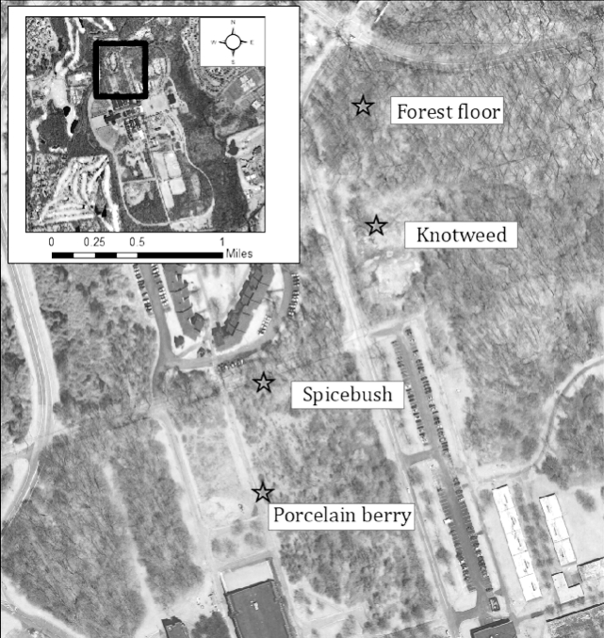
Figure 1. Study area: map of samples collected from four sites on SUNY Purchase College campus.

RESULTS
Seed Germination. Native soil types yielded greater germination rates than those of the invasive soil types (Fig. 2). The forest floor soil yielded the highest germination rate overall and spicebush yielded the next highest rate. The invasive soils took longer over the four-week period to germinate and were not as numerous as the native soil types used.
Overall, the total growth of germinated seedlings was greater in the native soil types, at 707.7 cm among the spicebush replicates and 609.7 cm among the forest floor replicates. The total growth among the knotweed replicates was 87.0 cm and was 69.0 cm among the porcelain berry replicates. Observing the mean height values (Fig. 3), forest floor and spicebush seedlings experienced greater growth with final mean heights of 22.2 cm and 21.4 cm, respectively, than those of porcelain berry at 8.4 cm and knotweed at 5.9 cm.

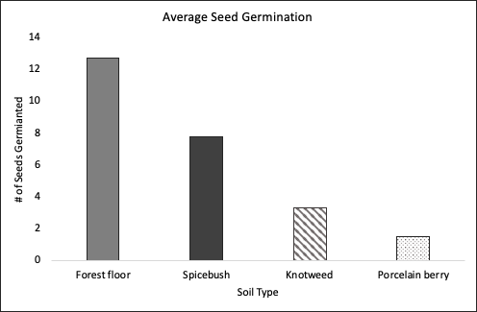
Figure 2. Average number of successfully germinated pumpkin seeds per soil type over the four weeks the experiment took place.
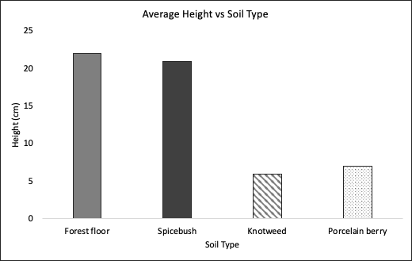
Figure 3. Average final height of pumpkin vs soil type.
Soil Nutrients. The pH values for both native soil types were neutral, while the porcelain berry soil type was slightly basic acidic a pH of 6.5 and the knotweed soil type was basic with a pH of 7.5 or greater (Fig. 4). Potassium and nitrogen varied greatly depending on the sample type (Fig. 5). A value of “1” = soil depleted of nutrient (lowest nutrient level), “2” = soil deficient of nutrients (intermediate nutrient level), and “3” = adequate amount of nutrient (highest nutrient level). Potassium was highest in both knotweed (“3”) and porcelain berry (“3”) soil type. These levels were lower in the native soil types, presenting as “2.5” in the forest floor sample and “2” in spicebush sample. Nitrogen levels were lowest in the invasive soil types, presenting as “1” in porcelain berry and knotweed samples. Phosphorus held constant across all native and invasive soil types.
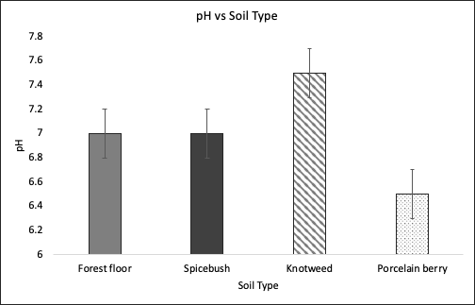
Figure 4. pH vs Soil Type. Results from October 16 were consistent with those from October 23. Error bars represent one standard deviation.
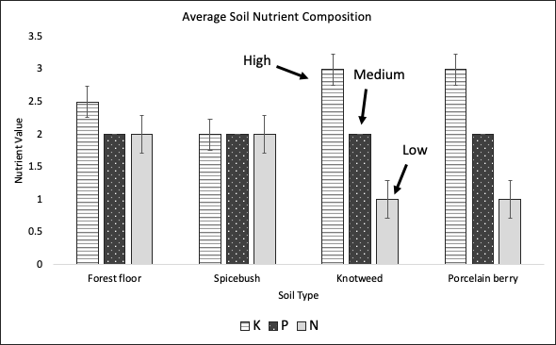
Figure 5. Average soil nutrient composition. Error bars represent one standard deviation. These results are an average of our findings from October 16 and October 23. A value of “1” = soil depleted of nutrient (lowest nutrient level), “2” = soil deficient of nutrients (intermediate nutrient level), and “3” = adequate amount of nutrient (highest nutrient level).

DISCUSSION
Germination rates for the native soil types proved to be more successful than those in the invasive soil types. The number of seeds germinated and the resulting height were both greater in native soil type while invasive types were not as numerous or successful. While the results for nutrient composition were mixed, the results of the pH tests show a clear difference between the native soil types, which were consistently neutral with a pH of 7, and the knotweed and porcelain berry soil types, which were basic and slightly acidic, respectively, with pH values of 7.5 or greater for knotweed and 6.5 for porcelain berry.
Our findings that knotweed and porcelain berry alter the soil pH are consistent with studies of other invasive plant species (Weidenhamer and Callaway 2010, Stinson et al. 2014, Huangfu and Li 2019) that have found alterations in soil chemistry, and with previous studies of knotweed (Stefanowicz et al. 2017, Lavoie 2017). Studies evaluating the impact of porcelain berry on soil chemistry were not readily available at the time of writing. It is possible that the changes in the invasive soil types account for some, if not all, of the discrepancy between germination and growth rates compared to the native soil types. Altering the soil pH may have dual benefits — it may be that knotweed grows better in basic conditions and porcelain berry grows better in slightly acidic conditions, that altering the soil pH reduces the relative fitness of competing native plants, or both.
It is also possible that one or both of the invasive species we tested secretes allelochemicals into the soil, like other successfully invasive plants have been shown to do (Lankau 2009; Silva et al. 2014; Li et al. 2015; Zheng et al. 2015). This is another potential explanation for our results regarding pumpkin germination and growth. Allelochemicals would be harmless to the plant that secretes them but would confer to that plant a marked advantage in competition for space by chemically limiting the ability of other plants to survive and grow in the area immediately surrounding the invasive plant.
Our largest potential sources for error are the imprecise nature of the tests we used to determine soil pH and nutrient levels and the irregularity of our watering regime. Though our results show clear trends, further testing with more standardized and precise protocols would lend much more certitude to our conclusions. The “Rapitest” soil test kit does not measure pH above 7.5, so it is possible that the pH of the knotweed soil sample was higher than 7.5. Though these results were confounded by variable watering regimes, the pumpkin seeds show a clear trend of higher germination rates correlated with the native soil types, and we measured significantly lower growth rates in the pumpkin plants grown in invasive soil types. Further testing with more precise equipment is especially needed to determine the exact pH of soil affected by knotweed. Additional studies could also examine other elements of soil chemistry or the makeup of soil microbial communities. Another potential for further study is the effects of these two invasives on mycorrhizal fungal communities. Studies of this manner are important for understanding soil composition on our campus, to hopefully advise management strategies for invasive species removal and the important conservation of native flora.

CONCLUSION
If confirmed by future studies, our findings indicate that both Japanese knotweed and porcelain berry alter soil chemistry and composition to their own benefit and to the detriment of neighboring native plants, one factor among many that makes them highly successful invaders. As with many other invasive plants, the ability to change the chemistry of the surrounding soil is a powerful advantage for these species, one which contributes to their ability to outcompete their rivals by reducing the relative fitness of the surrounding species. Invasive species ecology is highly variable, and our proposed explanations for our findings are just a few possibilities. Further studies are needed to explore the complex reasons for the success of these invasive plants.
ACKNOWLEDGEMENTS
We would like to thank Dr. Jackson and Sam Scalice for supporting us and supplying us with the materials necessary for this experiment and for the advice! We also would like to thank Dr. Taylor for helping us understand campus soil composition and offering encouragement. Thank you to the Purchase Natural Sciences department for making the General Ecology course possible. And again, thank you to Dr. Jackson for teaching us about the ecology of invasive species. Finally, thank you Ben the Dog for just being you.

LITERATURE CITED
Brenton-Rule, E., R. Barbieri, P. Lester, and E. Brenton-Rule. 2016. Corruption, development and governance indicators predict invasive species risk from trade. Proceedings. Biological Sciences, 283: 20160901–20160901.
Burke, D. J., S. R. Carrino-Kyker, A. Hoke, S. Cassidy, L. Bialic-Murphy, and S. Kalisz. 2019. Deer and invasive plant removal alters mycorrhizal fungal communities and soil chemistry: evidence from a long-term field experiment. Soil Biology and Biochemistry 128: 13–21.
Dassonville, N., S. Vanderhoeven, V. Vanparys, M. Hayez, W. Gruber, and P. Meerts. 2008. Impacts of alien invasive plants on soil nutrients are correlated with initial site conditions in NW Europe. Oecologia 157: 131–40.
Dommanget, F., A. Evette, T. Spiegelberger, C. Gallet, M. Pace, M. Imbert, and M. L. Navas. 2014. Differential allelopathic effects of Japanese Knotweed on willow and cottonwood cuttings used in riverbank restoration techniques. Journal of Environmental Management 132.
Echem, O. G. 2014. Determination of the levels of heavy metal (Cu, Fe, Ni, Pb and Cd) up take of pumpkin (Telfairia occidentalis) leaves cultivated on contaminated soil. Journal of Applied Sciences and Environmental Management 18: 71-77–77.
Huangfu, C. and K. Li. 2019. Growing density interacts with competitor identity to modulate nitrogen form preference of an invasive plant. Ecological Indicators 107: 105641.
Lankau, R. 2009. Intraspecific Variation in allelochemistry determines an invasive species’ impact on soil microbial communities. Oecologia 165: 453–463.
Lavoie, C. 2017. The impact of invasive knotweed species (Reynoutria Spp.) on the environment: review and research perspectives. Biological Invasions 19: 2319–37.
Li, Y. P., Y. L. Feng, Y. J. Chen, and Y. H. Tian. 2015. Soil microbes alleviate allelopathy of invasive plants. Science Bulletin 60: 1083–1091.
Liu, L., S. Wang, X. Guo, and H. Wang. 2019. Comparison of the effects of different maturity composts on soil nutrient, plant growth and heavy metal mobility in the contaminated soil. Journal of Environmental Management 250: 109525.
McEwan, R. W., M. A. Arthur, and S. E. Alverson. 2012. Throughfall chemistry and soil nutrient effects of the invasive shrub Lonicera Maackii in deciduous forests. American Midland Naturalist 168: 43–55.
Paulauskiene, A., H. Danilcenko, I. Pranckietiene, and Z. Taraseviciene. 2018. Effect of different fertilizers on the mineral content of pumpkin fruit. Journal of Elementology, 23: 1033-1042.
Silva, F. M. L., M. A. Donega, A. L. Cerdeira, N. Corniani, E. D. Velini, C. L. Cantrell, F. E. Dayan, M. N. Coelho, K. Shea, and S. O. Duke. 2014. Roots of the invasive species Carduus Nutans L. and C. Acanthoides L. produce large amounts of aplotaxene, a possible allelochemical. Journal of Chemical Ecology 40: 276–284.
Stefanowicz, A. M., M. Stanek, M. Nobis, and S. Zubek. 2017. Few effects of invasive plants Reynoutria japonica, Rudbeckia laciniata and Solidago gigantea on soil physical and chemical properties. Science of the Total Environment 574: 938–946.
United States Department of Agriculture Forest Service. 2017a. Invasive Plants Fact Sheet – Porcelain Berry.<https://www.fs.usda.gov/naspf/resources/invasive-plants-fact-sheet-porcelainberry>. Accessed 6 Nov. 2019.
United States Department of Agriculture Forest Service. 2017b. Invasive Plants Fact Sheet – Japanese Knotweed.<https://www.fs.usda.gov/naspf/resources/invasive-plants-fact-sheet-japanese-knotweed>. Accessed 6 Nov. 2019.
Weidenhamer, J. D. and R. M. Callaway. 2010. Direct and indirect effects of invasive plants on soil chemistry and ecosystem function. Journal of Chemical Ecology 36: 59–69.
Zheng, Y. L., Y. L. Feng, L. K. Zhang, R. M. Callaway, A. Valiente-Banuet, D. Q. Luo, Z. Y. Liao, Y. B. Lei, G. F. Barclay, and C. Silva-Pereyra. 2015. Integrating novel chemical weapons and evolutionarily increased competitive ability in success of a tropical invader. New Phytologist 205: 1350–1359.

BIRDS PREFER UNOCCUPIED BIRD FEEDERS COMPARED TO FEEDERS WITH REALISTIC OR NON-REALISTIC THREATS

Zackary Dicanio, Matthew Graham, Kimberly Robeson, Anton Creutzfeldt

ABSTRACT
Antipredator behavior is an essential principle in being a foraging bird. Birds observe their environment for threats and make decisions based on these observations which often have the goal of optimizing success in survival. We studied the birds of Purchase College to observe their feeding behavior in the presence of a threat to further understand their threat assessment, and what they determine to be threatening. We assessed two categories of objects- “realistic” meaning emulating a threat in which they may already be familiar with in the real world, and “nonrealistic” meaning a completely unfamiliar foreign object- and while there was no significant difference between these two categories, there was a clear preference for each respective control (empty) feeder compared to the experimental feeder. Purchase College birds show caution to potential threats, regardless of how realistic or familiar they are to that threat.
Keywords: Bird feeding, bird behavior, foraging, predation, preference
____________________________________________________________________________________

INTRODUCTION
Humans are no different than other animals in that we all make observations which influence our behavior. The decision-making process of an individual varies dependent on the surrounding environment and familiarity with the situation (Desportes et al. 1990). Safety, well-being, and optimizing resources are all common principles to consider in the decision-making process among many different animals. This pattern can be observed in colonial spiders, for instance, in which the spiders make the decision between whether they prioritize success in foraging or success in anti-predation (Raylor and Uetz 1990). Similarly, birds also express behavior in which they show high regard for safety from predators (Desportes et al. 1990).
Birds are intelligent creatures who assess their environment for threats before and even during their foraging processes (Desportes et al. 1990, Morrison 2011). This is an essential component in their antipredator behavior that optimizes the patterns of their feeding. Brandt et al. (2007) suggested that predation is relatively unimportant in shaping the daily feeding pattern of birds; however, Sam and Fuchs (2011) recognized that tit feeding differed based on what type of threat was near their experimental feeder, and how high the threat level appeared to be to the bird.
Assessing for threats is important in bird foraging success, but what exactly a bird deems as threatening is less clear to us. Experience with the specific threat is certainly the most easily understood way in which birds can recognize a familiar threat, but if a bird may have never been introduced to something, it’s more difficult to understand how they may find it threatening. Novakova et al. (2017) concluded that the assessment of a threat for their experimental titmice was mostly dependent on key features in which they recognized, and the birds showed less influence by the spatial orientation of those features. In other words, parts have more of an impact on the birds’ decisions than the whole picture. Birds recognized a part of a threat it was once familiar with rather than recognizing a whole ensemble as being threatening.
We observed the patterns Purchase College birds exhibit when choosing to feed at feeders where there is a potential threat, compared to where there is no obstruction. We explored how finely-tuned our birds’ anti-predator behavior is in regards to objects they have low or no familiarity with, as well as objects that may be more realistic and emulate a real-life threat they face. The goal of this experiment is to express if and how the presence of a foreign object impacts bird feeding by counting how often and how long the birds visit a feeder. We want to more greatly understand how birds categorize threats and the relationships they choose to have with different types of threats, based on how they have assessed it. We predict that in the presence of a threatening, realistic object, there will be a low amount of bird activity (number of visits to the feeder and number of different species). As the variable object begins to look less like a known threat, bird abundance will increase. There will be an indirect relationship between the realism of the object and bird abundance.

METHODS
Study Area. The field site of the experiment was the Purchase College native plant garden. The garden is a small open space with an adjacent woodlot. Dividing the two is a walkway, and the rest of the garden is surrounded by road. A picnic bench is located in the middle of the garden, from which data was collected. There are five small trees in the garden and four native plant beds. Alongside the field site was a small construction site from which human activity and loud noises were encountered at times throughout the study.
Field Data Collection. Field data collection is almost entirely observational. Two bird feeders filled with the same brand of seeds are placed at least 50 ft. from the observation site. In order to accurately count the number of visits to both feeders simultaneously, we found it best to place them in a fashion which both were easily visible from our site of observation, approximately 3 yards apart. Black oil sunflower seeds were used in this experiment. One feeder is the control and the other is the experimental feeder that has a prop attached. The six props that were tested include a small Christmas ornament, a large Christmas tree ornament, a small decoy bird, a decoy owl, a shoe, and a scarecrow which we created by putting a shirt on a hanger and hanging it next to the feeder. First, a timer was set to 30 minutes and observation began from a bench approximately 50 ft. from the feeder. Each bird visit of any length of time, to either feeder, was recorded for the exact amount of time it remained on the feeder. At the end of the 30 minute trial, the prop was switched to the neighboring feeder and studied for a second 30 minute trial. Conducting two trials in which the experimental feeder is swapped was essential to eliminate any possibility that there was a predetermined bias for a given feeder in the bird community, as the conditions and exact location for the feeders did vary slightly.

RESULTS
The total number of visits to the prop and control feeder were recorded (Fig. 1). It displays the small ornament had no visits to the prop feeder during its trial while its empty feeder had 12 total visits. It also shows that the small bird had 17 less visits than its corresponding empty feeder. Meanwhile, the shoe trial resulting in an equal number in visits to both feeders. There were almost twice as many bird visits to the empty feeder compared to the prop feeder for 5 out of 6 objects.
We also recorded the total amount of time spent on each feeder (Fig. 2). The amount of time indicates a clear preference for the empty feeder in every trial. The small bird trial had the biggest difference, birds stayed on the empty feeder for 2325 more seconds than the prop feeder.
We thought a good way to display the birds’ preference for the empty feeder was by showing the difference in total number of visits (Fig. 3) and total difference in time (Fig. 4). In all cases besides the shoe, the empty feeder received more visits, we subtracted the number of visits to the prop feeder from the number of visits to the empty in order to highlight this preference. Similarly, with the amount of time spent, we subtracted the number of time spent at the prop feeder from the total time spent at the empty feeder. This clearly shows the birds preference to the empty feeder.
Figure 5 shows a comparison between the time spent on the empty feeder between two categories of prop. We defined the small ornament, large ornament and the shoe as our unrealistic props and the small bird, owl and scare-crow as our realistic props. We added all the established differences in time spent on the feeders from Figure 4 for each of our defined categories to determine the total difference in time spent at unrealistic prop feeders compared to their control, and realistic prop feeders compared to their respective control. This showed that birds spent 128 seconds more on the empty feeder when the more realistic props were present.

Figure 1. The number of visits to a feeder with a prop present compared to their respective control feeder where no prop was present.

Figure 2. The total amount of time in seconds spent on a feeder with a dummy present compared to its respective control feeder where no dummy is present.

Figure 3. Comparison between the total amount of visits to the control feeder versus the feeder with the dummy present. We took the total number of visits to the dummy feeder and subtracted it from the total number of visits to the control feeder. We used the equation number of visits to control minus number of visits to dummy.

Figure 4. Comparison between the total amount of time in seconds spent on the control feeder versus total time in seconds spent at the feeder with the dummy present. We took the total time (sec) of the prop feeder and subtracted it from the total time (sec) of the control feeder with no dummy present. We used the equation total time spent at control (s) minus total time spent at dummy (s).

Figure 5. Comparison between the amount of time spent on the empty feeder due to prop, realistic vs non-realistic.
DISCUSSION
Our results suggest an object on or near the feeder did affect the birds feeding habits. The control/empty feeders had more birds visit as opposed to the experimental feeders. Throughout the experiment, birds would often check out the props on the feeders, flying around them but not landing at first as if they were assessing them to see if it was safe to feed. Overall, the birds did not reach a point where they fully trusted the props, as the feeders with the props remained significantly untouched compared to their controls. There was not a significant difference in the “realistic” (large bird prop, small bird prop, scarecrow) and the “non-realistic” (large ornament, small ornament, shoe) in terms of visits.
The location of the bird feeders was quickly realized to be crucial since goldfinches, which held the majority of the birds seen in the experiment, are picky about where they feel comfortable feeding (Dunn et al. 1990). Finches in general are measured in their searches for food, and pick their competition wisely, knowing the consequences (Krabbe 2004, Beal et al. 2011). The size and realistic properties didn’t play too much of a role with these finches, as both attracted and scared away birds virtually evenly. But according to Popp (2010), goldfinches again know when and when not to advance on a risky situation during feeding. We did see instances of these finches flying up and around our props, sizing them up, which not only tells them, but other birds watching whether this is a safe object or not. Based on what the object looks like and its general vicinity to safety which in this case was the brush about 50 feet away, helped the birds determine whether each object as harmless or not, which is very typical and precautionary behavior for goldfinches (Dunn et al. 1990, Popp 2010).
We also saw human interference, and weather during the trials play an effect on our experiment. In the trials, human activity and weather varied significantly for each trial and it did affect the habits of the finches. Parts of trials during our third session were interrupted by big construction activity very close by to the feeders. Sauvajot et al. (1998) suggested small mammals respond strongly to human disturbance-related vegetation changes, while birds showed little or no response. However, the construction evidently did not sit right with the birds, causing some to most likely omit visiting the feeders. This interference led our finches to become more cautious in deciding whether feeding was worth it or not. This is also the case with many other species of birds, not just finches. According to Krabbe (2004), interference competition plays a significant role in whether or not birds will not only feed, but also nest and socialize. During our first and third sessions, it was overcast, during the third session it was a sunny day and during our final session it was cold and cloudy. Inconsistent weather did inherently lead to different tallies, affecting data.
The presence of natural predators could also have affected some of our data. During our second trial, a bobcat was spotted hunting some rabbits, and that could have frightened the birds. In the first and fourth trials, hawks were seen circling either overhead or nearby, again potentially causing the birds to be scared. Goldfinches have evolved to know which other species present a threat to them and respond accordingly by not staying around (Dunn et. al 1994). Franks and Thorogood (2018) highlight the effect age of the birds had on foraging, which shows older birds are quicker to adapt to a situation in order to optimize their success. Older birds express greater regard for observation of their surroundings and subsequent understanding of the best approach to interact with their surroundings. No one factor alone can be attributed to how birds choose to feed, as they all play a role in that decision as well (Barta et al. 2004, Cueto et al. 2001). Food density could have served as a motivational factor to face risk as two feeders full of seed has remained in the same location for a few weeks. Beauchamp (2009) suggest that bird groups size has a confounding effect with food density in increasing vigilance in birds.
Since each feeder is situated a different distance from the road, construction, forest, etc., we recognized the possibility that the birds already favor a given location, regardless of what our experiment entails. In order to ensure our data has no discrepancies due to a predetermined preference, we alternated which feeder was the control and which was the experimental. For every variable, two trials were conducted in which the feeders were swapped.
In future experiments, we suggest extending the time of each trial from 30 minutes to at least 45 minutes or perhaps even an hour. A lot of our data came within the final 10-15 minutes of each trial, which we thought was due to the birds needing time to get acclimated to us observing them from a distance. We would also suggest a different location, perhaps a spot with less construction. Since the construction affected some days more than others, omitting it from a future experiment would be ideal. Lastly, with a larger time frame to prepare for the experiment, organizing the experiment to take place only on days with similar weather patterns may solidify any findings we have discovered. Since the weather influenced certain bird feeding activity, and subsequently affected our data, having a consistent weather pattern for each session would eliminate that source of error.
When it comes to feeding and avoiding competition, finches balance each as a priority and even express riskier behavior when they feel appropriate, because goldfinches seem to take extra caution giving themselves the best chance of survival (Krabbe 2004). Based on Dunn et al. 1990 and Popp 2010, goldfinches are wise in their choices for food, and who to interact with. They assess their odds against a given variable and use that assessment to their advantage for survival. Our findings at Purchase correlate with such data involving goldfinches elsewhere.

CONCLUSIONS
Purchase College birds exhibited a preference to the unoccupied/control feeder every time compared to the experimental feeder with the prop. This supports one aspect of our hypothesis, however, there is not sufficient enough information to conclude that there is any difference in the level of threat between a “realistic” and “nonrealistic” prop. Our prediction that birds will avoid the more realistic props due to a higher assessed level of threat was falsified by this experiment. With a continuously growing amount of construction and human activity across campus, it’s essential to understand how our interactions with the inhabitants of our local environment affect their day to day life, and what we can do to change these impacts.
ACKNOWLEDGEMENTS
We would like to thank Professor Allyson Jackson for aiding us in this experiment and providing many bird-related objects, Patrick Harmon for suggestions with our experimental process, as well as Ben the Dog for emotional support. We would also like to thank Tiffani, André, Dakota and Daniel for helping us out with great peer review suggestions.

LITERATURE CITED
Barta, Z., A. Liker, and F. Mónus. 2004. The effects of predation risk on the use of social foraging tactics. Journal of Animal Behavior 67: 301-308.
Beal, L. J., R. I. Hartley, and C. M. Mainwaring. 2011. Zebra finches are bolder in an asocial, rather than social, context. Behavioural Processes 87: 171-175.
Beauchamp, G. 2009. How does food density influence vigilance in birds and mammals? Animal Behaviour. 78(2): 223-231.
Brandt, M. J., and W. Cresswell. 2009. Diurnal foraging routines in a tropical bird, the rock finch Lagonosticta sanguinodorsalis: how important is predation risk? Journal of Avian Biology 40(1): 90-94.
Cueto, V. R., L. Marone, and J. Lopez de Casenave. 2001. Seed preferences by birds: effects of the design of feeding-preference experiments. Journal of Avian Biology 32(3): 275
Desportes, J., N. Metcalfe, J. Popp, R. Meyer, A. Gallo, and F. Cézilly. 1990. The predictability and patterns of vigilant behaviour. Behavioural Processes 22: 41-46.
Dunn, H. E., and D. L. Tessaglia. 1994. Predation of birds at Feeders in winter. Journal of Field Ornithology 65(1): 8-16.
Dunn, H. E., and J. T. A. Hussell. 1990. Goldfinch preferences for bird feeder location. Journal of Field Ornithology 62(2): 256-259.
Franks, V. R., and R. Thorogood. 2018. Older and wiser? Age differences in foraging and learning by an endangered passerine. Journal of Behavioural Processes 148: 1-9.
Krabbe, N. 2004. Pale-headed Brush-finch (Atlapetes pallidiceps): notes on population size, habitat, vocalizations, feeding, interference competition and conservation. Bird Conservation International 14(2): 77-86.
Morrison, B. E. 2011. Vigilance behavior of a tropical bird in response to indirect and direct cues of predation risk. Behaviour. 148(9): 1067-1085.
Nováková, N., P. Veselý, and R. Fuchs. 2017. Object categorization by wild ranging birds-winter feeder experiments. Journal of Behavioural Processes 143: 7-12.
Popp, J. W. 2010. Choice of ppponents during competition for food among American Goldfinches. Ethology 75(1): 31-36.
Raylor, L.S., and W. G. Uetz. 1990. Trade-offs in foraging success and predation risk with spatial position in colonial spiders. Behavioral Ecology and Sociobiology 27: 77-85
Sam, K., and R. Fuchs. 2011. Tits recognize the potential dangers of predators and harmless birds in feeder experiments. Journal of Ethology 30: 157-165.
Sauvajot, M. R., M. Buechner, D. Kamradt, and C. Schonewald. 1998. Patterns of human disturbance and response by small mammals and birds in chaparral near urban development. Urban Ecosystems 2(4): 279-297.

PESTICIDES IMPAIR THE GROWTH OF SUNFLOWER AND PUMPKIN SEEDS

Michelle Cavalieri, Jennie Consalvo, Tiffani Rushford, and Andre Selino

ABSTRACT
Human activities increase the amount of chemicals in Earth’s various biogeochemical cycles and ultimately lead to large scale ecosystem impacts. Pollution can have particularly detrimental effects on plants, which are essential primary producers that support all aerobic organisms and their respective ecosystems. To study this, we planted two fast growing seeds: sunflower (Helianthus annuus) and pumpkin (Cucurbita pepo), and observed the effects of pesticides, and urban runoff on the germination and growth of seeds. Our results show that the sunflowers showed the most growth with the urban runoff and deionized water, and the pumpkins showed the most growth with the dilute Ortho, an insecticide, and deionized water. Both groups were negatively impacted with the Roundup solution. Overall, the data reveals negative impacts that pollution has on ecosystems and can be used to support regulation of pesticides.

Keywords: Pesticides, Plant growth, Pollution, Pumpkin, Sunflower
____________________________________________________________________________________

INTRODUCTION
Human activities disturb ecosystems and discharge pollution into the Earth’s air, water, and soil. The integration of numerous chemicals and nutrients into the various biogeochemical cycles that promote life and the overall functioning of ecosystems has adverse effects as well as many unknown consequences. Every day humans send out extensive substances into the environment through agriculture, transportation, energy production, and industry. Urban runoff alone doses nearby ecosystems with elements such as lead, calcium, iron, copper, sodium, and zinc (Aljazzar and Kocher 2016). Pollution comes in many forms and finds its way into freshwater and marine bodies, as well as the atmosphere and soil.
Plants, as autotrophs and the bases of many ecosystems, must receive special attention regarding how they are affected by the pollution and ultimately what can be done to create an environment in which they can thrive. Experiments that investigate the impacts of human activities on plants are critical to understanding how we can alter our habits to better protect the environment. Apart from their intrinsic value, plants provide the entire planet with an essential gas: oxygen. Many living organisms would cease to exist without plants due to their dependency on them for oxygen and food. Human activities that prevent plants from functioning properly should be studied further to observe the effects. Soils and plants that are nearby roads, driveways, highways, and parking lots are more susceptible to urban runoff from various modes of transportation and activities that occur in urban areas. There is an evident negative correlation between pollution concentrations and distance from the road (Aljazzar and Kocher 2016). Vehicles pollute land and water with contaminants such as lead, chlorine, and cyanide through gas, corroded car parts, cooling liquids, and tires. Petrochemical products, such as diesel, damage the environment and deteriorates soil quality for plants. After being exposed to diesel through the soil, Vetiver grass was shown to experience a decrease in shoots and roots (Waqar-un-Nisa et al. 2016).
Humans also cause plants unintended consequences due to pesticide and fertilizer application in both agricultural and residential settings. Pesticides have been used for thousands of years and were once natural and organic. In the 20th century, however, many harsh and synthetic pesticides were discovered and implemented into practices. They are being continually developed as organisms become resistant, which increases the ambiguous threats of pesticides (Sparks 2013). Pesticides are a cause for concern due to the impacts they have on the biological functioning of plants. It has been proven that around livestock areas, waters are polluted by pesticides as well as animal waste that disrupts whole nutrient cycles in plants (Hooda et al. 2000). Once the nutrients are incorporated into the water, they become mobile and can spread to areas far from the location of discharge. Another contaminant that affects the biological functioning of plants is herbicides. One popular herbicide is Roundup, which although effective, threatens many non-target species. It negatively impacts the compositional and functional diversity of soil microorganisms (Bruckner et al. 2019), as well as interfering with plants’ internal processes. The active chemical in Roundup, glyphosate, inhibits a metabolic pathway called the shikimate pathway causing a buildup of shikimate acid in plant leaves, the acid is a useful biomarker for glyphosate (Peterson et al. 2006). The normal functioning of this pathway, however, is critical for the creation of aromatic amino acids and aromatic secondary metabolites which ultimately determine many of the plants’ biological functions (Hermann and Weaver 1999). An experiment by Tesfarmarian et al. (2009) focused on sunflower seeds specifically, and showed a decrease in both the growth and biomass production of sunflower seedlings after Roundup application.
We set out to perform an experimental study to better understand the effects of different types of human pollution on the growth of sunflowers and pumpkins over time. We hypothesized that the plants watered with deionized and urban runoff would grow more in the three weeks than those watered with dilute Ortho and dilute Roundup.

METHODS
We first collected several black oil sunflower sprouts (Helianthus annuus, from hereafter referred to as sunflower) from the native plant garden on the SUNY Purchase College campus. We chose short, thick, and long sprouts from our collection. We then transplanted the sprouts into plastic drinking cups using Vigoro all purpose garden soil. Immediately after, we planted sunflower seeds into different plastic cups with the same garden soil. Three seeds were planted in each cup. All of the cups were then moved onto trays and placed in a plant incubator that supplied a constant light source and was maintained at a temperature of 73°F.
In order to obtain the urban runoff water, we visited the West 2 parking lot on the SUNY Purchase campus and collected water from various puddles and potholes. To make the Roundup and Ortho solutions, we used an Eppendorf reference micropipette to transfer 150µL of each solution into their own 500mL Kimax erlenmeyer flask. Each flask was then diluted with 500mL of deionized water.
We began watering the transplants and seeds daily with 40mL of each of their respective waters. After a few days of watering at 40mL, we noticed the transplanted sunflowers were struggling to absorb the water. We decided to adjust the amount of water for the transplants to 10mL increments until the soil was damp while continuing to water the seeds with 40mL each. Due to the questionable state of the transplanted sunflowers, we decided to plant pumpkin (Cucurbita pepo, from hereafter referred to as pumpkin) seeds during the second week of growth. The same methods were used for these seeds, except two seeds were planted in each cup instead of three. During the pumpkin seeds’ first week of growth, all of the transplanted sunflowers died. This issue of data collection led us to revise the experiment to focus only on how the different types of water affect seed germination and growth.
Once a week for three weeks, we visited the incubator to measure the growth of each plant. We measured the plants in centimeters using a standard twelve inch ruler by starting from the top of the soil to the place where the stem split, also known as the first node. After we collected the data, we calculated the average height of the sprouts in each cup for both the sunflowers and pumpkins.

RESULTS
Plants watered with the urban runoff solution in the sunflower trial grew the most, with an average of 17.8 cm, over the three week data collection period. The plants watered with the control of the deionized water had the second largest average growth of 14.5 cm. The dilute Roundup and the dilute Ortho yielded similar results with averages of 9.5 and 9.8 cm respectively. Figure 1 shows the progress of the sunflower plants growth throughout the data collection period. The Roundup group consistently yielded the lowest growth, resulting in the shortest plants for the sunflower trial. The plants that received the deionized water and the urban runoff treatments both had steady and constant growth. Only the plants receiving dilute Ortho had a decrease in plant height from the highest average point of 16.9 cm down to an average of 9.8 cm.
For the pumpkin trial, the plants that were watered with the deionized water grew the most over the three week data collection period, ending at an average of 13.5 cm. The plants that were watered with the dilute Ortho had the second largest average growth of 13 cm. The third highest yield were the plants watered with the urban runoff solution with an average of 12 cm and finally, the dilute Roundup had the poorest growth with an average of 9.5 cm. Figure 2 shows the progress of the pumpkin plants over the three week data collection period. Similarly to the sunflower trial, the pumpkin plants watered with the roundup consistently yielded the lowest growth. The pumpkin plants watered with the urban runoff solution showed a decrease in height from the highest point of 12.7 cm to 12.2 cm.
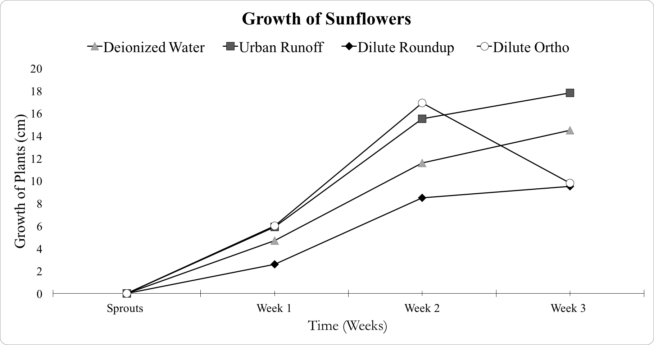
Figure 1. Growth of sunflower seeds over a three week period. Each plant was watered with deionized water, urban runoff collected from West 2 parking lot, dilute Roundup, and dilute Ortho.
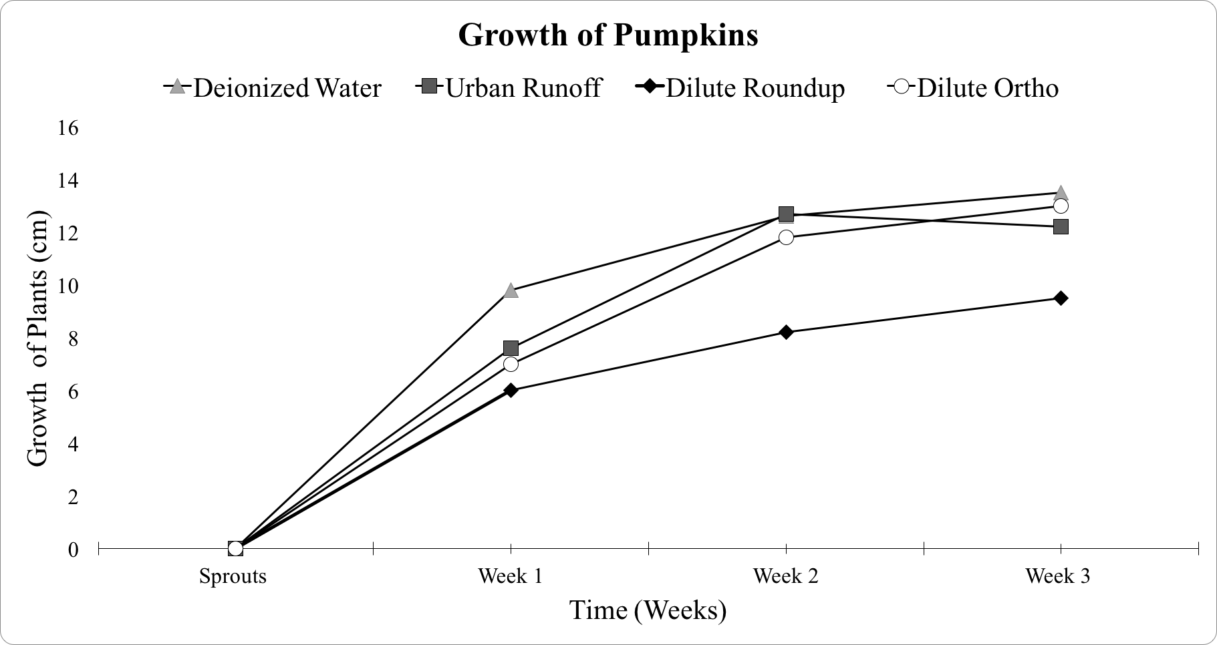
Figure 2. Growth of pumpkin seeds over a three week period. Each plant was watered with deionized water, urban runoff collected from West 2 parking lot, dilute Roundup, and dilute Ortho.
Figure 3a and 3b display the heights of the sunflower and pumpkin plants for each of the water types after 3 weeks of growth. Sunflowers watered with the control of the deionized water displayed an average height of 14.5 cm and for the pumpkins an average height of 13.5 cm. The sunflowers watered with the urban runoff solution showed an average height of 17.8 cm and the pumpkins showed an average height of 12.2 cm. The plants watered with the dilute Roundup solution showed identical average heights of 9.5 cm for pumpkins and sunflowers. Lastly, the dilute Ortho solution showed an average height of 9.8 cm for sunflowers and an average height of 13 cm for pumpkins.
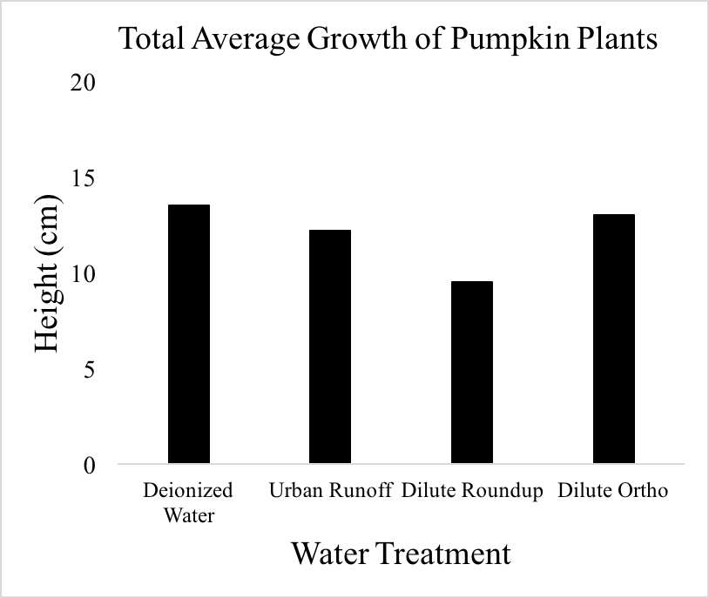
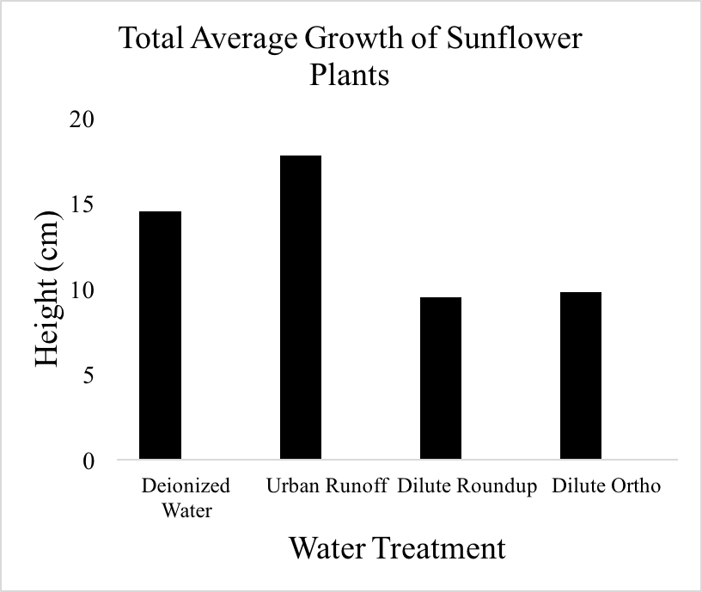
Figure 3. a) The total average growth of the sunflower plants at the end of the three week period; b) The total average growth of pumpkin plants at the end of the three week period.

DISCUSSION
Our hypothesis was that the plants that were watered with deionized water and the urban runoff would grow more than the plants watered with dilute Roundup and dilute Ortho. The purpose of this experiment was to see how human pollution has an impact on plants and their environmental growth settings. We tested this in the lab, focusing specifically on sunflower and pumpkin plants, with the goal of determining the effects of four types of water: deionized water, urban runoff, dilute Roundup, and dilute Ortho.
We noticed some puzzling trends in our pesticide results. For instance, the dilute Ortho had differing impacts on the growth of the two plant species. By the last week of measurements, the sunflowers watered with dilute Ortho had grown to a height of 9.8cm, while the pumpkins had grown to 13cm. The cause of this disparity may be explained by a difference in the genes of the sunflowers and pumpkins. Pumpkins may be more resilient to acephate, the active ingredient in Ortho which degrades rapidly in soil (Yen et al. 2000). We also noticed that the roots of the sunflowers treated with dilute Roundup were significantly shorter than all other treatments, refer to Fig 4. This is similar to an experiment done with maize, in which the same degradation of the roots occurred due to Roundup application (Gomes et al. 2019), though it is not clear exactly why the roots were impacted in this way.
Both the sunflowers and pumpkins watered with the dilute Roundup solutions showed the least amount of growth out of all of the water samples. Our findings for this were similar to the results found by Tesfamariam et al. (2009). Their research was strictly based on glyphosate, the active ingredient found in Roundup, which is easily transferred from shoots to roots and released into the soil where the microbials of glyphosate may interact with other root systems of plants. They found that on both soils they experimented on, the sunflower seedling growth and their biomass production was damaged and impaired by glyphosate treatments. However, in contrast, Silva et al. (2016) found that low doses of glyphosate can actually increase plant growth. This was not the case for our experiment, though this can offer insight as to why the plants watered with urban runoff grew more than with the deionized water. There may have been substances in the urban runoff that we were unaware of that enhanced plant growth.
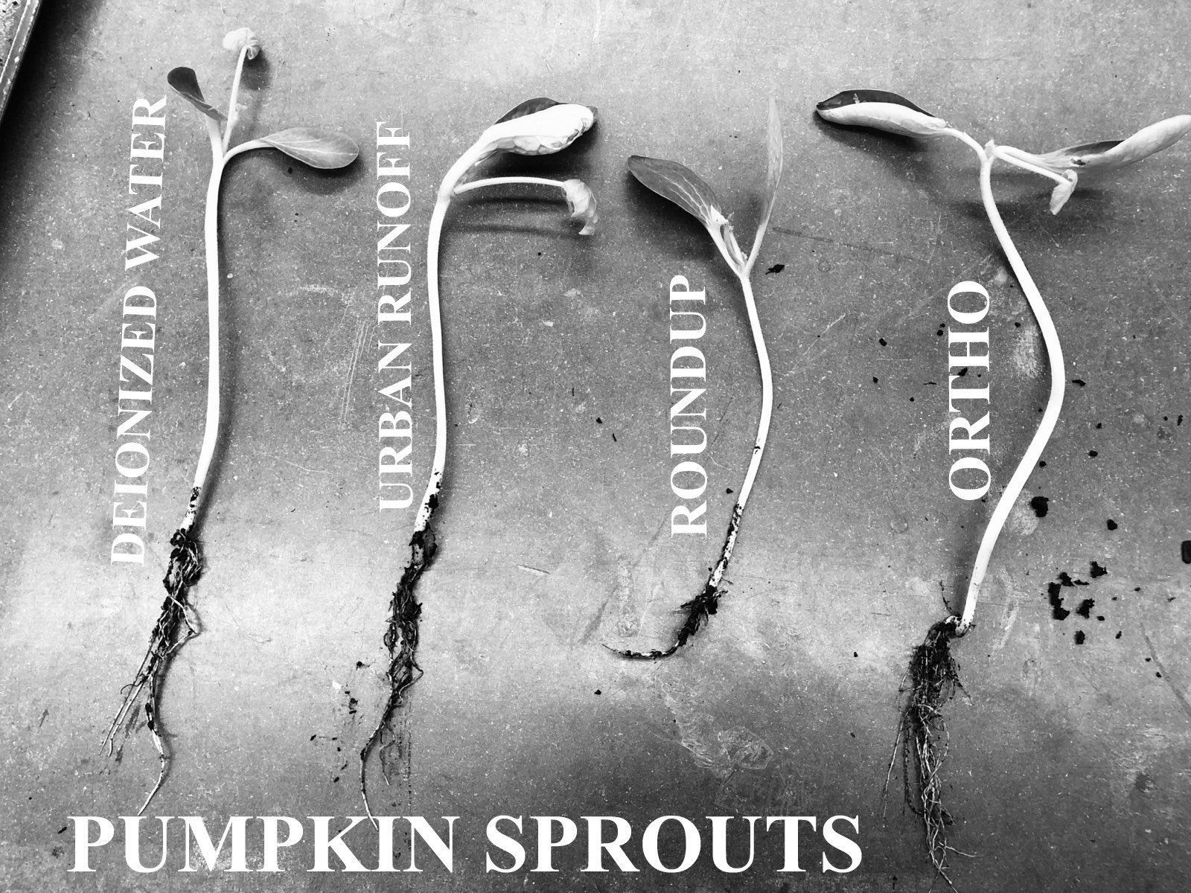
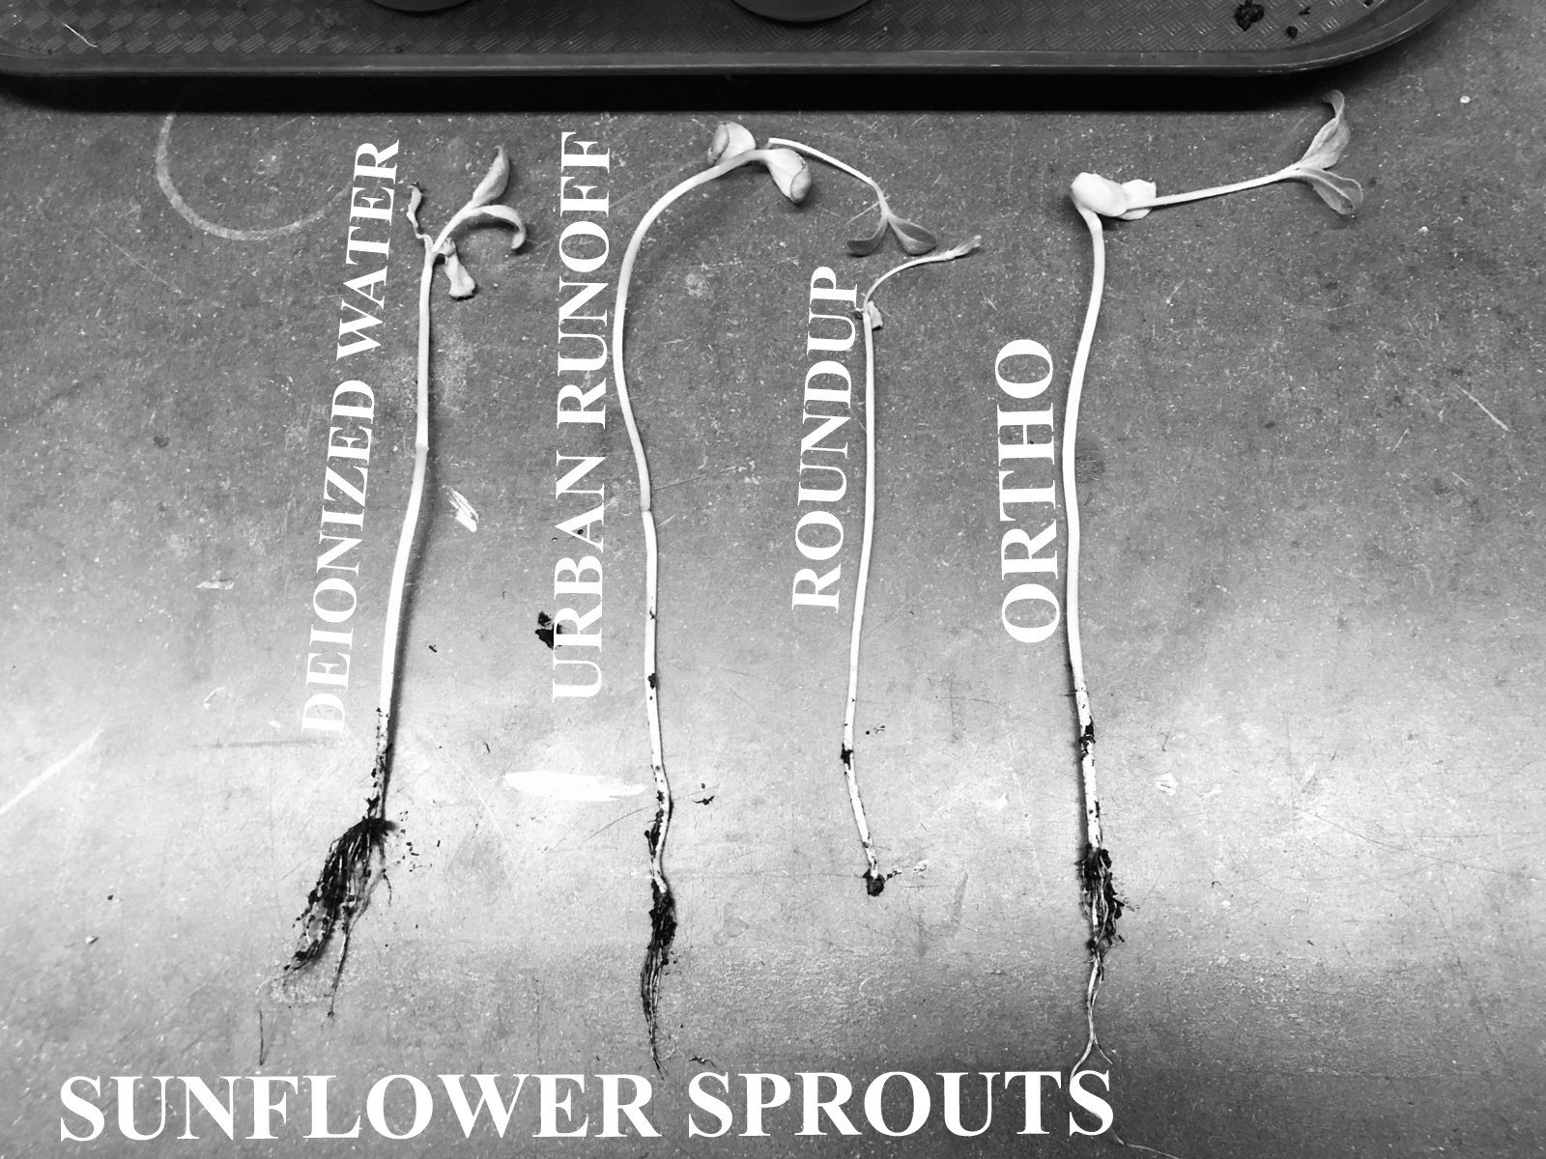
Our experiment gave us mixed results of what we predicted and future experiments can be done differently to get more uniform results. For example, due to differing findings of the effect of glyphosate and acephate on plant growth, future experiments should include multiple concentrations of each. We maintained a specific ratio of Roundup and Ortho to water throughout the experiment, though it has been found that when plants receive a concentration of pesticides above a certain level, they will experience maximum toxicity towards plant growth traits (Ahemad et al. 2012). Therefore, lesser concentrations may have beneficial effects while greater concentrations may have detrimental effects. A variety of concentrations are essential to having a more well-rounded experiment. Additionally, different types of pesticides are shown to have different degrees of impacts (Prasad et al. 2015). A study by Dhungana et al. (2016) shows variable effects of structurally different classes of insecticides on germination and early plant growth of soybean plants. Future experiments should extend the breadth of pesticides from Roundup and Ortho to include other common pesticides.
Figure 4. The effects of Roundup on the roots of sunflowers and pumpkins
Another improvement that can be made to this experiment is to more accurately measure the overall health and growth of the plants. As we measured the heights, we also took into account that many of these plants by week 2 or week 3 could not support their own weight and started to droop over the sides of the cups, in some cases causing the stems of the plants to break or wilt. We could have yielded more accurate measurements if we placed stakes into the soil and used those stakes to support the weight of the plants as they grew. Additionally, the health of the plants would be better maintained throughout the growing period if watered in small increments at a time until the soil is moist, rather than all at once. We believe the initial water doses may have been too high. Future researchers attempting this experiment should take caution in the watering amounts and rates. Lastly, when collecting urban runoff, it should be gathered from multiple locations, rather than just one. The location of collection can have an impact on how well the plants watered by urban runoff grow. Lastly, we would suggest conducting an experiment with a longer time frame to see how these plants further develop.
Human pollution through modern agricultural and industrial practices have major impacts on ecosystems and the species that inhabit them. We conducted this research experiment to study the impacts of different sources of water on the germination and growth of sunflower and pumpkin seeds. Polluted water sources from urban runoff and agricultural practices can have significant effects on the livelihood of plant species. This data, and that of future experiments, should be used towards the creation and implementation of regulations that benefit the environment and its ecosystems. These regulations would protect water and soil from harmful substances.

CONCLUSIONS
We can conclude that the presence of human pollution has impairing effects on the growth of pumpkin and sunflower seeds. There is also strong evidence from our data that shows that the herbicide, Roundup, has detrimental effects on the growth of plants by stunting their growth. This is important because it shows the negative effects that glyphosate has when it is released into an ecosystem. With this information, policies should be altered or put in place to better restrict the applications of this detrimental chemical.

ACKNOWLEDGEMENTS
We would like to thank Dr. Jackson with her assistance and guidance throughout this project. Dr Jackson helped provide materials for our experiment such as the insecticide, Ortho, and plastic cups for our plants and soil. We would also like to thank Mr. Selino who provided us with the Roundup. Finally, we would also like to thank our peers who helped us by reviewing this paper.

LITERATURE CITED
Ahemad, M., and M. Saghir Khan. 2012. Effects of pesticides on plant growth promoting traits of Mesorhizobium strain MRC4. Journal of the Saudi Society of Agricultural Sciences 11: 63-71.
Aljazzar, T., and B. Kocher. 2016. Monitoring of contaminant input into roadside soil from road runoff and airborne deposition. Transportation Research Procedia. 14: 2714-2723.
Beier, C.M., J. Caputo, G.B. Lawrence, and T.J. Sullivan. 2017. Loss of ecosystem services due to chronic pollution of forests and surface waters in the Adirondack region (USA). Journal of Environmental Management: 19-27.
Bruckner, A., A. Schmerbauch, L. Ruess, F. Heigl, and J. Zaller. 2019. Foliar Roundup application has minor effects on the compositional and functional diversity of soil microorganisms in a short-term greenhouse experiment. Ecotoxicology and Environmental Safety. 174: 506-513.
Dhungana, S.K., I.D. Kim, H.S. Kwak, and D.H. Shin. 2016. Unraveling the effect of structurally in different classes of insecticide on germination and early plant growth of soybean [Glycine max (L.) Merr.]. Pesticide Biochemistry and Physiology 130: 39-43.
Gomes, M.P., 2019. Effects of Ciprofloxacin and Roundup on seed germination and root development of maize. Science of The Total Environment. 651: 2671-2678.
Hermann, K.M., and L.M. Weaver. 1999. The Shikimate Pathway. Annual Review of Plant Physiology and Plant Molecular Biology 50: 473-503.
Hooda, P.S., A.C. Edwards, H.A. Anderson, and A. Miller. 2000. A review of water quality concerns in livestock farming areas. Science of the Total Environment: 143-167.
Petersen, I.L., K.E. Andersen, J.C. Sorenson, and H. Sorenson. 2006. Determination of shikimate in crude plant extracts by micellar electrokinetic capillary chromatography. Journal of Chromatography A: 253-258.
Prasad, S.M., A. Singh, and P. Singh. 2015. Physiological, biochemical and growth responses of Azolla pinnata to chlorpyrifos and cypermethrin pesticides exposure: a comparative study. Chemistry and Ecology 31: 285-298.
Schipper, P.N.M., R.N.J. Comans, J.J. Dijkstra, and L. Vergouwen. 2007. Runoff and windblown vehicle spray from road surfaces, risks, and measures for soil and water. Water and Science Technology 55: 87-96.
Silva, F.M.L., S.O. Duke, F.E. Dayan, E.D. Velini, and P. Kudsk. 2016. Low doses of glyphosate change the responses of soybean to subsequent glyphosate treatments. Weed Research 56: 124-136.
Tesfamarian, T., S. Bott, I. Cakmak, V. Romheld, and G. Neumann. 2009. Glyphosate in the rhizosphere—Role of waiting times and different glyphosate binding forms in soils for phytotoxicity to non-target plants. European Journal of Agronomy 31: 126-132.
Waara, S., and C. Färm. 2008. An assessment of the potential toxicity of runoff from an urban roadscape during rain events. Environmental Science and Pollution Research International 15: 205-210.
Waqar-un-Nisa, B. Nazneen, A.R. Saleem, A. Rashid, and L. Dawson. 2016. Effect of diesel contamination on the physico-chemical characteristics of soil and growth of vetiver grass. Soil and Environment 35: 91-98.
Yen, J.H., K.H. Lin, and Y.S. Wang. 2000. Potential of the insecticides acephate and methamidophos to contaminate groundwater. Ecotoxicology and Environmental Safety. 45: 79-86.

Water Quality Testing at Varied Urban Runoff Locations Shows Impacts on Stream Health

Dane Kranjac, Dakota Crowley, Daniel Parker

Abstract
Runoff often influences multiple factors of water quality, most often negatively affecting the ecosystem downstream from the point source. In a four week study of water quality and the effects of runoff in Blind Brook watershed south of Westchester County Airport, our group tested three sites with varying activities and runoff present (Airport Site, Golf Course Site and Anderson Hill Rd Site) where runoff was observed from airport traffic, agricultural activity and roadway traffic. At each site a YSI meter was used to quantify levels of dissolved oxygen, pH, conductivity, turbidity, temperature, dissolved solids, and other water quality parameters. The results varied from test to test with some outliers in the data that were unexplained. Over the testing cycle some trends were observed with turbidity, pH, DO%, temperature, Conductivity, and Total Dissolved Solids. The overall highest at the airport over all testing days with DO (mg/L) and TDS showing similar trends regardless of outliers on two separate days. All other sites show similar trends overtime with varying levels not greatly exceeding those observed at the airport site.

Keywords: Airport Runoff, Human Interaction, Pollution, Urban Runoff, Tributary-Long Island Sound
____________________________________________________________________________________

Introduction
Runoff in the New York area and around the world is a huge problem for ecosystem resilience as well as water quality. Runoff from urbanized areas and from agriculture are the main sources of pollutants that find their way into waterways like the local Blind Brook watershed. Runoff impacts ecosystems in a variety of ways, and frequently contains common pollutants such as motor oil, grease, and solid deposits of metals, many of which stem from local roadways and vehicles which may then enter the waterway (MacKay et al. 2011). Agricultural additions to runoff commonly include fertilizers, dirt, pesticides and other toxic chemicals used in the industry, but are also frequently found in developed areas which use materials such as turfgrass (Phillips and Bode 2004). These pollutants negatively impact the quality of the water, in turn making the environment prone to modification via eutrophication and other processes which lead to die-offs and succession by organisms more suited to the toxic environment. This may make recovery difficult, especially if toxins are continually released. Bodies of water exposed to an increased runoff volume and total suspended solids will increase the cyanobacteria biomass, causing greater chances for a water ecosystem to undergo eutrophication (Silva et al. 2019).
The Blind Brook watershed is a waterway heavily affected by runoff because of its proximity to the Westchester County Airport, Blind Brook Club Golf Course, and Anderson Hill Road. Previous studies have determined that urban and suburban developments such as those near the Blind Brook watershed may accelerate the movement of storm runoff and its carried pollutants into local streams and groundwater supplies (Burns et al. 2005). In fact, materials from airfield pavement, such as those which may be found at the Westchester County Airport, have previously been shown to lead to concerning levels of aquatic toxicity in runoff (Corsi et al. 2009). Urban stormwater carrying runoff pollution into tributaries and rivers is increasing the chemical oxygen demand for these locations showing that the ecosystem is becoming pressured in a way that it cannot sustain in terms of supplying chemical oxygen demand to biological communities without the need for human intervention to prevent ecosystem damage or regime shift (Luo et al. 2012).
We will use the YSI water quality tester to determine the differences between our three test sites each located in close proximity to locations producing source and non-source runoff into the Blind Brook. Deicers at the airport are common with showing reduced DO as well as contain additives like ammonia which impact aquatic life and human health due to their toxicity in water. Runoff associated with agriculture results in high levels of nitrogen and phosphorus into the water sources resulting in increased nitrate and ammonia levels. Runoff from roadways as well as non-deicer pollutants from runways are most commonly petroleum by-products that sit on the asphalt surface till rain events which were not extensively studied during our four test days.

Methods
Our group used the YSI water quality testing unit to test for dissolved oxygen, pH, conductivity, turbidity, temperature, dissolved solids, and other water quality parameters. To determine flow rate we measured the amount of time a bottle with a little water inside could float down a 3 meter section of the Blind Brook Tributary. We tested these parameters at three locations on the Blind Brook Tributary to determine the differences the different environments and runoff types affected the water quality within each location of the Blind Brook.

Results

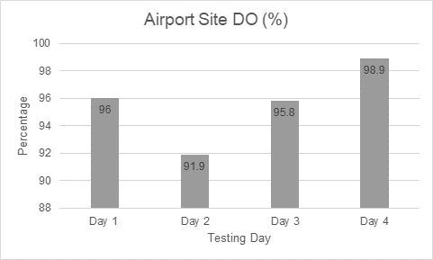 | 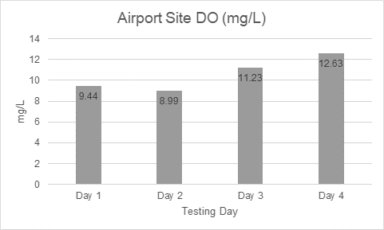
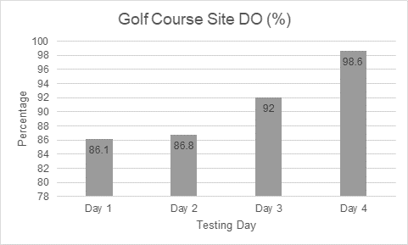 | 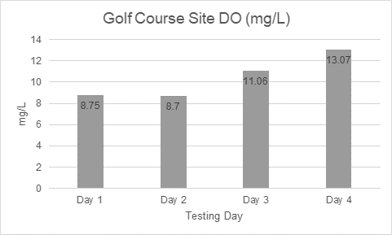
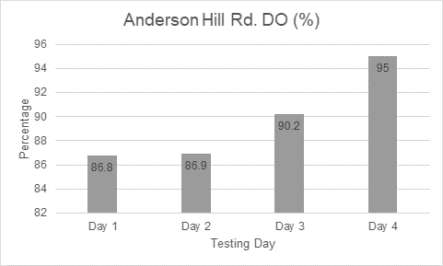 | 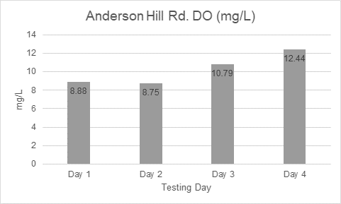

Average percent dissolved oxygen (DO%) was highest at the Airport site (95.65%), while the average percent dissolved oxygen was the lowest at the Anderson Hill Rd. site (89.725%), and the Golf Course site being the second highest average percent dissolved oxygen for the three sites (90.875%). Average dissolved oxygen ( DO mg/L) was highest at the Airport site (10.5725 mg/L), while the average dissolved oxygen was lowest at the Anderson Hill Rd. site (10.215 mg/L), and the Golf Course site having the second highest average dissolved oxygen (10.395 mg/L).

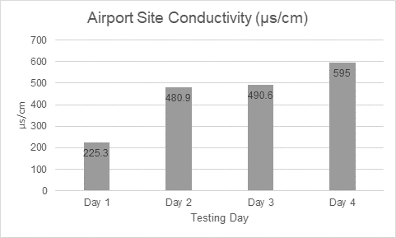 | 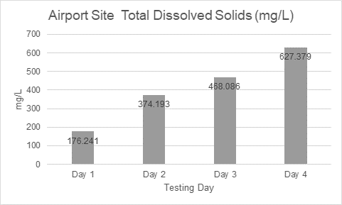
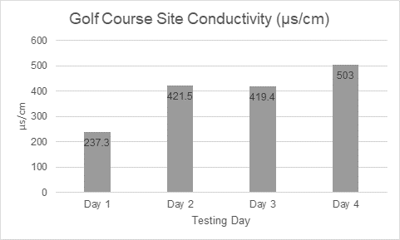 | 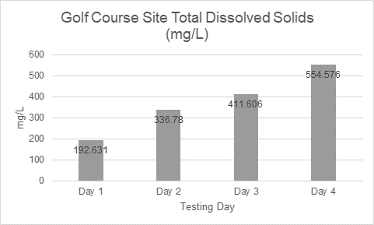
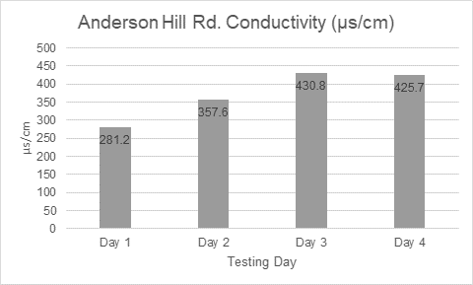 | 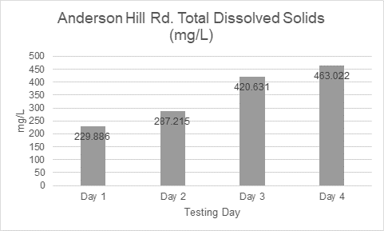

Average conductivity (us/cm) was the highest at the Airport Site (447.95 us/cm), while the lowest average conductivity was at the Anderson Hill Rd. site (373.825 us/cm), and the second highest was at the Golf Course site (395.3 us/cm). Average total dissolved solids (TDS mg/L) were the highest at the Airport site (411.47475 mg/L), while the average total dissolved solids were the lowest at the Anderson Hill Rd. site (350.1885 mg/L), and the second highest were at the Gold Course site (373.89825 mg/L).

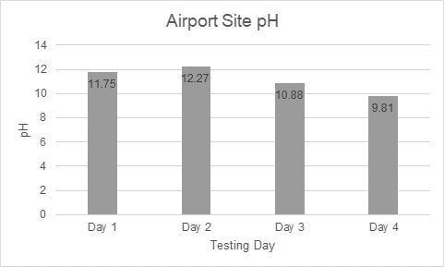
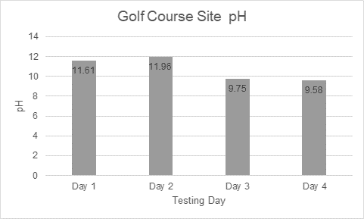
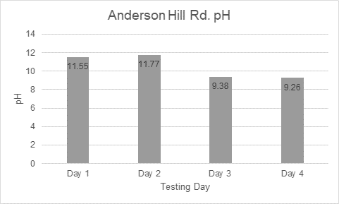

The pH level at the Airport site was the highest (11.1775), while the pH level at the Anderson Hill Rd. site was the lowest (10.49), and the Golf Course site having the second highest pH (10.725).

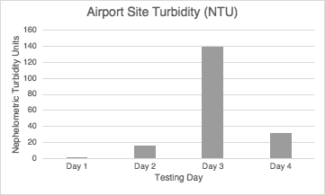
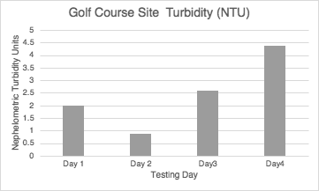
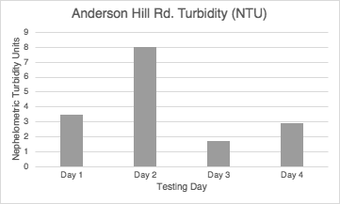

The average turbidity (NTU) was highest at the Airport site (47.5 NTU), while the average turbidity was lowest at the Golf Course Site (2.475 NTU), and the Anderson Hill Rd. site having the second highest average turbidity level (4.025 NTU).

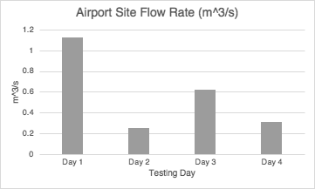
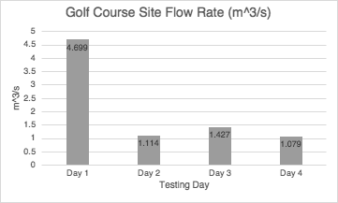
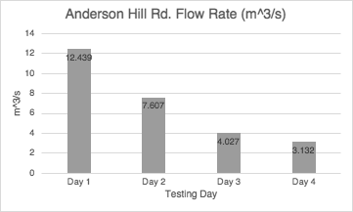

Average flow rate (m^3/s) was highest at the Anderson Hill Rd. site (6.80125 m^3/s), while flow average rate was lowest at the Airport site (0.58025 m^3/s), and the Golf Course site having the second fastest average flow rate (2.07975 m^3/s).

The average temperature (Celcius) was highest at the Airport site (11.425 °C), while the average temperature was lowest at the Golf Course site (10.15 °C), and the second highest average temperature was the Anderson Hill Rd. site (10.175 °C). These graphs where not show because the steady decrease in temperature was because of moving into the winter season as we tested.

Discussion
In the course of this field study, we sought to determine the differences, if any, between the water quality observed at three different locations along the Blind Brook as it flows across SUNY Purchase campus. The key differences between the three locations were, going from north to south downstream, the first location is immediately adjacent to water catchment areas on the property of Westchester County Airport near to their runways, the second location is about halfway south along the east side of campus and is near a golf course and housing development, the third location is just south of where the stream crosses under Anderson Hill road just off campus. The comparison of these three types of adjacent uses, commercial airport, housing/recreational, and roadway, was the main investigation of our project. We observed that the first location, on average, had a higher water temperature, and slower flow rate, as well as higher levels of DO, pH, and total dissolved solids, as compared with the subsequent two locations. It is difficult to infer a strong trend, based on limited sampling events, but implies that there is likely a higher nutrient concentration at that point in the stream near the airport. The Airport Site and the Golf Course site had the highest levels of total dissolved solids, pH, and conductivity are markers of having high nutrient levels as well as showing that runoff from these locations affects the Blind Brook significantly. High nutrient levels, pH, and total dissolved solids usually correlate to high phosphorus, nitrogen, and other fertilizers as well as shows that these sites are directly affecting the health of the tributary. The conductivity of the water is its ability to have electrical current run through it. Conductivity is directly related to pH, Salinity, and Total Dissolved Solids. Seeing the results show high Total Dissolved Solids and seeing High Conductivity levels as well as these results increasing as the DO% and DO mg/L went up.
The results varied from test to test with some outliers in the data that were unexplained nevertheless, over the testing cycle some trends were observed with turbidity, pH, DO% and Temperature all being the overall highest at the airport over all testing days with DO(mg/L) and TDS showing similar trends regardless of outliers on two separate days. All other sites show similar trends overtime with varying levels not greatly exceeding those observed at the airport site. The average turbidity was highest at the Airport site (47.5 NTU) and the Anderson Hill Rd. site (4.025 NTU) compared with the Golf Course Site site (2.475 NTU) most likely because the the Airport Site and the Anderson Hill Rd. site are in close proximity to vehicle traffic where dumping is caused by runoff directly going in clouding the water while at the Golf Course site with fertilizers and sprays being applied that get into the Blind Brook through groundwater contamination which gets into the stream causing higher total dissolved solids but low turbidity. At the Airport Site and the Golf Course site they saw a trend that the average pH, Total Dissolved Solids, and Conductivity had their highest levels compared with the Anderson Hill Rd. site. This could imply that the dumping of runoff into these sites is highest at the Airport and Golf Course sites. Pollution of ecosystems can be caused by the relatively high levels of de-icing agent, cleaning products used on the planes and equipment, fuel, and other sources of emissions deposited into biological communities by runoff. The pollution caused by runoff affects soil quality, groundwater quality, and stream/lake/ocean/etc. waters (Sulej et al. 2011).

Conclusion
Throughout our field study we showed that the Runoff from the Airport and the Golf Course site had the highest levels of total dissolved solids, pH, and conductivity showing that there is high salinity caused by pH increase which can damage the Blind Brook ecosystem. The Tributaries of the Long Island Sound see large volumes of sewage, industrial waste, etc. due to heavy urbanization. These added pressures being put on the Long Island Sound are increasing the amount of dissolved trace metals as well as inorganic nutrients. These are causing a potential toxic effect on the biological communities of the Long Island Sound, its tributaries, and the surrounding areas along the East River of New York. (Sweeney et al. 2004) The high conductivity levels seen at the airport site, anderson hill rd. site, and the golf course site all seem to confirm higher dissolved trace metals in the waters of the Blind Brook. the high total dissolved solids seen at the three sites also seems to point at increased runoff pollution making its way into the water. The highest levels of conductivity and total dissolved solids in the water seen where on the 4th day while from day 1-4 of testing increases where seen each day and this could be from the movement into the winter season causing higher levels of de-icing agent, fuel, and other pollutants to be released into the Blind Brook.
Total dissolved solids show that there is a large amount of runoff entering the water at these two locations. The dissolved oxygen showed high levels at each of the three sites because the movement of the water across the rocks in the Blind Brook as well as the trees and shrubs surrounding the Tributary contribute to high oxygen levels. This would not occur if there was less oxygen transfer because of the surrounding ecosystem because bacteria and algae blooms would use the increased nutrients as well as the increase in the pH and conductivity to use up all the oxygen during the process of them feeding on the nutrients. This shows that the parts of the Tributary close to the Airport and the Golf course are most heavily affected by runoff because of their proximity to the runoff as well as these sites having slower flow rate causing the runoff, nutrients, etc. to pool and concentrate in these locations.

Acknowledgements
Thanks to SUNY Purchase Environmental Science Department, Dr. Jackson, our classmates, and peer reviewers.

Literature Cited
Burns, D., T. Vitvar, J. McDonnell, J. Hassett, J. Duncan, and C. Kendall. 2005. Effects of suburban development on runoff generation in the Croton river basin, New York, USA. Journal of Hydrology 311(1-4):266-8.
Corsi, S. R., S. W. Geis, G. Bowman, G. G. Failey, and T. D. Rutter. 2009. Aquatic toxicity of airfield-pavement deicer materials and implications for airport runoff. Environmental Science and Technology 43(1):40-46.
Garrah, J., B. Frei, and E. Bennett. 2019. Bright spots among lakes in the Rideau valley watershed, Ontario. Ecology and Society 24(3):164-180.
Luo, H., M. Li, R. Xu, X. Fu, G. Huang, and X. Huang. 2012. Pollution characteristics of urban surface runoff in a street community. Sustainable Environmental Research 22(1): 61-68.
MacKay, A. A., S. Zinke, J. Mahoney, and J. T. Bushey. 2011. Roadway runoff water quality from milled and unaltered surfaces during convective storms. Journal of Environmental Engineering 137(12):1165–75
Pereira, L., D. Reis, H. Roeser, and A. Santiago. 2019. Relationship between land use and water quality in a watershed impacted by iron ore tailings and domestic sewage. Environmental and Water Magazine 14(5):1-11.
Phillips, P. J., and R. W. Bode. 2004. Pesticides in surface water runoff in south-eastern New York state, USA: seasonal and stormflow effects on concentrations. Pest Management Science 60(6):531–43.
Silva, T. F. G., B. Vinçon-Leite, J. B. Lemaire, G. Petrucci, A. Giani, C. C. Figueredo, and O. N. Nascimento. 2019. Impact of urban stormwater runoff on cyanobacteria dynamics in a tropical urban lake. Water (MDPI) 11:946.
Sulej, A. M., Z. Polkowska, and J. Namiesnik. 2011. Analysis of airport runoff waters. Critical Reviews in Analytical Chemistry 41:190-213.
Sulej, A. M., Z. Polkowska, and J. Namieśnik. 2012. Contaminants in airport runoff water in the vicinities of two international airports in Poland. Polish Journal of Environmental Studies. 21(3):725-739.
Sweeney, A., and S. A. Sanudo-Wilhelmy. 2004. Dissolved metal contamination in the East River–Long Island Sound system: potential biological effects. Marine Pollution Bulletin 48:663-670.
Wada, K., and S. Fujii. 2010. Estimation of pollutant loads from urban roadway runoff. Water Science and Technology. 61(2):345-354.

