View: What to study at college, and why
Jennifer Uleman Published 9:02 a.m. ET Sept. 16, 2015 | Updated 2:27 p.m. ET Sept. 16, 2015

Aristotle was onto something: A liberal arts education enhances one's life, and earnings potential
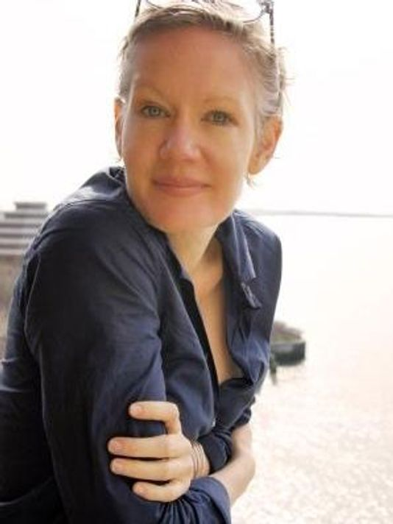
You can study things that make you a better slave and you can study things that make you a better free human being. So Aristotle thought when he distinguished the illiberal or servile from the liberal arts. The servile arts make you good at carrying out the wills of others. The liberal arts make you good at being a free human being – hence the "liberty" in their name.

Aristotle's liberal arts, standard curriculum in Rome by Cicero's time, were grammar, logic, rhetoric, arithmetic, geometry, music, and astronomy. Today's liberal arts are languages, mathematics, philosophy, history, physics, chemistry, biology, literature, art history, political science, economics, anthropology, psychology, sociology, and their newer interdisciplinary kin (cultural, gender, and ethnic studies; linguistic and cognitive sciences). U.S. liberal arts colleges are internationally admired and families of elites, in this country and globally, send their children to us.
But in ordinary households, and for many new college students, the liberal arts seem an unaffordable luxury. Liberal arts degrees cost more than they used to, public investment in them has fallen, and most families are getting poorer. Liberal arts majors like math and history are losing students, while practical-sounding majors, like business, communications, and engineering, grow.
It is important to know that practical-sounding majors often fail to deliver. People whose highest degree is a B.A. in philosophy make more money mid-career (that is, 15 years after graduation) than their counterparts with bachelor's degrees in accounting, nursing or public administration. Anthropology, chemistry and Spanish majors do better on the law school admissions test (LSAT) than those with majors in law or criminal justice. Humanities majors (literature, history, foreign languages) score higher on the medical school test (MCAT) than those in practical-sounding health sciences programs. Liberal arts training builds skills that transfer. For this reason, liberal arts degrees also impress good employers, setting them at ease. Practical-sounding degrees can signal a narrow skill set, liable to be out-of-date by graduation, or worse (from the employer's point of view), to signal a lack of interest in learning for its own sake. Financially, as prep for graduate work, and professionally, practical-sounding majors often let students down.
But the crucial thing goes back to Aristotle: the liberal arts make people free, or anyway contribute powerfully to their freedom. Sustained, college-level work in the liberal arts trains people to read, write, discover, confirm, analyze, report, and debate in the ways scholars and experts do – and to challenge scholars and experts. It trains people to argue about what is real and true and important in ways that deeply respect other people and reality. It trains people to think independently, and thus to speak and act in ways not dictated by fear of the boss or anxiety about money or craving for power. It helps ordinary people understand ourselves, and our individual and collective efforts at understanding and shaping the world, and it helps us do this as something worthwhile apart from earning potential, MCAT or LSAT scores, or skill at carrying out the wills of others.
For Aristotle, a slave is fundamentally a person who has been turned into a tool, an instrument. The wills of enslaved people do not matter under slavery; only the wills of owners matter. A slave is therefore not trained to think independently, to collaborate in deciding what matters, to debate values and aims, to shape policy and action. These things are for free people. Free people, like those equipped by the liberal arts, know their own and others' intrinsic worth and are able to insist on lives shaped by their own wills. In this respect, free people represent not just the sheer persistence but the full flowering of humanity. Free people are the kind of people that Aristotle, Thomas Jefferson, and many others have wanted as citizens, because they are equipped to resist tyrants.
It's also true that Aristotle defended slavery and that Jefferson practiced it, exploiting hundreds. Aristotle thought some people were naturally slavish—slavery was bad, except for them. I want my first-semester freshmen to reject this, and with it the view that the liberal arts are not for everyone. I want them to major in art history if they love art history, in physics if that is what they love. And I want them to push the powers that be to make college education in the liberal arts – from art history to physics to sociology – more affordable for more people. I want them to know that the alternative is what we really cannot afford. We need free people, people schooled in freedom, the more the sooner the better.
The writer is an associate professor of philosophy at Purchase College, SUNY. She grew up in Pearl River.
[Lohud is USA Today's local paper for New York's Lower Hudson Valley. The original appears online at the lohud website.]

