Contents
GLOSSARY
Add Classes Worksheet
The registration screen where you enter CRNs to be added to your
Course Reference Number (CRN)
The 5-digit number that refers to a specific course section, needed to register
Registration Status
Any information relevant to your eligibility to register for a given term, including holds, course overrides, and academic information
Waitlist
The sequential roster of students who will get priority to register for a closed course should spots open up

Introduction
Accessing Registration
Add Classes Worksheet
Class Search
Adding Courses
Registration Errors
- Time Conflicts
- Closed Courses
- Major/Program Restrictions
- Permission of Instructor
- Pre-requisites
- Co-requisites
- Duplicate Courses
Waitlists
Dropping Courses
Billing and Payment
Introduction
These instructions will guide you through the online course registration process in myHeliotrope for visiting non-degree students. You will learn how to add and drop courses and sign up for course waitlists using Course Reference Numbers (CRN) and the Add Classes Worksheet.
If you are registering for the first time, you will have to create your student record by filling out the Student Data Form prior to registration. Student Data Form guides are available for visiting students and senior auditors. After you complete your Student Data Form, you will receive instructions to activate your Purchase account and will be able to access the myHeliotrope self-service system.
Before you register, it may be helpful to view your Registration Status. You may do this by logging in to my.purchase.edu, clicking myHeliotrope, and navigating to Student > Registration > Registration Status. Select the term you will be registering for to view your registration eligibility information, including holds, curriculum, and any course overrides assigned to you by faculty.
Accessing Registration
1. Go to my.purchase.edu.
2. Click on myHeliotrope and log in with your Purchase College ID and password.
3. Click on Student
4. Click on Registration.
5. Click on Add or Drop Classes.
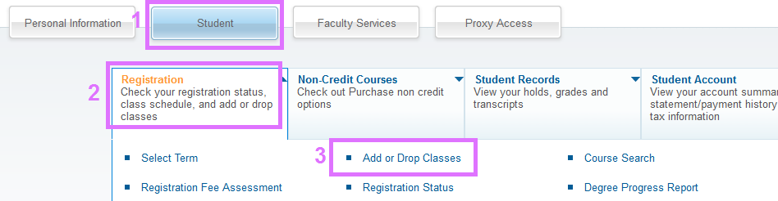
6. Select the term you are registering for from the dropdown menu.
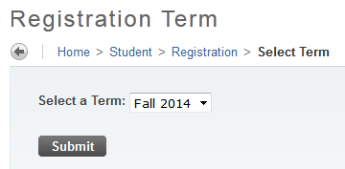
Add Classes Worksheet
After you choose a term, you will be taken to the Add Classes Worksheet. This is where you enter the 5-digit Course Reference Numbers (CRN) of the course sections to be added to your schedule. Confirm that you are logged in correctly and in the correct term by checking for your name and the selected term in the top right corner of the page. If you already know the Course Reference Numbers (CRN) of the course sections you want to add to your schedule, type them into the fields provided and click Submit Changes.
The Reset button will clear any CRNs you have entered into the worksheet.
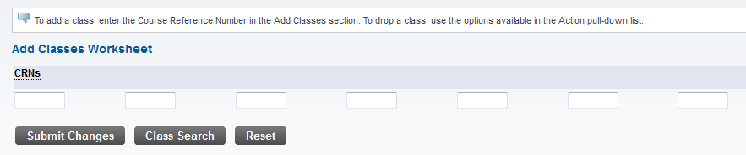
If you need to search for classes, click Class Search at the bottom of the worksheet.
Class Search
After clicking on Class search, you can look up classes by subject. You can search for multiple subjects at a time by holding down the Ctrl button on your keyboard and clicking multiple categories. Once you have selected the subject(s) you want to search within, click Course Search.
If you would like to search by other criteria, such as instructor, days and times, or course attributes, click Advanced Search. For Advanced Search instructions, see the Course Search guide.
Find the course you want to register for and click View Sections. This will show you every section of this course that is being offered in the selected term.
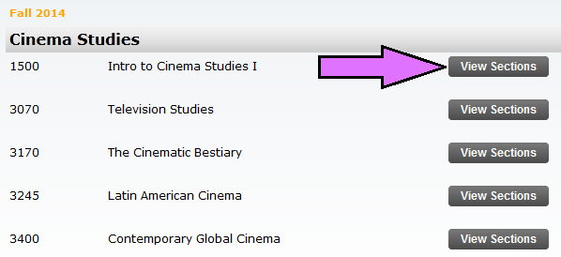
Clicking View Sections will bring up all sections of that course being taught in that semester.
You can view the number of credits, days and times, enrollment numbers, instructor, start and end dates, location, and course attributes. You can hover over any text underlined with a dotted line to see its expanded text.
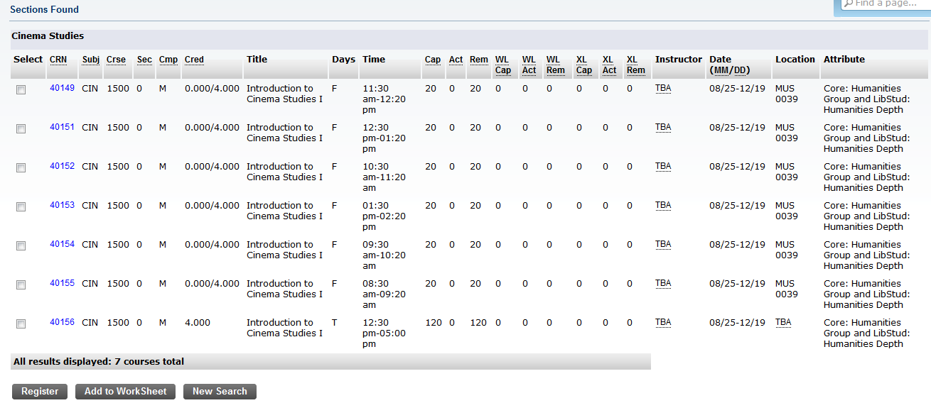
The number of open seats remaining in the section is in the Rem (Section Remaining) column. If this number is zero, the course is closed. If the course has open spots on the Waitlist, those spaces will appear in the WL Rem (Waitlist Remaining) column.
To view more information about a specific section, click on the CRN. From there, you can also click on View Catalog Entry to see the course description and additional course information. Hit the back button to return to your search results.
Adding Courses
Once you have found the section you would like to register for, check the box in the Select column.
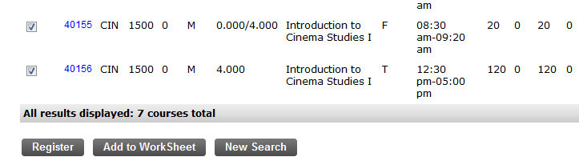
If there is a letter in the Select column rather than a box, it means the section cannot be added. You can hover over the letter(s) to see the reason the course cannot be added (e.g., a “C” means the course is closed). If there is no checkbox or letter, it means that course is already in your current schedule.
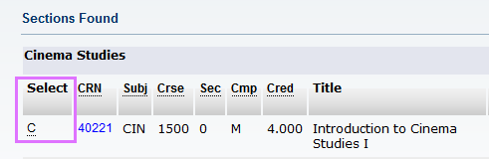
You can either click Register to add the course instantly and be taken back to the Add Classes Worksheet, or click Add to Worksheet, which will take you back to the Add Classes Worksheet and show the CRN now populated in the worksheet. The second method allows you to search for and add multiple courses to your worksheet and register for the courses all at once by clicking Submit Changes, once all of your course selections have been populated in the worksheet
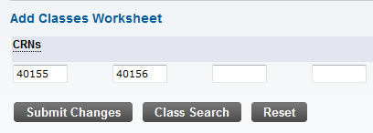
There are two instances when you cannot use the Register button. If a course is closed and you would like to be added to the waitlist, you must manually type the CRN into your worksheet, and then submit changes. If there is space left on the waitlist, you will be given the option to sign up for it. You can read more about this option in the Waitlists section of this guide.
Additionally, co-requisite courses must be added simultaneously. This means that you must add each co-requisite course to the worksheet before submitting changes. If you do not add co-requisite courses simultaneously, you will receive an error. You can read more about this in the Co-requisites section of this guide.
If the course sections you select are successfully added, they will appear in your Current Schedule, above the worksheet.
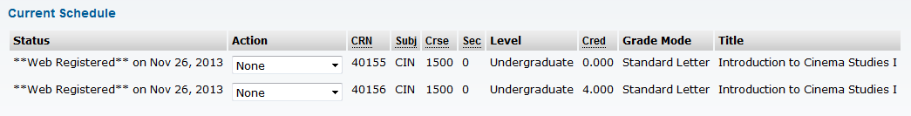
Registration Errors
When you attempt to add a course that cannot be added to your schedule, it will appear under the Registration Add Errors section just above your worksheet. There are several different reasons why you may not be able to add a particular course or section. The reason a course cannot be added will appear under the Status column.
Time Conflicts
If a course conflicts with a course already in your current schedule, it cannot be added. Additionally, you may not be added to the waitlist of courses that conflict with your current schedule. If you attempt to add a course that has a time conflict you will receive an error like this:
If you believe the course should not have a time conflict, contact the Registrar’s Office. In appropriate instances, the Chair or Coordinator of your program may be able to override time conflicts.
Closed Courses
If a course is full, it cannot be added. Depending on whether there are open spots on the waitlist, you will receive different errors.
If a course is full but there are spaces open on the waitlist, you will receive the above error. In the above example, “1 Waitlisted” means 1 student has already signed up for the waitlist. From here you may add yourself to the waitlist by selecting Waitlist from the dropdown menu under Action and clicking Submit Changes at the bottom of the worksheet. After adding yourself to the waitlist, the course should appear in your current schedule with the word “Waitlist” under Status.
In the case that the course has an open spot, but also has students signed up for the waitlist, the open spot will be reserved for the next student on that waitlist. You will not be able to add the course in this case, but may add yourself to the waitlist if there are waitlist spaces available.
Sometimes waitlists are also at capacity. In those cases, you may not add the course or sign up for the waitlist. You must wait for students to drop from the waitlist before you can sign up for it.
Major/Program Restrictions
Some courses are restricted to students outside of that program. If you attempt to add a course outside of your program that is restricted to non-majors, you will receive the following error:
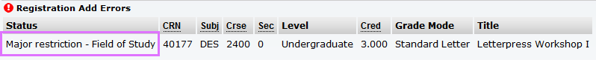
Make sure your major is correctly defined in your student information. If you believe there is an error, contact the Registrar’s Office.
Permission of Instructor
Some courses require permission of the instructor to be added. If you attempt to add such a course without permission of the instructor, you will receive the following error:
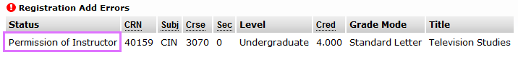
To request permission to add a course, contact the instructor. Contact information can be found in the Campus Directory. The instructor can add the permission to your student record, so the next time you log in to register you are able to add the course.
Pre-requisites
If you have not met the pre-requisites of a course, you will receive the following error:
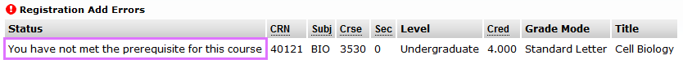
If you believe this is incorrect and you have met all prerequisites for the course, contact the Registrar’s Office.
Co-requisites
If courses are co-requisites, meaning they must be taken together, you will receive the following error, or similar, if you attempt to add one without the other:
To add co-requisite courses, you must enter the CRN for both courses into your worksheet and add them simultaneously. If you have already completed one of the co-requisites and want to add one without the other, you must contact the Registrar’s Office to do so. This is not possible in all cases.
Duplicate Courses
If you attempt to add the same class twice, you will receive the following error:
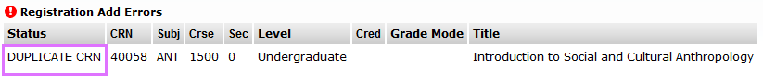You may not add duplicate courses to your schedule.
If you have any questions about registration errors, or encounter one not described above, please contact the Registrar’s Office. Some errors may be overridden by the instructor or the chair/coordinator of your program with special permission.
Waitlists
If a course is closed, you may be able to sign up for the waitlist. There are a finite number of spaces on a waitlist, meaning waitlists can also fill up, and students are given preference in the order they sign up.
To be added to a waitlist, you must enter the CRN or add it to your worksheet from the class search and click Submit Changes. You will receive an error saying “Closed - # on Waitlist.” The “#” will be the number of students who have already signed up ahead of you on the waitlist. In the example below, “1 Waitlisted” means 1 student has already signed up for the waitlist.
You may add yourself to the waitlist by selecting Waitlist from the dropdown menu under Action and clicking Submit Changes at the bottom of the worksheet. After adding yourself to the waitlist, the course should appear in your current schedule with the word Waitlisted under Status.
If a spot opens up in a course, the first student on the waitlist will be notified by e-mail and given a 24-hour window to add the course. You must add the course manually. If you do not add the course in this 24-hour window, the next student on the waitlist will be offered the spot and you will be removed from the waitlist. You can add yourself back to the waitlist by repeating the steps above.
Please note: Courses you are on the waitlist for will appear in your student schedule with your other courses, but the credits will show as zero. Please remember that this does not mean you are registered for the course.
Additionally, you may not add yourself to the waitlist of a course that conflicts with any course you are already registered for. Similarly, you may not register for a course that conflicts with a course you are on the waitlist for.

Dropping Courses
If you would like to drop a course from your schedule, select **Web Drop** from the dropdown menu next to the course.
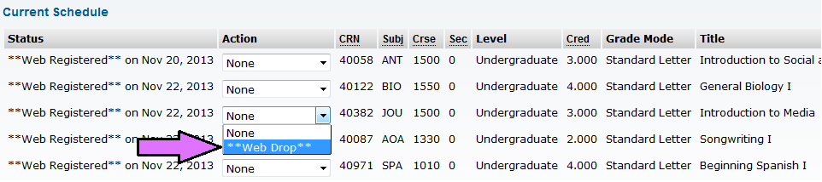
Then scroll down and click Submit Changes at the bottom of the worksheet.
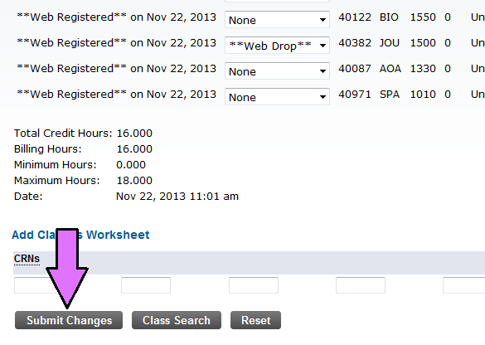
The course should be removed from your current schedule. You will no longer have the option to drop courses after the add/drop period. After that, you will have to submit a Course Withdrawal form to the Registrar’s Office.
Billing and Payment
Please note that non-degree students have a unique billing and payment policy. Please see the School of Liberal Studies and Continuing Education website for information and deadlines. Bill Payment Guide

